openIMIS-DHIS2 Configuration Installation SOP

Contents

1. Background 3
2. Installation of opIMIS-DHIS2 Package 4

Background

Digital Square is leading a partnership of a group of digital health experts and organisations working in countries to strengthen the design, development, and implementation of Digital Health Systems. The program works towards coordinating technical and financial investments in scalable technology solutions and their sustainable implementation. HISP India is one of the partners working with Digital Square on the openIMIS Modular Transformation initiative, focusing on the work for integration between openIMIS and DHIS2, with the latter working as the analytics platform of health insurance data captured in openIMIS.

This document provides the standard operating procedures for the end-users/system administrators to set-up the configuration of openIMIS-DHIS2 program configuration for openIMIS data analytics dashboards.

Installation of opIMIS-DHIS2 Package

The pre-requisite for installation of the openIMIS DHIS2 configuration are given below:

- DHIS2 instance (version 2.33 and above) with blank database.
- A stable internet connection, and a web browser such as Google Chrome, Mozilla Firefox, Microsoft Edge, or Safari.
- openIMIS DHIS2 configuration JSON file.

To import the DHIS2 configuration, the users needs to download the JSON file from the GitHub repository.  https://github.com/openimis/openimis-dhis2-configuration_json  Please note: The JSON file is supported only in version 2.33 and above. | 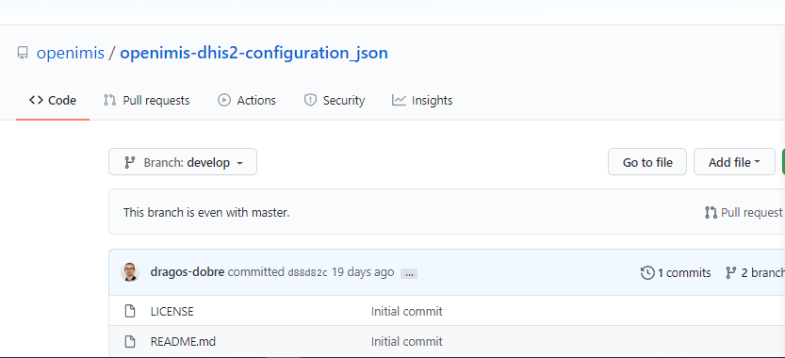
Signing In  Enter the given URL in the browser.  Enter the username and password.  Click on ‘Sign in’ | 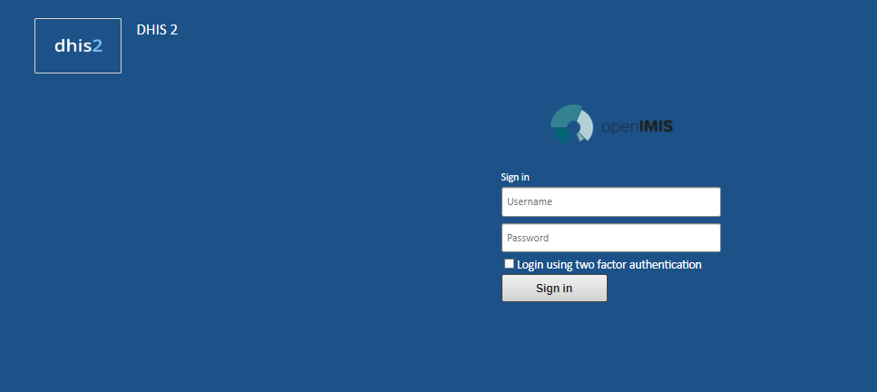

On logging in, select the Import Export app from the Apps menu | 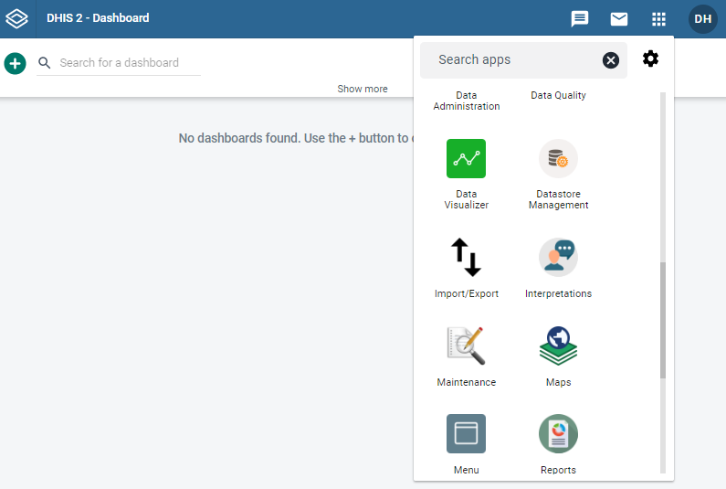
In the options under the Import Export app, select ‘Metadata Import’  In the Metadata Import home page, make the following selections:  Upload the JSON file as downloaded above.  Format will be selected as JSON.  If the user wants to do a test run, select ‘Yes’ under Dry Run.  Identifier will be selected as UID.  Import Report Mode will be selected as Errors.  Preheat mode will be selected as Reference.  Import strategy will be selected as New and Updates.  Atomic mode will be selected as All.  Merge mode will be selected as Merge.  Under ‘More Options’ let the default selection be as it is.  Click on ‘Import’ | 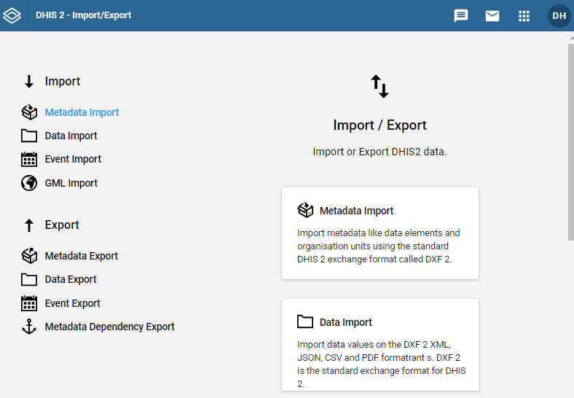  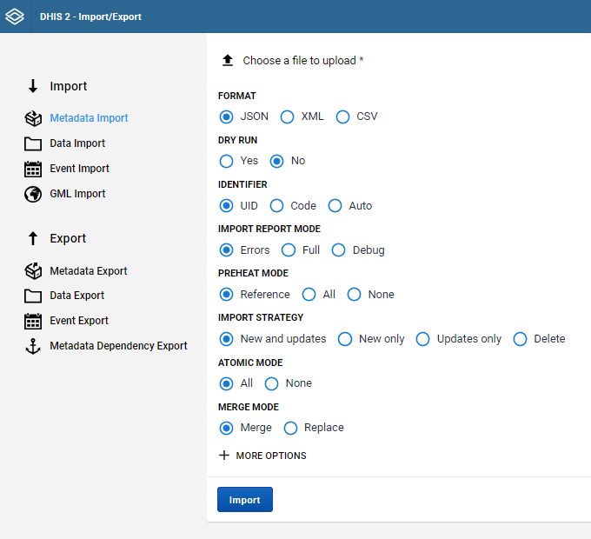  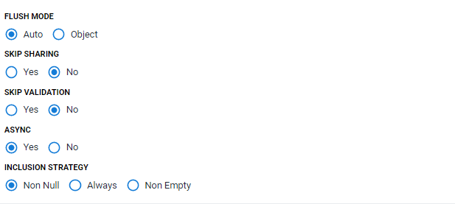  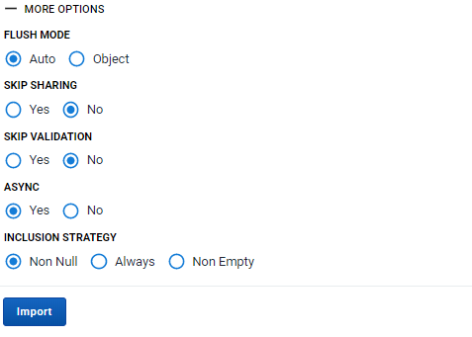
At the bottom of the page, a logger is available which keeps a track of the import process, and shows if any errors are encountered.  During the import process, if there are any issues encountered, it wil show some erros, which will need fixing before the next import cycle.  If there are no issues found in the JSON, the metadata import will give a successful import status. | 