Version 1
openIMIS-DHIS2 Integration
Software Requirements Specifications Document

Contents
List of figures 2
Abbreviations 3
1.Executive Summary 4
2.Introduction and Background 5
2.1 Open Insurance Management Information System (openIMIS) 5
2.2 District Health Information System 5
2.3 Information Sources 6
3.Business Process Modelling 7
3.1 Existing Business Process 7
3.1.1 Actors/Checkpoints 7
3.1.2 Existing Workflow 9
3.1.2.1 Patient/Household Registration 9
3.1.2.2 Recording patient’s facility visit and service utilisation recording 9
3.1.2.3 Claim Submission 10
3.1.2.4 Claim Review and Valuation 10
3.1.2.5 Claim Audit and Feedback 11
3.2 System Integration 13
3.2.1 Integration Building Blocks 13
3.3 Proposed Workflow 14
4.Data Analysis and Outputs 16
4.1 Beneficiary Indicators 16
4.2 Claim Indicators 22
4.3 Operational Indicators 26

List of figures

Figure 1 Existing Workflow 12
Figure 2 Proposed Workflow 15

Abbreviations

API: Application Programming Interface
DHIS2: District Health Information System 2
FHIR: Fast Healthcare Interoperability Resources
HISP: Health Information Systems Programmes
HMIS: Health Management Information System
MoH: Ministry of Health
openIMIS: Open Insurance Management Information System
REST-API: Representational State Transfer Application Programming Interface

Executive Summary

Digital Square is leading a partnership of a group of digital health experts and organisations working in countries to strengthen the design, development, and implementation of Digital Health Systems. The program works towards coordinating technical and financial investments in scalable technology solutions and their sustainable implementation. HISP India is one of the partners working with Digital Square on the openIMIS Modular Transformation initiative, with the proposed integration between openIMIS and DHIS2, with the latter working as the analytics platform of health insurance data captured in openIMIS.
This document provides an overview of the requirements (both conceptual and technical) of the envisaged DHIS2 based analytics platform integrated with openIMIS which will help in defining the approach for design and development of the openIMIS data analytics platform based on DHIS2.
The document starts with understanding and illustrating the business processes that are currently followed to record the data collected from various stakeholders involved in the program. The current data collection workflow is mapped to the corresponding data recording and reporting events. The workflow defines the patient checkpoints with respect to the system and the corresponding actions to be taken by the users at each level. Through this illustration, the data flow across the system is also highlighted.
In the next section, the system integration requirements have been illustrated where the building block of the integration i.e. use of FHIR API, DHIS2 FHIR adaptor, and the FHIR server used for openIMIS are defined. Their proposed integration mechanism is defined in the System Design Document for openIMIS-DHIS2 integration.
In the last section of the document, the output requirements have been mentioned as the indicators required to be generated from the system with their corresponding to openIMIS concepts, FHIR response, and mappings.

Introduction and Background

2.1 Open Insurance Management Information System (openIMIS)

openIMIS (www.openimis.org ) is an open-source information system for managing data for health financing processes Ministries of Health and their respective country Health Insurance Boards/Funds. The openIMIS application is jointly funded by the Swiss Agency for Development and Cooperation (SDC) and the German Federal Ministry for Economic Cooperation and Development (BMZ).
The system allows to manage the data pertaining to the following processes:
- Membership/Patient Registries.
- Benefit packages (services available, permissible items, and their prices.)
- Facility/Provider Registries.
- Claims filing and submissions, review, feedback, and valuation.
The system is capable of producing reports, and analytics based on the data generated by the above processes, but lacks effective visualisation and data presentation aspects, which are now being taken care by integrating it with another open-source data management platform known as District Health Information System (DHIS2), the summary of the same is given next.

2.2 District Health Information System

DHIS 2 (www.dhis2.org ) is a tool for collection, validation, analysis, and presentation of aggregate and patient-based statistical data, tailored (but not limited) to integrated health information management activities. It is a generic tool rather than a pre-configured database application, with an open meta-data model and a flexible user interface that allows the user to design the contents of a specific information system without the need for programming. DHIS2 and upwards is a modular web-based software package built with free and open-source Java frameworks.
DHIS2 can support both the tracking on individual entities like patients in this case (through the Tracker module) and aggregate data at each level in the hierarchy. The existing data model allows for individual-level data stored in the Tracker to be seamlessly aggregated and taken into the generic DHIS2, where it can use the functionalities of the dashboards, GIS maps, and other analytical tools to conduct analysis, visualization, and dissemination of data.
In this context, the analytical capabilities of DHIS2 will be used to full effect, where the data received from openIMIS will be processed and visualisations will be drafted in the form of standard health insurance dashboards for various processes identified during the requirements gathering phase of the project.

2.3 Information Sources

This software requirement specification document is in reference to the discussions done in the following order:

- Series of Skype call and discussions with GIZ HQ, GIZ Nepal teams to understand the openIMIS system, its processes, and the implementation in Nepal. In addition to Nepal, the openIMIS system Cameroon, Chad, Congo DRC, and Tanzania.

- Review the key monitoring and evaluation indicators documented till date, and further revision of the same to come out with a generic indicator set divided into categories for Beneficiary Management, Claims Management, and Operations/Process Indicators.

- HISP India’s participation in the JLN Workshop in Kathmandu on June 2019, and further discussions on openIMIS workflows, and functionalities.

Business Process Modelling

This section describes the current business processes followed in the implementation of the openIMIS which includes information on the actors/checkpoints in the workflow, their contribution to the workflow, roles, and responsibilities.

Existing Business Process

In the current scenario, the data collection process is paper-based using registers or using the openIMIS app. The functioning of the program involves the following actor/checkpoints:

3.1.1 Actors/Checkpoints

The following actors are involved in the existing process

3.1.1.1 Enrolment Officers

The Enrolment Officers are responsible for registering the individuals or households in the system with their key demographic information. The officers visit different households offering door-to-door registrations of the members either using registers, or the openIMIS app.

3.1.1.2 Individual/Household

The individual members/household are the beneficiaries of the benefit packages made available in the country by the Health Insurance Board/Ministries of Health. These beneficiaries are enrolled in the system into different insurance policies and are tracked for availed services and the management of the associated claims. The individual/household head needs to pay a minimum amount for getting covered under the enrolled policy and can get the further subsidy from the payer institutions for the services availed as part of the benefits package.

3.1.1.3 Health Facility/Provider

The Health Facility provides the health services to the patient, which involves both preventive and curative care with treatment plans including medicines, ancillary items, etc. Depending upon the country context, during the enrolment process, the patient can be assigned a facility/provider to be the primary healthcare service provider, and through them, the patient could be advised tertiary care (if needed).

3.1.1.4 Payer Institutions (Ministries of Health/Health Insurance Board)

The Payer Institutions are the primary source of finances and reimbursements given to the facility, or the beneficiaries. The payer institutions receive the contributions made by the individuals/household on enrolment into a benefits package, and also on its renewal thereby maintaining their funds for issuing re-payments to the health facility for the medical care taken by the beneficiaries on through a claim submitted for the availed services.

3.1.1.5 Claims Administrator

The Claims Administrator is responsible for managing all data received through the individual’s health facility into a claim submission form and entering the data as Claims against the registered individual for getting the review, approval, and valuation of the submitted claims.

3.1.1.6 Claims Reviewer

The Claims Reviewers validate the submitted claims based on the benefits package availed by the individual/household by assessing the services availed, and items procured during the course of the treatment. Based on factors associated with eligibility, coverage and previous utilisation a claim can be accepted or rejected by the Claims Reviewer.

3.1.2 Existing Workflow

3.1.2.1 Patient/Household Registration

Actors involved: Individual/Household, Enrolment Officer or Health Facility
Process Flow:

- The Enrollment Officers visits the households and enrolls the household (household head, and family members) either using paper registers.

- Once the registration is done, the contributions are collected, and receipts are issued for the same.

- Membership ID cards are generated and given to the household for future use.

- The filled enrollment forms are submitted to the Insurance Operator/Data Entry operator for adding the collected data into openIMIS.

3.1.2.2 Recording patient’s facility visit and service utilisation recording

Actors involved: Individual/Household, Health Facility/Provider
Process Flow:

- The individual who is seeking medical care visits the health facility preferably with the membership card issues during the registration process.

- The individual’s data is validated, in case the patient is not available in the database, then on consent, the individual can be registered in the system.

- The individual consults the doctor and gets the required treatment plan which comprises of the care instructions, medicines, and any ancillary items required for treatment.

- The health facility personnel fill the service utilization form to document the services given by the doctor towards claiming reimbursement for the services provided by the facility.

3.1.2.3 Claim Submission

Actors involved: Health Facility/Claims Administrator
Process Flow:

- The service utilization form filled in the above step is used to submit the claim for the services/items availed by the individual in the last documented visit.

- The claim is submitted in openIMIS and the system makes it available for the Claim Reviewer to take the next set of actions.

3.1.2.4 Claim Review and Valuation

Actors involved: Claim Reviewer
Process Flow:

- The submitted claim undergoes a review by the Claim Reviewer and based on the eligibility, coverage, and past utilization of the benefits package the Claim Reviewer decides to approve or reject a claim. The claim can be accepted partially as well depending upon the rules applicable on each specific claim.

- Alternatively, there is a mechanism available in the system to put business rules in place, which can automate the claim review process to an extent and can accept/reject claims based on set business rules.

3.1.2.5 Claim Audit and Feedback

Actors involved: Claim Reviewer
Process Flow:

- A sub-set of claims are selected for medical audit, and feedback as part of routine assessment and sanity check for the claims already reviewed and valuated.

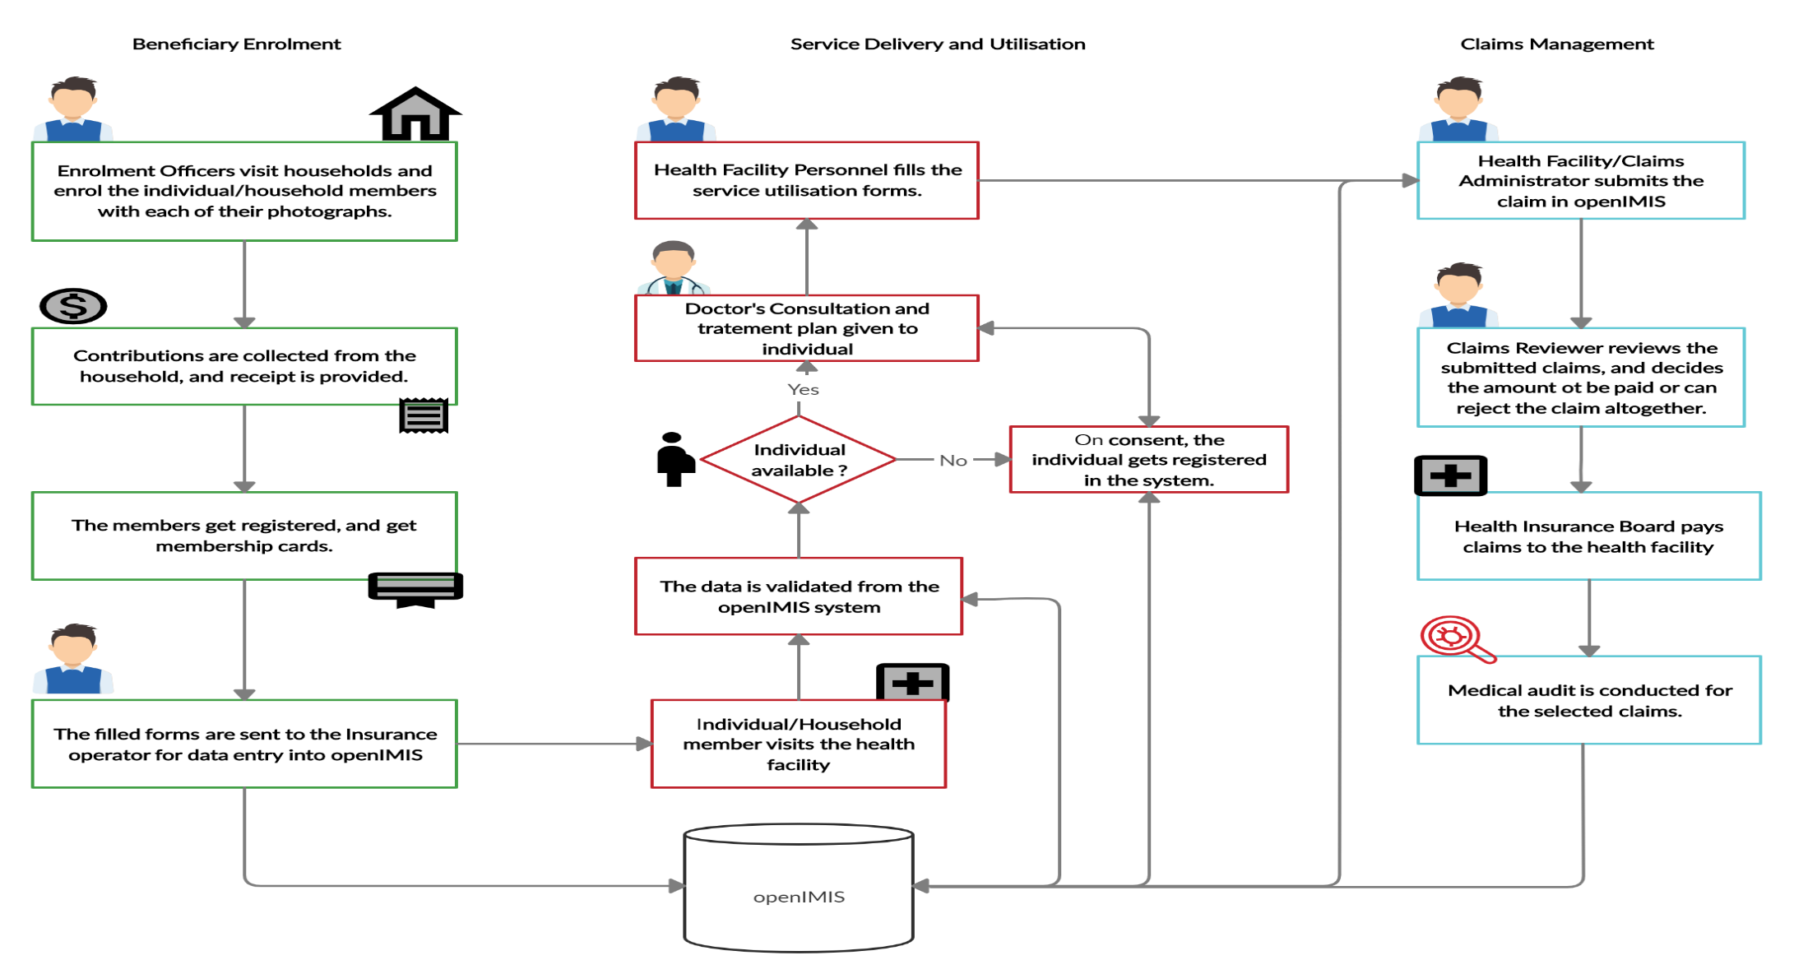

Figure 1 Existing Workflow

3.2 System Integration

3.2.1 Integration Building Blocks

3.2.1.1 openIMIS

openIMIS will be the source of all information required (metadata, and data) in this system integration. The reporting units of the openIMIS i.e. the health facilities will be pulled into DHIS2, to create a hierarchical reporting structure which would be then utilised for storing data and doing analytics in DHIS2. The concepts available in openIMIS can be pulled in DHIS2 for storing the data coming from openIMIS.

3.2.1.2 FHIR Server/Reference Module

A FHIR server/reference module has been configured for openIMIS which contains the FHIR extensions created for co-relating the openIMIS concepts to required FHIR resource, and FHIR entity thus facilitating the exchange of data between two systems.

DHIS2 FHIR Adapter

A DHIS2 FHIR Adapter is being developed which allows the import of FHIR Resources into DHIS2 by using FHIR Subscriptions defined at the suggested FHIR server/reference module. The import and export of data work based on a domain-specific business rule engine that decides about transformations of patient-related data to questionnaire-like structures (For e.g. DHIS2 Tracker Programs and their Program Stages). It is optimized for national FHIR profiles that are based on standard coding systems like LOINC, SNOMED CT, CVX, and others or even on national coding systems.
The Adapter receives FHIR subscription notifications from one or more FHIR Servers when there are created or updated or at a scheduled time period based on the traffic. To perform transformations to DHIS2 there are configured rules and transformations which can use reusable JavaScript code snippets. In order to identify already created DHIS2 tracked entity instances, a kind of national identifier must be provided by the FHIR patient resource (or any other FHIR resource that is mapped to a DHIS2 tracked entity type). The Adapter uses a database to store mapping data and temporary processing data.
For example, in this case, the FHIR resource named ‘Patient’ can be mapped to DHIS2 Tracked Entity type ‘Person’, and ‘InsureeID’ can be used as the identifier for identifying patients.
The rules that are used for the import are also used for the export of DHIS2 resources to a FHIR server, also the FHIR REST interfaces provide the data based on these rules.
The details of this adapter and its compatibility with the openIMIS FHIR resources will be studied and worked upon to define the working mechanism between the two resources.

DHIS2

DHIS2 will be the recipient of the information in this system integration. It will be receiving the metadata and data from openIMIS where using the data received, indicators will be defined in DHIS2 to do the required calculations. The indicators once configured will produce the required results for plotting the data on the dashboard.

3.3 Proposed Workflow

The proposed workflow will involve the addition of the above defined integration building blocks in addition to the Existing workflow, which is shown in the figure given below:

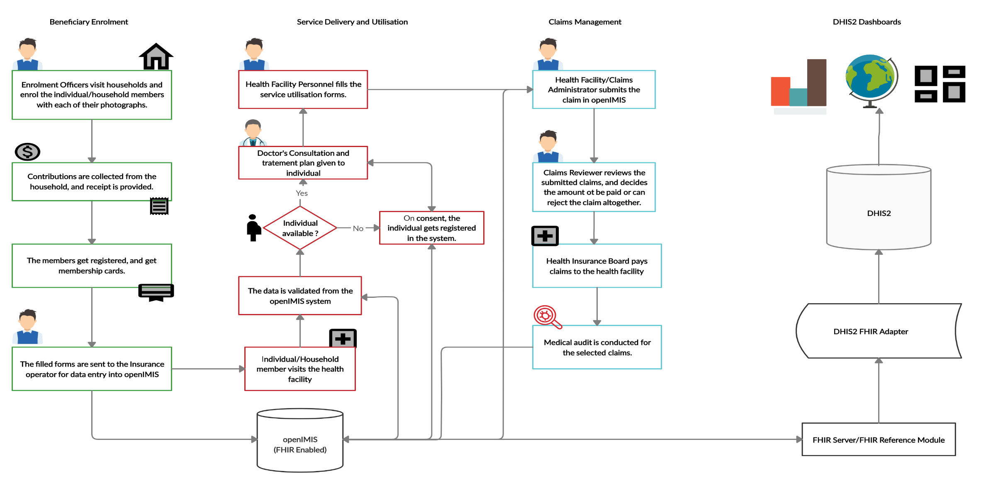
Figure 2 Proposed Workflow

Data Analysis and Outputs

The following indicators have been compiled in relation to the actors and processes described above and have been mapped to the corresponding data reporting format from where the data would originate for further processing. FHIR resources, FHIR mapping, and Open IMIS concepts are also mentioned.
The indicators have been categorised into the below-mentioned categories based on openIMIS monitoring and evaluation requirements.
- Beneficiary Indicators
- Claim indicators
- Operational indicators

Beneficiary Management Indicators

S.No. | Indicator | Numerator | OpenIMIS Concept | FHIR Resource | FHIR Mapping | Denominator | OpenIMIS Concept | FHIR Resource | FHIR Mapping | Disaggregation | Target User Group
1 | Individuals enrolled | Individuals enrolled | InsureeID | Patient | identifier | 1 | NA | NA | NA | Gender, Age groups, Geography/Level, Residence, Ethnic group, Education, Facility Type, Income Category | Facility
2 | Individuals enrolled (%) | Individuals enrolled (by all available disaggregation) | InsureeID | Patient | identifier | Individuals enrolled | InsureeID | Patient | identifier |  | Facility
3 | Households enrolled | Households enrolled | InsureeID | Patient | identifier | 1 | NA | NA | NA | Geography/Level, Residence | Facility
4 | Households enrolled (%) | Households enrolled | InsureeID | Patient | identifier | Households enrolled | InsureeID | Patient | identifier | Geography/Level, Residence | Facility
5 | Individuals enrolled and covered with an active policy | Individuals with an active policy | PolicyStatus | Coverage | status | 1 | NA | NA | NA | Gender, Age groups, Geography/Level, Residence, Ethnic group, Education, Facility Type, Income Category | Facility
6 | Individuals enrolled and not covered (policy suspended, idle or expired) | Individuals with inactive policy | PolicyStatus | Coverage | status | 1 | NA | NA | NA | Gender, Age groups, Geography/Leve, Residence, Ethnic group, Education, Facility Type, Income Category | Facility
7 | HHs enrolled and covered with an active policy | Households with an active policy | PolicyStatus | Coverage | status | 1 | NA | NA | NA | Geography/Level, Residence | Facility
8 | HHs enrolled and not covered (policy suspended, idle or expired) | Households with inactive policy (suspended, idle, or expired) | PolicyStatus | Coverage | status | 1 | NA | NA | NA | Geography/Level, Residence | Facility
9 | Enrollment rate (individuals) | Individuals enrolled | InsureeID | Patient | identifier | Total Population | NA | NA | NA | Gender, Age groups, Geography/Level, Residence, Ethnic group, Education, Facility Type, Income Category | Facility/Policy Decision Making
10 | Enrollment rate (HHs) | Households enrolled | InsureeID | Patient | identifier | Total Households (number) | NA | NA | NA | Geography/Level, Residence | Facility/Policy Decision Making
11 | Individuals enrolled with a new policy | Individuals with a new policy | PolicyStage and Prod ID | Coverage |  | 1 | NA | NA | NA | Gender, Age groups, Geography/Level, Residence, Ethnic group, Education, Facility Type, Income Category, Product type | Facility/Policy Decision Making
12 | Individuals enrolled with a renewed policy | Individuals with a renewed policy | PolicyStage and Prod ID | Coverage |  | 1 | NA | NA | NA | Gender, Age groups, Geography/Level, Residence, Ethnic group, Education, Facility Type, Income Category, Product type | Facility/Policy Decision Making
13 | Households enrolled with a new policy | Households with a new policy | PolicyStage | Coverage |  | 1 | NA | NA | NA | Geography/Level, Residence | Facility
14 | Households enrolled with a renewed policy | Households with a renewed policy | PolicyStage | Coverage |  | 1 | NA | NA | NA | Geography/Level, Residence | Facility
15 | Renewable rate (individuals) of active policies | Individuals with a renewed policy | PolicyStage | Coverage |  | Individuals with active policy minus newly enrolled | NA | NA | NA | Gender, Age groups, Geography/Level, Residence, Ethnic group, Education, Facility Type, Income Category | Facility/Policy Decision Making
15a | Renewable and remigration rate (individuals) | Individuals with a renewed policy | InsureeID | Patient | identifier | Individuals enrolled | NA | NA | NA | Gender, Age groups, Geography/Level, Residence, Ethnic group, Education, Facility Type, Income Category | Facility/Policy Decision Making
16 | Renewable rate (households) of active policies | Households with a renewed policy | PolicyStage | Coverage |  | Households with active policy minus newly enrolled | NA | NA | NA | Geography/Level, Residence | Facility/Policy Decision Making
16a | Renewable and remigration rate (households) | Households with a renewed policy | InsureeID | Patient | identifier | Households enrolled | NA | NA | NA | Geography/Level, Residence | Facility/Policy Decision Making
17 | Poor HH registered | Poor households enrolled | InsureeID | Patient | identifier | 1 | NA | NA | NA | NA | Facility/Policy Decision Making
18 | Poor vs. non-poor HH coverage in the scheme | Poor households enrolled | InsureeID | Patient | identifier | Non-Poor Households enrolled | NA | NA | NA | NA
19 | Poverty outreach ratio | Poor households enrolled | InsureeID | Patient | identifier | Total poor households | NA | NA | NA | NA | Facility/Policy Decision Making
20 | First service point distribution | First service point disaggregated by facility type | HFlevel | Location | type | 1 | NA | NA | NA | Facility Type | Policy Decision Making
21 | First service point distribution (%) | First service point disaggregated by facility type | HFlevel | Location | type | Total of all first service point distribution availed by individuals/households | HFlevel | Location | type | Facility Type | Policy Decision Making

Claim Management Indicators

S No | Indicator | Numerator | openIMIS Concept | FHIR Mapping | Denominator | openIMIS Concept | FHIR Mapping | Disaggregation
1 | Value of all claims entered in openIMIS | Value of all claims | ClaimStatus | claimResponse.processNotexx
2 | Individuals/HHs with claims |  | ClaimCode | claim.Identifier
3 | Average value claimed per member/HH with claims | Value of all claims | RemuneratedAmount | claimResponse.item.adjudication.amount | Number of members with claims
4 | Incurred claims per capita | Value of all claims | RemuneratedAmount | claimResponse.item.adjudication.amount | Total number of enrolled persons
5 | Average claim value | Value of all claims | RemuneratedAmount | claimResponse.item.adjudication.amount
6 | HHs hitting ceiling | HHs whose claims add up to 50000 NPR | ExceedCeilingAmount | claimResponse.item.adjudication.amount
7 | HHs hitting ceiling through families (%) | HHs hitting ceiling up to 50000 NPR during the time period | ExceedCeilingAmount | claimResponse.item.adjudication.amount | Families with claims during the time period
8 | Rejected claims | Number of rejected claims | ClaimStatus | claimResponse.processNote |  |  |  | Facility type
9 | Submitted claims | Number of submitted claims |  |  |  |  |  | Facility type
10 | Pending claims | Number of pending claims | ClaimStatus | claimResponse.processNotexx |  |  |  | Facility type
11 | Pending claims (%) | Number of pending claims | ClaimStatus | claimResponse.processNotexx | Number of submitted claims |  |  | Facility type
12 | Reimbursed claims | Number of reimbursed claims | RemuneratedAmount | claimResponse.item.adjudication.amount |  |  |  | Facility type
13 | Reimbursed claims (%) | Number of reimbursed claims | ClaimStatus | claimResponse.processNotexx | Number of submitted claims |  |  | Facility type
14 | Rejection rate of claims (automated/by claims review) | Total Number of rejected claims during the time period | ClaimStatus | claimResponse.processNote | Total number of claims during the time period |  |  | Facility type, Type of Claim, emergency, OPD, IPD, Referral
15 | Total Revenue in Health Insurance Fund | Premium plus subsidy from public fund/MoF plus other private sources (e.g. donations) |  |  | NA |  |  | Enrollment data, MOF/HIB,
16 | HHs revenue contribution (%) | Total premium collected from HHs |  |  | Total revenue in Health Insurance fund
17 | Government subsidy contribution (%) | Total premium received from MoF |  |  | Total revenue in Health Insurance fund
18 | Total claims by types | Total claims by the type (OPD, Emergency, IPD, Referral) | VisitType | claim.type
19 | Claim type (%) | Number of claims by each type (OPD, Emergency, IPD, Referral) | VisitType | claim.type | Total number/value of all types of claims
20 | Top 10 Diagnoses | Number of claims per diagnosis | ICDID | claim.diagnosis
21 | Trend of Diagnoses-Groups, i.e. NCD | Number of Claims for Treatment of Diagnosis Group | ICDID | claim.diagnosis | several possible: Number of Claims for Diagn. A group in year before, an average of several years before
22 | List of number/value of the type of service per period per level |  | ServiceID | claim.item.service
23 | List of Numbers/Value of most prescribed drugs per period | Numbers/Value of most prescribed drugs per period of time
24 | List of Numbers/Value of most prescribed drugs per period as % of total Number/Value of claims | List of Numbers/Value of most prescribed drugs per period of time |  |  | Total Number/Value of all claims
25 | List of Numbers/Value of most prescribed drugs per period as % of total Number/Value of claims which prescribed drugs | List of Numbers/Value of most prescribed drugs per period | HFLevel/LegalForm | type | Total Number/Value of all claims which prescribed drugs
26 | Number/Value of Claims reviewed/valuated |  | HFLevel/LegalForm/Valuated | type |  |  | Facility Type, Gender | Claim reviewer
27 | Number/Value of Claims reviewed/valuated (%) | Total Number/Value of claims reviewed/valuated | HFLevel/LegalForm/Valuated | type | Total Number/Value of all claims submitted |  | Facility Type, Gender, Age Group | Claim reviewer
28 | Valuated Value of claims as a share of total value of submitted claims | Aggregated Value of claims after being revised (include rejected claims?) |  |  | aggregated Value of all submitted claims |  |  | Facility types
29 | Incurred administration expense ratio | Total value of incurred administration expenses |  |  | Total value of collected contributions and subsidies
30 | Incurred claims ratio | Total value of incurred claims |  |  | Total value of earned contributions and subsidies
31 | OOP ratio | Total sum of OOP spending |  |  | Total sum of health expenditure = OOP + claims
32 | Benefit coverage rate | Number of accepted claims | Approved | claimResponse.totalBenefit | Total number of reported medical cases
33 | Complaint ratio | Total number of complaints |  |  | Total number of covered individuals
34 | Promptness of claim approval | Period of time between submission and approval of a claim | DateClaimed - DateProcessed | claim.created - claimResponse.created
35 | Health infrastructure | Number of health facilities/health personnel |  |  | Population
36 | Average cost per (inpatient) visit | Total Value of all (inpatient) claims |  |  | Total number of inpatients
37 | Number of cases for specific diseases |  | ICDID | claim.diagnosis
38 (a) | Payment allocation by diseases and its severity/Inpatient admissions/Primary health care sensitive diagnosis/tracer conditions | Total payments in the defined time period | RemuneratedAmount | claimResponse.item.adjudication.amount | Total enrolled population in the defined time period
39 (b) | Ratio of highly complex to fewer complex patients. | Total number of highly complex patients seen in the defined area during the defined time period |  |  | Total number of low complexity patients seen in the defined area during the defined time period
40 | Net income(profit) ratio | Total Value of collected (premiums + subsidies) - paid claims |  |  | Total amount of collected premiums + subsidies

4.3 Operational Indicators

S.No | Indicator | Numerator | openIMIS Concept | FHIR Mapping | Denominator | openIMIS Concept | FHIR Mapping | Disaggregation | Target User Group
1 | Households enrolled by Enrollment Assistants (EA) | Households enrolled (by Enrollment Assistants) |  |  | 1 |  |  | Geography/Level, Residence | Facility
2 | Average Time used to enter form by EA/EO
3 | Covered people without a photo (Tanzania)
4 | Covered ppl with the photo but missing personal data
5 | Promptness of claim approval | Period of time between submission and approval of a claim | DateClaimed - DateProcessed | claim.created - claimResponse.created |  | 1 | NA | NA | Geography/Level, Residence, Facility type
6 | Health infrastructure | Health facilities/Health personnel | HfID | Identifier |  | Population |  |  | Geography/Level, Residence

