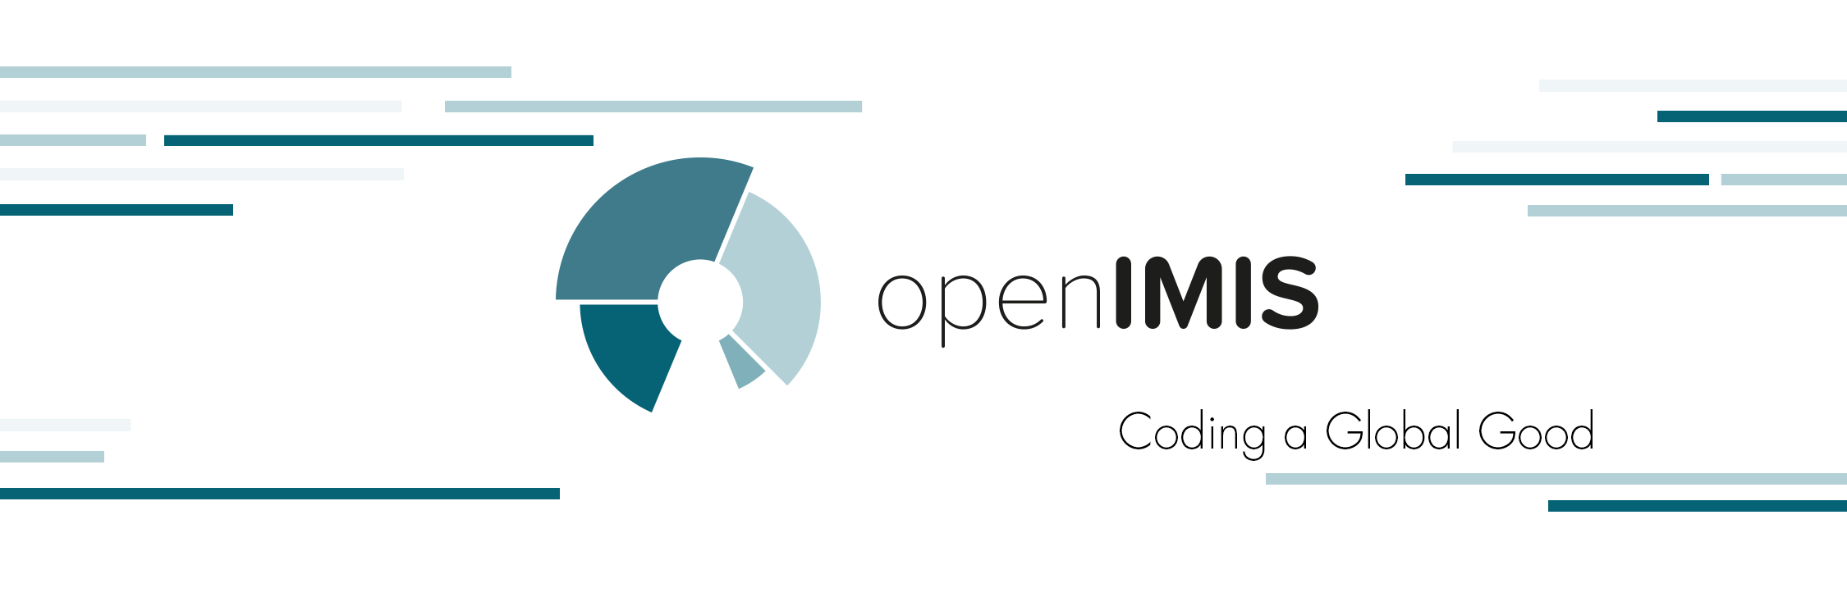

COMMUNICATIONS STRATEGY
of the openIMIS Initiative
(Working Paper 2.3)

Last revision: 21 December 2018

Table of Contents
EXECUTIVE SUMMARY 4
1 OVERVIEW 6
2 VALUE PROPOSITION NARRATIVE 7
The origins of the openIMIS product 7
The openIMIS Initiative 8
3 VISION, MISSION AND PROBLEM STATEMENT 9
Vision Statement of the openIMIS Initiative 9
Mission Statement of the openIMIS Initiative 9
External Communications Objectives 9
Internal Communications Objectives 9
Problem Statement for communications of the openIMIS Initiative 10
4 KEY MESSAGES and FAQ // “10 Reasons to use openIMIS” 11
Storytelling Opportunities 13
5 DELIVERING THE MESSAGE 14
Target Audiences & Key Messages 14
Formats / Marketing-Materials (Must Have’s) 16
Communication Channels 17
Owned Channels 17
Partner Channels 18
Other relevant Channels 19
Monitoring, KPIs & Feedback Loops 20
Proposed measures 20
6 THE COMMUNICATIONS TEAM & COLLABORATIONS 22
Communications with partners 22
7 OTHER COMMUNICATIONS OPPORTUNITIES 23
Awareness Days 23
8 REVISION & MAINTENANCE 24
9 PROJECT IMPLEMENTERS 25
ADDENDUM 1: Target Group Analysis 26
1. Target group: COUNTRIES 26
Key messages COUNTRIES 26
The openIMIS product 26
Providing for Health Network, P4H (36 countries in various constellations) 27
Multipliers 27
2. Target Group: DONORS 28
Multilateral Donor Organizations 28
Bilateral Donor Organizations 31
Platforms / Events / Conferences 34
Key Messages DONORS 34
3. Target Group: DEVELOPERS 35
Community of Developers 35
Communication Channels (Target Audience: Developers) 35
Key Messages DEVELOPERS 36
Target Group: DEZA & BMZ 36
ADDENDUM 2: Instruments for inspiration (Nice to Have’s) 37
Channels 37
Tools 39
Monitoring 40
ADDENDUM 3: AKRONYMS AND DEFINITIONS 42

EXECUTIVE SUMMARY

Why openIMIS?
More and more countries in the world seek to achieve Universal Health Coverage (UHC) and Universal Social Protection (USP) for their population. Interactions between stakeholders in health and social protection systems are very complex and generate a lot of data. That is why Information and Communication Technologies (ICT) can provide support and help to navigate a system for policy makers and users. Unfortunately, existing ICT solutions can be expensive and difficult to maintain. Furthermore, many countries do not have sufficient technical and financial capacity to cope with complex ICT structures. Many health system related ICT projects have been focusing on data extraction, monitoring and evaluation in the recent years. What has been lacking is a tool addressing health financing interactions among the key stakeholders in a health care system.

As an open source product, openIMIS is a comprehensive and affordable tool, linking beneficiary, provider and payer data. openIMIS offers a simple and user friendly way to manage core processes from beneficiaries and patient registration to transmitting and verifying claims.

The openIMIS Initiative promotes global exchange around the openIMIS software and links global and local communities to the benefit of one another. The Initiative was founded and is collaboratively financed by the Swiss Agency for Development and Cooperation (SDC) and German Development Cooperation (GDC).

The purpose of this communications strategy
The openIMIS Initiative sets out to use continuous communication throughout the openIMIS project cycle, to lay the ground for its successful implementation and coordination. The communications strategy provides an overview of the vision, mission and problem statement, key messages, value proposition narrative, target audiences, communication channels, communications team and monitoring, KPI’s and feedback loops. The strategy answers questions such as:
- What are the benefits of openIMIS and what does the Initiative stand for (chapter 2)?
- What image of openIMIS is it supposed to create for the respective target audiences (chapter 3)?
- How can we package information about openIMIS to reach the relevant audiences (chapter 4)?
- What is the target audience and which communication channels can be used to reach this target group (chapter 5 and chapter 6)?

This communications strategy defines the communication objectives, key messages, a story line, the relevant target audiences and appropriate communication channels (internal and external) for continuous communication throughout the openIMIS project cycle.
External channels could be a range of international initiatives that seek to support efforts towards Universal Health Coverage (UHC) and Universal Social Protection (USP), including UHC2030, HDC, P4H, SPIAC-B and JLN. These initiatives could contribute to making openIMIS known, target potential partner countries and generate interest for the openIMIS community.
openIMIS Messaging (chapter 4)
The mission and vision statements shall be supported by strategic communications work.
The communications strategy provides 10 key messages on openIMIS. They are identified by the analysis of the relevant target groups.

Furthermore, the openIMIS country implementations cases provide various opportunities for storytelling. Through storytelling, the target audiences are captured emotionally by sharing real life authentic stories related to them. To achieve emotional capture, the storytelling must demonstrate original cases and experiences in order to answer the questions why, how and what, showing the purpose of openIMIS. Storytelling should communicate the systematic message to all target groups via different channels.

Based on the problem statement and the analysis of the target groups key messages like “coding a Global Good” with openIMIS, the guidance by international frameworks and policies, the integration of ICT tools into the countries’ social protection systems and the promptitude of implementation, should be stated.

Target Audiences (chapter 5 & Addendum 1)
The openIMIS target audiences can be classified in five major groups: stakeholders in countries with demand for a digital health financing management tool and potentially further social protection solutions, donors, international development organisations, developers and developer communities, implementing partners. The main target audience are countries and their respective institutions looking for IT solutions for their health and social protection financing schemes as potential users of the software. The second priority target group are donors who are willing to support the core development of the software and/or country level implementations and/or the initiative.

Available Channels (chapter 5)
The previously mentioned target groups can be reached through several communication channels. These communication channels are owned by openIMIS, whereas there are several communication channels owned by partner institutions. Through the collaboration of partner institutions, their communication channels interlink the content in order to expand the reach of openIMIS to all major target groups.

Monitoring / KPIs (chapter 5)
To find out if communication work was successful and has improved the openIMIS Initiative, the outcomes have to be monitored frequently and compared to previous data and the adaption of the communication work to capacities is necessary. Different KPI’s can measure the outcomes of the communication work. These indicators are, among others, numbers of attendees at an event/presentation, numbers of contacts following presentations/speeches, numbers of visitors to the website, numbers of donors/influencer/countries implementing openIMIS, numbers of likes/followers on social media. To be able to cover a regular flow of the communications work of openIMIS, the Initiative established a communications team that is situated at the GIZ headquarter in Bonn. The team plans and oversees the communication activities of the openIMIS Initiative aiming at the implementation of the communication work and communication strategies.

1 OVERVIEW

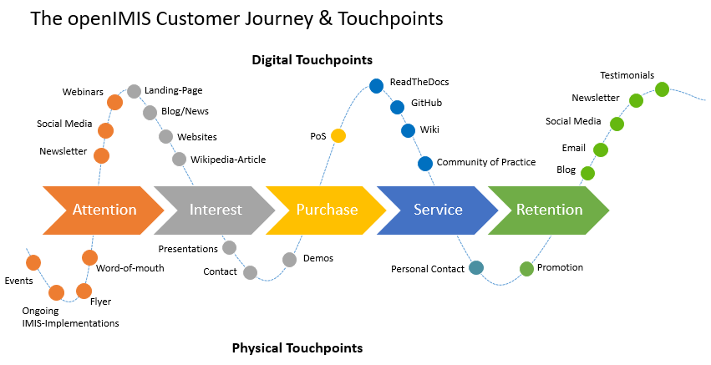
The openIMIS Initiative sets out to use continuous communication throughout the openIMIS project cycle, to lay the ground for its successful implementation and coordination. This strategy defines a relevant communication objectives, key message and story line. It shall also identify relevant target audiences and appropriate communication channels (internally and externally). Internal channels are among the initiative structure and its stakeholders, externals channels are among developer communities, existing as well as prospective users of the software, donors and anyone of the public interested in its progress. External channels could be a range of international initiatives that seek to support efforts towards Universal Health Coverage (UHC) and Universal Social Protection (USP), including UHC2030, HDC, P4H, SPIAC-B and JLN. These initiatives could contribute to making openIMIS known, target potential partner countries and generate interest for the openIMIS community.

This communications strategy of the openIMIS Initiative answers questions such as: What does openIMIS stand for? Where are our digital and physical touchpoints? How does the customer journey work?

2 VALUE PROPOSITION NARRATIVE

More and more countries worldwide are aiming to achieve UHC as well as USP for their populations.

Given the many stakeholders involved in health care (beneficiaries, payers, providers,) and their interactions, health care systems are extremely complex. The variety of processes, e.g. medical treatments, result in a large amount of data. This complexity and density of information makes it challenging to design, manage and adjust system processes. Information and communications technology (ICT) has been extremely helpful in supporting these tasks. However, in the health sector, many ICT solutions have been developed in isolation, piloted and not scaled up.

Software solutions are often piloted within narrow geographical boundaries or address selected processes. As a result, many countries face challenges when trying to integrate and scale up these solutions to the wider contexts required for UHC. The lack of compatible formats and interfaces among ICT tools, or interoperability, inhibits the coherent and comprehensive flow of data and information, creating highly fragmented national eHealth systems.
ICT solutions are often expensive and difficult to manage. Many countries lack the financial and technical capacity to maintain existing systems.

Additionally, in recent years, the focus of ICT projects in health systems has been on data extraction, monitoring and evaluation, and not on improving the operational core of scheme management. What has been lacking is a tool addressing health financing interactions among the key stakeholders in a health care system. As an open source product, openIMIS is a comprehensive and affordable tool, linking beneficiary, provider and payer data. openIMIS offers a simple and user friendly way to manage core processes from beneficiaries and patient registration to transmitting and verifying claims.

Importantly, openIMIS is a powerful tool to support the movement from passive towards strategic purchasing of health care services and link the reimbursement of providers to their outputs. Strengthening strategic purchasing as a key health financing function is currently an important priority in many countries lacking the ICT tools to make that shift possible.

The origins of the openIMIS product
With support from the Swiss Agency for Development Cooperation (SDC) in 2012, the Swiss Tropical and Public Health Institute (Swiss TPH), Microinsurance Academy and Exact Software developed an Insurance Management Information System (IMIS) to operate community health funds (CHF) in several districts of Tanzania.
In 2014, a mutual health insurance scheme in Cameroon adapted the software. Since 2015, the German Development Cooperation (GDC) has been providing assistance to customize IMIS for Nepal’s national health insurance scheme.
IMIS has grown organically and has demonstrated potential for easy adaptation to different types of health financing mechanisms needed for UHC. In 2016, GDC and SDC invested jointly to make IMIS an open source application. The openIMIS source code has been publicly available since 2018.

Now it is a Global Good which is business process and data driven. It has been is designed with the user, for potential scale and local need. It grew organically and has been successfully running on a significant scale providing proof of work. The software will be continuously improved and applied in new settings, benefitting from the collaborative nature of the Initiative.

The openIMIS Initiative

- honours the principles for digital development, which are “living” guidelines that can help development practitioners integrate established best practices into technology related programs;
- seeks to provide a comprehensive IT system linking all participating parties of a social (health) protection system (i.e. beneficiaries, providers and payers);
- hosts and facilitates a CoP for software development and end users, and provides capacity development services;
- engages diverse expertise across disciplines, continuously documents the work on openIMIS and shares best practices and experiences widely and regularly;
- is a global community, which is open to all stakeholders interested in exchanging and collaborating in the area of social (health) protection;
- is part of global networks developing standards in digital health.

3 VISION, MISSION AND PROBLEM STATEMENT

Vision Statement of the openIMIS Initiative
The overall vision of the openIMIS Initiative (discussed and approved in the aftermath of the steering group meeting on March 1st 2018) reads: “The implementation of a continuously improved open source Management Information System for social (health) protection schemes (openIMIS), will lead to effectively managed insurance schemes and other financing mechanisms, and ultimately to UHC and USP.” Communications shall strategically be used to reach this goal.

Mission Statement of the openIMIS Initiative
The overall openIMIS Initiative’s mission statement reads:
“Continuously and collaboratively develop shared, open-source software to improve data and information management of (health) insurance and other financing mechanism for universal health coverage and universal social protection in low and middle-income countries, making openIMIS product a freely available Global Good”

External Communications Objectives
- Make openIMIS and its main features and (potential) comparative advantage known to potential users
- Intended result: Countries decide to use openIMIS and increase their demand for implementation support
- establish Community of Practice (CoP) of users
- Attract more funding by third party donors
- Intended result: Co-financing of global openIMIS Initiative or allocation of country level openIMIS implementation funding
- Attract IT developers and create a Developer Community
- Intended result: Lively CoP is established and advances the software by tackling upcoming questions and challenges
- Attract Implementing partners and create a marketplace for openIMIS
- Intended result: Broad network of implementing partners on global, regional and local level to support countries in their implementation efforts
- Position Germany and Switzerland as innovators in the digital health and social protection landscape as well as UHC/USP discussions

Internal Communications Objectives
- Sharing implementation experiences and knowledge
- Increasing collaboration
- Identifying information and communications needs
- Optimizing tools, timing and targeting
- Streamlining of communications processes
- Prioritize and filter messages to reduce information overload
- Increase compliance and comprehension

Problem Statement for communications of the openIMIS Initiative

SWOT Analysis
Strengths:  - Existing and promising use cases, aligned with current policy priorities available.  - Interest of various stakeholders  - Experience of the partners in the field and with preceding software IMIS (Swiss TPH, GIZ Nepal)  - Already existing structure of centralized project coordination team complimented by communications team at GIZ | Weaknesses:  - Complex topic which is difficult to communicate  - Value proposition is an assumption, not proven  - Lack of emotional images showing program “in action” to engage more storytelling  - Customer Journey and stakeholder personas need (further) development  - Communications processes and roles of partners will need to be established “on the go”  - Lack of human resources for the increasing amount of requests
Opportunities:  - Great opportunities to “ride the wave” of global policies, digitalization, frameworks for UHC, USP (USP2030 campaign), Donor principles, etc.  - openIMIS is a new product, the first of its kind, which can fill a gap/niche and become the golden standard for health financing information systems and beyond  - Strong trend towards the development of global goods for digital health | Threats:  - Risk averse sector, takes long time for implementation decision making and reacts strongly to failures  - New EU-Data protection legislation needs to be regarded by communications efforts, but also puts the topic high on the agenda of many stakeholders.  - openIMIS is working with highly sensitive data, questions regarding the protection of this data might be fierce

4 KEY MESSAGES and FAQ // “10 Reasons to use openIMIS”

For short, elevator-pitch-style occasions, the following key points can serve as a guideline:
openIMIS is …
- the first open source software for health financing operations. It supports the management of social (health) protection schemes. It links beneficiary, provider and payer data.
- a powerful tool to strengthen strategic purchasing of health services and digital processing of health system data.
- A global good - free to download, customize and use.
- adaptable, with a modular design for different country needs.
- interoperable and compatible with various formats and interfaces for data exchange.
- sustainable, driven by the openIMIS community and supported by the global openIMIS Initiative.
- The openIMIS Initiative promotes global exchange and links global and local communities to the benefit of one another.

Based on the problem statement and the analysis of the target groups the following key messages were identified thus far:

- openIMIS is a Global Good.
Global Goods are classified as digital health tools, which are easy to implement and scale, and adaptable to different countries and contexts. The software is a free and open-source tool funded by a variety of donors. openIMIS is complying with the Principles for Digital Development and the Donor Principles. It is positioned on and coordinated with global platforms such as Digital Square. Through the openIMIS initiative the digital tool has a clear governance structure and is designed to be interoperable.

- openIMIS is built as a free and open source software which is user friendly, easy to customize and operate.
The software can be adapted to various data and process requirements. Due to its modular and flexible structure it can grow with the evolving complexity of a given scheme. Online support platforms assist implementers in the process of adoption and peer-to-peer exchanges allow for co-creation and solution sharing.

- Data collected and stored in openIMIS is safe!
Social health protection systems operate with large data sets including most sensitive individual information. Therefor data safety is one of the corner stones of an information management system in the sector. The Initiative puts an explicit focus on the definition and implementation of security rules such that all personal data is stored safely!

- openIMIS is being continuously improved and applied in new settings, benefiting from the collaborative nature of the Initiative.
The interoperable and modular structure of openIMIS shall allow for an adaptation to the needs of a variety of low- and middle-income countries. The core product of the Initiative is developed incrementally. It is designed with the user and for the user, aiming at sustainable growth. Upgrades and more sophisticated functions developed by members of the developer community are accessible for free

- openIMIS is ready for implementation.
openIMIS is ready to be implemented at any time. Even if the software is experiencing ongoing changes – it is ready for implementation! The Initiative provides a demo version that familiarizes the user with the system and visualizes how it automates most key processes ranging from beneficiary/claims management to reporting.

- The work of the openIMIS Initiative is guided by international frameworks and policies (such as the SDGs, UHC2030 and USP2030).
The work of the openIMIS Initiative contributes to United Nations Sustainable Development Goal #3, Target 3.8: to achieve UHC by 2030. Adapting and extending the application to social protection systems in the future, openIMIS would be an important contribution to SDG Goal #1, Target 1.3 as well as the overall goal of “leaving no one behind”.

- The openIMIS Initiative has a transparent, collaborative non-hierarchical approach that is geared towards self-sustainability of the product and community around it.
The Initiative engages diverse expertise across disciplines as well as enhances the information exchange between actors of the national health and social protection systems. The Initiative will continuously document its work and share best practices and experiences widely and regularly in order to create a truly global good and a supportive global community of users, implementers and funders.

- The openIMIS Initiative envisages step-wise integration of ICT tools into the countries’ health and social protection systems, reducing the barriers to implementing a digitized system.
Started out as an IT framework for social health insurances, openIMIS provides an important tool for the management of health financing operations in low- and middle-income countries.The vision is to expand the potential usage of the application by the modular transformation to other social protection schemes.

- The openIMIS Initiative provides many valuable links to development partners, networks and regional hubs.
openIMIS Governance Structure reflects on the local, regional and global outreach of the Initiative. Each level allows for donors and international organizations` support through several channels (e.g. financial, conceptual, promotional). The Initiative offers and coordinates capacity strengthening activities and partnerships with training institutions.

- By providing technical expertise developers have the chance to revolutionize the social (health) protection system.
Maintenance, planning and coordination of the software development is driven by a core development team. Local adjustments/adaptations need to be applied by local project partners/programmers. By contributing to openIMIS, developers gain the chance to become a member of a global Initiative and share knowledge and experiences. Local programmers can contribute to a revolution of their country’s social health protection system. This is an opportunity for programmers to start a career as developers and openIMIS-specialists, to earn an income and build up a business.

Storytelling Opportunities

Storytelling is one of the most powerful ways to breathe life into a brand or product. The objective is to give the product an identity by capturing and sharing the real life stories related to them. With this, the target audience is taken on an experience journey making it less abstract. The stories must be authentic, creative and inspirational.

The work of the openIMIS Initiative and the added value of its product provide various opportunities for storytelling. Storytelling measures should demonstrate original cases and experiences helping to answer the questions why (purpose of openIMIS and the Initiative`s work), how (open source, setup, community of practice, networks, etc.) and what (explanation of the product).

Main storylines should address the following topics.
- Make people understand the implementation procedure: How to implement and strengthen a health system supported by IT-products? Nepal could serve as an example: The country is undergoing a major reform of the social health protection system. How did the stakeholder learn about openIMIS?
- How was the decision taken to implement openIMIS?
- How did the implementation start and where is it now?
- What were challenges/successes underway? How can the experience be rated so far (recommendations, caveats, satisfaction level, etc.?)
- Illustrate advantages: Improved exchange of information leading to more efficient data exchange processes, faster processing times, less errors and more efficient communication among stakeholders/users in the system.
- Knowledge exchange: How does the global exchange among developers and users help to advance the product?
- Form a development partners` perspective: Why have these partners joined forces to push the openIMIS Initiative? What are the priorities and objectives?
- To demonstrate the applicability of the product for different health financing contexts (not just for health insurance systems!) and eventually broader social protection system. Front liners to demonstrate these intentions are needed,
- Especially position openIMIS as a powerful tool to support strategic purchasing of health care services. Strengthening strategic purchasing as a key health financing function is currently in high demand by countries as well as developing agencies and donors. Implementation cases are important to generate in the nearest future. Possible example in the pipeline: Malawi.

Storytelling should help convey the messages to all target groups and can be applied via different channels.

5 DELIVERING THE MESSAGE

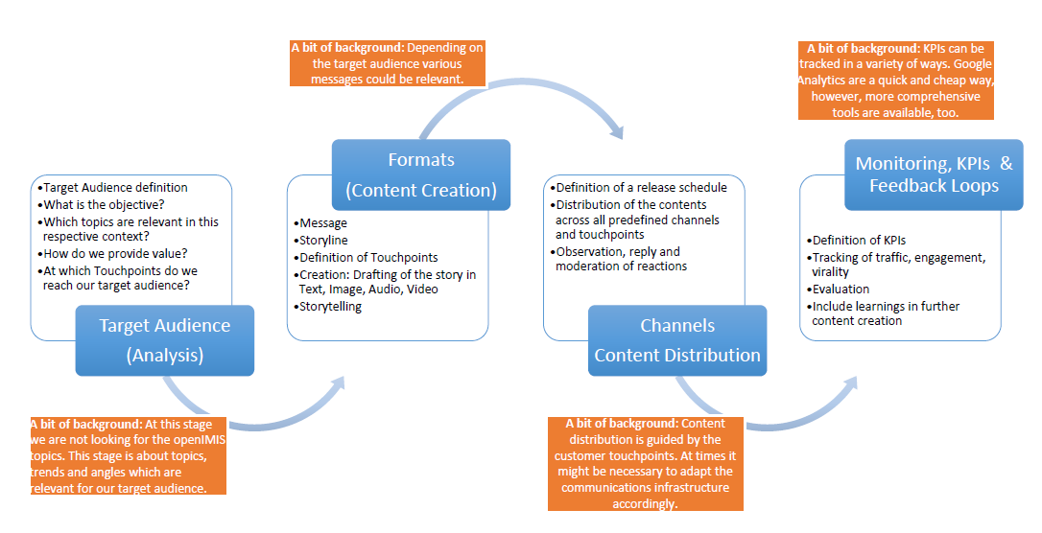
In this section we want to take a closer look at the openIMIS Target Audiences, the Formats, the various channels as well as relevant Monitoring tools and KPIs (Chapter 5.4). The sections can be read as a process – to get the right message, at the right time to the right people.

Target Audiences & Key Messages
The target audiences comprise the following major groups:
- Countries with demand for social protection ICT solutions
- Donors (on global, regional or country level)
- Developers / Developer community
- Implementing partners
- International organisations (including networks, platforms, initiatives)

The main target audience in the current phase are countries (and their institutions) looking for IT solutions for their social health protection systems. Donors willing to support the core development of openIMIS and the initiative are another priority target group. The developer community (IT Companies, Non-profit organizations, Developer Hubs) is another important audience to address.

It is important to note that communications will have to be adapted depending on whether or not the openIMIS Initiative is already in implementation mode within a specific country. Then a country specific approach is needed to attract local specialists to engage with openIMIS. Please see Addendum 1 for detailed analysis of the various relevant target audiences.
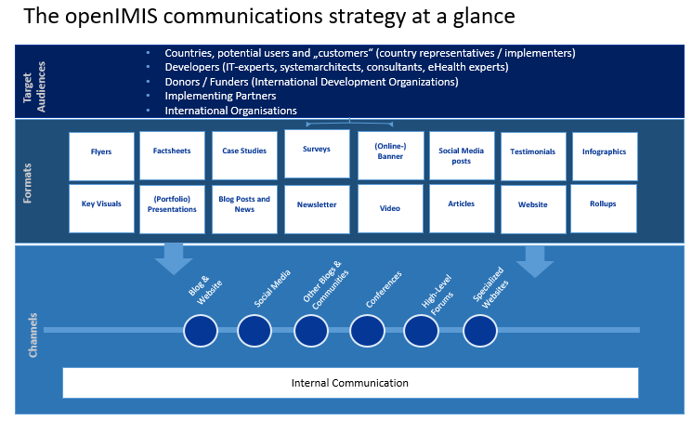

Formats / Marketing-Materials (Must Have’s)

- Flyers: Key information about openIMIS provided in brief (various formats possible, currently business card format and a brochure are available in English – possibility to have bilingual version French/English).
- Portfolio presentation: This presentation introduces the audience to the work of openIMIS. Featuring key facts & figures on implementation, technology, results the initiative achieves, etc. It provides a first impression of the initiatives strategy, structure and operations – both for a target audience acquainted with the work of the openIMIS Initiative and for anyone without any prior knowledge.
- Factsheet: The factsheet complements the openIMIS presentation (preferably a portfolio of various types and levels of basic information, that can easily be shared) with a comprehensive listing of key facts & figures. This document is intended more as an introduction to the openIMIS product and the initiative`s work.
- Key visuals: It is recommended to establish a set of key visuals for the initiative. This should ideally include videos, photos and graphics, which illustrate our work. These can be shared across all channels.
- Infographics: As with results, infographics are today widely used in the development and aid context to outline complex issues in an easily understandable manner. The infographics can be used as standalone images or integrated in a wide variety of media channels and formats.
- Events Checklist: To ensure events run smoothly and in line with guidelines, e.g. proper processes for inviting VIPs and officials, the checklist should be available to programme staff involved in arranging events. Equally, the checklist ensures a level of consistency in the event design to the outside world.
- Roll-ups are portable and – when well designed – a good eye catcher for positioning centrally in any venue. Posters are a more permanent fixture and a more elegant option for attaching to wall space. Both need to adhere to corporate design guidelines. Most openIMIS implementation sites should have their own roll-ups and posters (currently 1xSDC, 2xGIZ).
- Banner: An eye-catching visual for various events, such as: signings, speeches, press conferences, it guarantees visual coverage in the press.
- Testimonials: For every picture of a person (beneficiary, official, expert), there is almost always a testimonial or a quote to go with it. Equally, testimonials let others speak for the achievements of openIMIS. They are invaluable for reinforcing our positioning. A database of quotes (best would be as text, video and photo/graphic) is useful for quick access for use with all sorts of communications instruments or channels.
- Wikipedia Article: Getting an article published on Wikipedia to reach more people. It is one of the most frequently used encyclopedias and ranks among the top results on Google. Placing an article about the openIMIS Initiative could reach a broad audience. It shall be noted, however, that it is pretty complicated to actually achieve the publication of a new article.

Communication Channels

The openIMIS Initiative is already working various playing fields of communication and has several communication channels established. These are all interlinked. Additional channels will be leveraged in liaison with partner institutions.
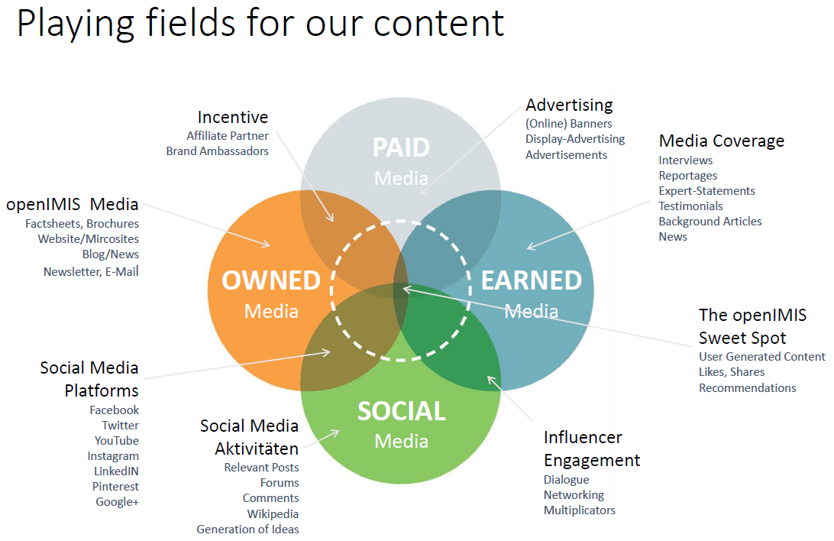

Owned Channels
Website www.openimis.org: The website is the central information platform for a broader public. It is the cornerstone of the communication efforts of the openIMIS Initiative. Information on news, events and background information are shared regularly to provide insights into current developments.

Twitter-Channel @openIMIS: The initiatives Social Media activities currently focus on sharing information on Twitter. This channel is predominantly used to promote activities at events, but shall also provide updates on new developments of the initiative.

InfoMail -> Newsletter: At present an InfoMailing has started in May 2018 on a bi-monthly basis. As the list of recipients increases (sign-up is possible on the website) this InfoMailing will be upgraded to a designed Newsletter. The intent here is to showcase updates, stories, interviews, pictures and features from the openIMIS community and give insights into the new developments at the openIMIS community. The newsletter is a good opportunity to interlink publication and communication efforts.

Wiki: The openIMIS wiki is the main source for community and product-related information. From documentation on community meetings, guides on installation and functionality to implementation experiences, openIMIS wiki serves to share ideas, build community and get work done all in one place. Users can freely access openIMIS wiki without an account and view its content.

https://openimis.atlassian.net/wiki/spaces/OP/overview

GitHub: The source code for openIMIS is available on GitHub. The source code can be viewed and downloaded as well as allows access to different versioning.

https://github.com/openimis

ReadtheDocs: ReadtheDocs contains technical openIMIS documentation. On ReadtheDocs, users can find developer documents on the system architecture, versioning and releasing, as well as user documentation for implementers.

http://openimis.readthedocs.io/en/latest/

Partner Channels
For most partner institutions, the website is the most important tool for presenting itself and its work to the outside world. Interlinking content with partner channels will expand the reach to all major target groups. Content therefore should be a combination of hard facts and figures with reportages and features and should have both rational and emotional appeal for a wide range of users.

Federal Ministry of Economic Cooperation and Development (BMZ)
Founded in 1961, the Ministry works to encourage economic development within Germany and in other countries through international cooperation and partnerships. It cooperates with international organizations involved in development including the International Monetary Fund, World Bank, and the United Nations.
- Website (www.bmz.de)
- Social Media (Twitter: @BMZ_Bund; Facebook: @BMZ.Bund)
- Healthy Developments (www.health.bmz.de) – sector specific website; important platform to be used more intensely
- Internal newsletter

Swiss Agency for Development and Cooperation (SDC)
The SDC is Switzerland’s international cooperation agency within the Federal Department of Foreign Affairs (FDFA). In operating with other federal offices concerned, SDC is responsible for the overall coordination of development activities and cooperation in Africa, Asia and central/south America, as well as for the humanitarian aid delivered by the Swiss Confederation.
- Website (www.sdc.admin.ch)
- Social Media: Twitter: @2030agendaCH; Facebook: @2030agendaSwitzerland
- SDC Health Network Shareweb (www.sdc-health.ch), quarterly SDC Health newsletter

Swiss TPH
In 2012 Swiss TPH has been commissioned by SDC with the HSSP in Tanzania. Part of this programme was the development of IMIS, which in 2014 has been adapted to a church based scheme in Cameroon and in 2015/16 to the national scheme in Nepal supported by Swiss TPH. Since 2016 Swiss TPH supports the Global Initiative in further develop IMIS as an open source solution being openIMIS. Ideally, IMIS will be presented on the same website. This has to be agreed upon with Swiss TPH (migration strategy, transition, etc.).
- Website (www.swisstph.ch)
- Social Media (Twitter: @SwissTPH; Facebook: @SwissTPH)

Deutsche Gesellschaft für Internationale Zusammenarbeit (GIZ) GmbH
- Website (www.giz.de)
- Social Media Channels (Twitter: @giz_gmbh; Facebook: @GIZprofile)
- External Stakeholder Magazine „Akzente!”

Asian eHealth Information Network: The AeHIN promotes better use of information communication technology (ICT) to achieve better health through peer-to-peer assistance and knowledge sharing and learning through a regional approach for greater country-level impacts across South and Southeast Asia.
- Website (http://www.aehin.org/)

Other relevant Channels

Socialprotection.org
- Website (www.socialprotection.org)
- Relevant Tools: Webinars, Blog, Communities, Publications, Calendar, News
- Social Media (Twitter & Facebook: @SPgateway)

Joint Learning Network: The JLN is a global community focused on developing practical approaches to achieve UHC. openIMIS Initiative is trying to establish a Collaborative on Health Financing Information Systems among the JLN member countries.
- Website (http://www.jointlearningnetwork.org/)

Health Data Collaborative: HDC is an inclusive partnership of international agencies, governments, philanthropies, donors and academics, with the common aim of improving health data. The openIMIS Initiative participates at the discussions of the Digital Health & Interoperability Working Group (DH&I WG) in order to put health financing in the scope of the digital health framework.
- Website (https://www.healthdatacollaborative.org/how-we-work/digital-health-interoperability-working-group/)

openHIE (Health Information Exchange): openHIE is a Global mission-driven Community of Practice dedicated to improve the health of the underserved through open and collaborative, development and support of country driven, large scale health information sharing architectures. The openIMIS Initiative participates at the “Health Financing towards UHC Subcommunity” in order to connect with other stakeholders and identify health care financing needs, working synergistically with the OpenHIE community to ensure that data exchange processes and requirements meet the needs of the health care financing communities.
- Website (https://ohie.org/)

Monitoring, KPIs & Feedback Loops

The only way to find out whether or not communications work has improved at the openIMIS Initiative is to monitor outcomes, compare them to previous data and adapt the communication concept to capacities (staff, partners and financial). Frequent monitoring thus ensures a continuous optimization of communication work through feedback loops. Indicators for success could be measurable results, such as number of attendants at presentations and events, number of contacts following presentations/speeches, number of visitors to the website, etc.

Strategic priorities of the openIMIS Initiative are defined by the Steering Group and reviewed on an annual basis. Please find these in the attached document on the “openIMIS Strategic Principles”.

As a first step towards a more comprehensive monitoring, baseline data should be acquired.

Proposed measures

- Revision of the Communications Strategy (annually, by March)
Communication Strategies are living documents and always are an assessment of the current situation, paired with an overall vision where the openIMIS Initiative wants to go. Therefore, it is advisable to regularly update the strategy (at least annually) as milestones are reached and objectives might change.
- Contact List
For events, as well as newsletters et cetera, a big number of contacts in different lists will be involved. If the contacts compiled at different occasions are fused into one list, a good overview of stakeholders can be achieved and the number, level, area of work and expertise, as well as location of the openIMIS initiative can be assessed and consolidated. Comparison over time may also indicate potential shortcomings, e.g. in the involvement of a specific stakeholder group.

- Annual Objectives and KPIs
In order to ensure continuous quality of communication, communication goals and monitoring should be included in the annual objectives each year, which will ensure commitment of all partners to an aligned communication work and increase projectability and strategic orientation of openIMIS initiative’s communication. Defining these objectives is the responsibility of the openIMIS steering group in collaboration with the communications team.

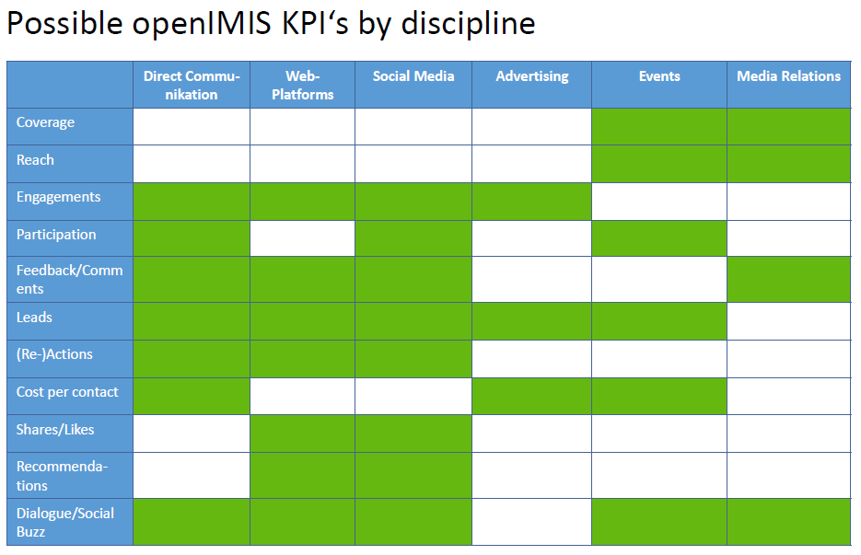

More examples of openIMIS-related KPIs (external communications):
  - X new countries ask for openIMIS consulting services
  - Y countries decide to use openIMIS
  - Co-financing of global initiative and/or allocation of additional country level implementation budgets are sourced.
  - CoP is established (Baseline: No CoP)

And more examples of openIMIS-related KPIs (internal communications):
- Established a core set of communications channels including a content plan, which illustrates which type of content will be shared through which channel when.
- Communications activities are streamlined through a core communications team, which is supported by focal points in the partner organisations.
- Corporate design manual is developed

- Responsibility & Accountability
Since the openIMIS Initiative is a partnership between multiple organisations, all tasks should be appointed to responsible staff, who will be held accountable for the achievement of outcomes.

6 THE COMMUNICATIONS TEAM & COLLABORATIONS

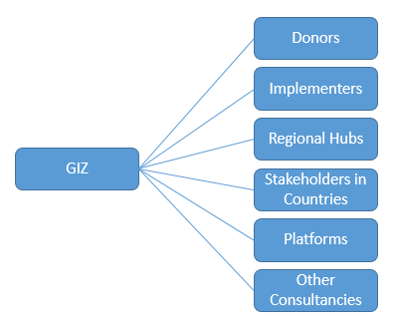The openIMIS community is growing rapidly. To ensure a regular flow of information the openIMIS Initiative has established a communications team, which is situated at GIZ Headquarters.

The communications team closely collaborates with focal points of the various partner institutions, especially the ones who implement activities linked to the openIMIS community. Depending on activities (either by the openIMIS Initiative, by partners, or joint activities) these contacts shall be leveraged to plan and execute targeted communications activities.

The communications team at GIZ Headquarters currently comprises of:
      - Communications Advisor (40%)
      - Intern Communications (50%)

Supported by:
      - Project Coordinator (50%)
      - SHP Advisor (30%)

Communications with partners
The openIMIS communications team is proactively leveraging communications opportunities (as elaborated in this strategy) together with the whole openIMIS community, by providing overview of ongoing communications activities and support.

To get all partners involved and on the same page the communications team will set up two video conferences for all communications focal points of partnering organisations in 2019, with the possibility of extending the total number to four per year. The video conference shall serve as a platform for information on communications related openIMIS issues and as a platform for active exchange among partners.

If not established already, each partner is encouraged to establish a Jour Fixe or a Jour Variable with the openIMIS communications team for joint planning and exchange about ongoing developments. This shall increase transparency and enable joint communications planning.

The goal of an increase in exchange about ongoing developments shall make jointly organized campaigns possible and make use of synergies. The openIMIS communications team proactively curates all information provided and creates content for dissemination across all owned channels. Hence, partner content can also be disseminated through the established openIMIS channels (News and Events section on Website, Social Media, Newsletter, etc.). The content will also be shared with partners for dissemination across their channels.

To increase the collaboration the communications team is in the process of defining a project management tool to plan and oversee the communications activities of the openIMIS Initiative. Part of this endeavour will be to develop a log-in page on the current website, which the communications focal points may use to access jointly used tools of the Initiative. These tools are currently being discussed and possibly ready for roll-out over the course of 2019. Among the tools are:

- openIMIS event calendar
- Kanban Board (e.g. Trello) / content plan for planning and dissemination of content across all channels
- Contact list of all relevant communications focal points
- Shared documents (e.g. standard presentations, flyers, photos, etc.)
- Communications WIKI

To ensure all new partners can join the communications efforts in a meaningful manner the core communications team will provide appropriate onboarding in order to explain and inform about openIMIS communication activities, the current network and enable collaborative communications work. The development of an appropriate approach has been started in 12/2018. Workshops on Persona, Value Proposition, Branding & Company Organisation, Customer Journey and Open Source Strategy are to follow until 3/2019.

7 OTHER COMMUNICATIONS OPPORTUNITIES

Awareness Days

Selected awareness days cover a wide range of relevant topics and generate a buzz on these topics. By piggybacking specific observance days, openIMIS can position itself in the context and show its own results, either on the website, Social Media or in themed press releases. Examples are:

- 20 February: World Day of Social Justice
- 8 March: International Women’s Day
- 7 April: World Health Day
- 28 April: World Day for Safety and Health at Work
- 12 June: World Day Against Child Labour
- 1 October: International Day of Older Persons
- 17 October: International Day for the Eradication of Poverty
- 12 December: Universal Health Coverage Day

8 REVISION & MAINTENANCE

This communications strategy is a living document and shall be revised regularly, but at least annually. The revision is the responsibility of the communications team at GIZ Headquarters.

Recommended next revision steps:
- Involvement of partners in openIMIS communications will be revised after Workshops on Persona, Value Proposition, “Company Organisation”, and Open Source Strategy.
- The KPIs should be defined in above mentioned Workshops
- The SWOT Analysis (Chapter 3) is subject to revision during above mentioned workshops
- Compare alignment of Key Messages to Principles for Digital Development and Donor Principles
- Job description of core communications team might be elaborated and added
- Regular revision of Project Implementers / Include new Partners to the Initiative in Chapter 8
- Perhaps add Addendum “Implementation sites” including contacts and possible sources of information.
- Produce a communications PowerPoint based on this communications strategy for quick and easy comprehension.
- List of Akronyms (Addendum 3) needs to be elaborated

9 PROJECT IMPLEMENTERS

- Deutsche Gesellschaft für Internationale Zusammenarbeit (GIZ) GmbH

Friedrich-Ebert-Allee 36 + 40
53113 Bonn
Germany

Dag-Hammarskjöld-Weg 1-5
65760 Eschborn
Germany

info@giz.de

- Direktion für Entwicklung und Zusammenarbeit (DEZA/SDC)

Freiburgstraße 130
3003 Bern
Switzerland

Mdeza@eda.admin.ch

- Swiss Tropical and Public Health Institute (Swiss TPH)

Socinstrasse 57
4051 Basel
Switzerland

library@swisstph.ch

ADDENDUM 1: Target Group Analysis

In this section, we present a detailed analysis of the various target groups of the openIMIS Initiative as described in Section V. Each Target Group is also associated with selected key messages.

Target group: COUNTRIES

Key Communications Objectives
1) Create attention for openIMIS within the national health and social protection sector
2) Attract interested parties and start a dialogue
3) Communicate the solution`s benefits to initiate implementations
4) Document and communicate implementation progress/lessons learned
5) Make use of multiplier effects

This target group consists of multiple stakeholder groups which can be subdivided in:
- Political level: Leading decision makers in ministries
- Implementation level: health care purchaser/payer institutions (e.g. insurance funds)
- End users interacting with interface: e.g. enrolment officers, providers, claim managers

Due to the variety of national set up of agencies within the sector and the level of current ICT implementation, the specific country level address will be tailored to the situation. Current country examples are:
    - National scheme
      - Nepal
    - District based scheme
      - Tanzania (moving to regional/national)
    - Community-based insurance
      - recently started in Democratic Republic of Congo and in Chad

As the goal is to expand implementations to various social protection schemes, the target group also includes:

- Political level: Leading decision makers in ministries responsible for social protection
- Implementation level: institutions implementing social protection schemes (e.g. social insurance funds)
- End users interacting with interface: e.g. enrolment officers, social workers/case managers

Key messages COUNTRIES

The openIMIS product

- provides a solid foundation for the management and administration of social (health) protection schemes
- Contributes to the SDG target 3.8 of establishing UHC by 2030
- Reduces the barriers to implementing a digitized social (health) protection system
- Implementation and maintenance can be followed and supported by the global Initiative
- Product and related global expertise can be used at no (direct) cost
- Low risk due to independence from commercial products (no vedor lock-in)
Can be adapted according to the requirements of each country and expanded as necessary
- Enables the exchange of information between actors in the national health and social protection system
- Increases the efficiency and transparency in the system, e.g. for the billing of health services
- Helps to (re-)organize business processes due to pre-defined structure
- Enables to move towards strategic purchasing of health care services
- Applicable as ICT framework for social protection schemes, openIMIS provides an important contribution to the promotion of social protection

Providing for Health Network, P4H (36 countries in various constellations)

- Countries willing to change their existing systems or implement new ones
- Health ministers, decision makers of government authorities
- Example processes
- Health insurers
- e.g. managers of national health insurance schemes in the target countries
- Institutions/ associations/ authorities administrating health financing processes
- Representatives of health systems in target countries (e.g. health care providers)
- Public Health Specialists
- Development workers/consultants

Multipliers
- World Health Organization (WHO)
- Organization for Economic Cooperation and Development (OECD)
- Bilateral and individual international networks related to UN Sustainable Development Goals 2030 (SDG)
- Consultants (advising countries)
- SAP, Bearing Point & CO.
- Implementation partners
- NGOs
- BMZ
Universities educating health economists

Target Group: DONORS

Key Communications Objective

Donor acquisition/financing for the global openIMIS Initiative as well as for country implementations.

Multilateral Donor Organizations

World Bank
- International Finance-Corporation (IFC), UHC and USP frontliner, with respective strategies and positions in place. However oftentimes without strong central coordination, i.e. country level contacts are helpful.
  - Priorities:
- Affordable pharmaceuticals and medical products.
- Access to quality healthcare: IFC finances integrated healthcare networks and providers that strive to deliver quality care to lower-income patients.
- Knowledge and capital transfer: IFC conducts advisory and convening work to ensure replication of best practices in cost efficient health delivery systems.
- Recently launched TechEmerge Health Brazil (2018), a matchmaking program offering market access and funding to global technology startups with proven health innovations relevant to Brazil. IFC is seeking applications from technology companies interested in scaling their business in this market.
- Hygeia (2018), an IFC client, seeks to address the problem by bringing integrated healthcare—a combination of insurance and care often seen in developed countries—to Nigeria. Hygeia encompasses two entities: Hygeia Health Management Organization (HMO) which mitigates health-related financial risks of its insured members, and Lagoon Hospitals, a network of six facilities.

Regional Development Banks

African Development Bank (AfDB)
- Funds, initiates and co-organizes conferences and awards related to eHealth:
- eHealth Award to seek African ICT health solutions (2013)
- eHealth Africa Conference: Integrating mHealth into eHealth Strategy Implementation (2012)
- Africa Science, Technology and Innovation Forum in Egypt (2018)
- Invests in legislative and regulatory frameworks to improve social protection e.g. the Social Protection Governance Support Programme (PAGPS) in Morocco

Asian Development Bank (ADB)
- Recent publication on Transforming Health Systems through Good Digital Health Governance (2018): Highlights necessity to develop a health ICT governance architecture framework through consultations and close collaboration with experts.
- Recent publication on “Improving the Delivery of Social Protection through ICT - Case Studies in Mongolia, Nepal, and Viet Nam” (2017): In the areas of health and social protection, between 2000 and 2013, ADB supported 24 ICT-related projects in nine counties (i.e. Bangladesh, Cambodia, the People’s Republic of China, the Lao People’s Democratic Republic, the Marshall Islands, Mongolia, Pakistan, the Philippines, and Viet Nam).Five of the projects relate to non-health care social protection programs, including developing management information systems, upgrading ICT systems, conducting ICT skills training, and creating a computerized verification system.

Inter-American Development Bank (IDB)
- Funds regional eHealth initiatives e.g. the Health Services Support Program in Trinidad and Tobago (2014) enhancing health facilities investment management through the innovative application and use of information and communication technology (ICT) including hardware, software, people, data and network.
European Bank for Reconstruction and Development (EBRD)

Development Gateway Foundation (DGF)
- Aims to reduce the digital divide between developing and industrialized countries by use of information and communication technologies (ICT)
- Independent, recognized as a non-profit organization since 2004
- Connects public and private partners, provides access to development-related knowledge
- Organizes an annual forum on ICT and development
- Headquarters in Washington, DC

United Nations Foundation / Digital Impact Alliance
- DIAL unlocks markets to deliver digital services to the most vulnerable, working with partners to overcome these challenges.
- DIAL Open Source Center: Convene a inclusive community for builders of free and open source software, promoting knowledge sharing, collaboration and co-investment in technology and human capacity to support positive social change in communities around the world. Possibility to apply for funding;

United Nations Population Fund (UNFPA)
- Launched a new eHealth MeetUp series on strengthening health systems through digital solutions (October 2017). It aims to strengthen the ecosystem around healthcare innovations in Kenya by offering a platform for information and knowledge exchange, as well as building and fostering partnerships for advancing partners’ respective mandate and programming.
- Co-hosted forum on improving access to sexual and reproductive health (SRH) information through ICT-based innovations (13 December, 2017).

Organizations with special focus:
- Gavi, the Vaccination Alliance (Gavi)
- Public-private partnership committed to saving the lives of children and protecting people’s health. Facilitates access to vaccination in the world’s poorest countries
- Gavi is an instrument of international cooperation that is intended to open up additional financing opportunities in addition to existing bilateral and multilateral activities.
- Based in Geneva

- Global Fund to fight AIDS, tuberculosis and malaria (GFATM)
- GFATM will fund national actions against those diseases, including the strengthening of health systems
- Germany is 4th largest donor to the fund and member of the Board of Directors
- Based in Geneva

  - International Telecommunications Union (ITU)
- United Nations specialized agency for information and communication technologies – ICTs.
- Numerous eHealth projects:
- Extension of Telemedicine to cover remote Areas in Zimbabwe 2015-2018: providing connectivity between hospitals in Zimbabwe with ICTs.m Health for Strengthening National Diabetes Prevention and control in Tunesia (2017-2020).
- mHealth for NCDs Joint Programme (2013-2021): This project is based on the cooperation agreement signed by ITU and the WHO regarding the development and implementation of a Mobile for Health (mHealth) for Non-Communicable Diseases (NCDs) Joint Programme

Foundations, initiatives, philanthropists
  - Hasso Plattner, Hasso-Plattner-Institute
- Organizes various events, conferences and symposia
- Based in Potsdam

  - Robert Bosch Foundation
- One of the major corporate foundations in Germany promotes among others in the field of health
- Based in Stuttgart

  - Dietrich Grönemeyer Foundation
- Supports many projects aimed on the prevention of diseases and health promotion
- Based in Bochum

- MAHLE-Foundation
- Supports approx. 150 projects worldwide per year
- Commitment to education, health and care, arts and culture, agriculture and nutrition
- Based in Stuttgart

  - Marie-Luise und Ernst Becker Foundation
- Promotes medical science and medical and therapeutic research in the sense of the WHO bio-physical-social health model
- Based in Cologne

  - Porticus Düsseldorf
- In the tradition of the charitable commitment of Clemens and August Brenninkmeijer, the founders of C&A
- Commitment to various projects in education, social affairs, faith and health around the world

Bill & Melinda Gates Foundation
  - Funding eHealth Projects:
      - The MOTECH Platform is an open source enterprise software system from the Grameen Foundation dedicated to health system strengthening across the globe. Primarily funded by the Bill & Melinda Gates Foundation, the MOTECH Platform started from the needs of a maternal and child health implementation in Ghana that aimed to improve health across the country. The MOTECH Platform connects eHealth systems (e.g. OpenMRS and DHIS2), frontline worker systems (e.g. CommCareHQ) and communication systems (e.g. IVR, SMS and email) to expand the capabilities of each. Our field-tested use cases have been deployed at district scale in Ghana and Zambia as well as numerous states in India.
      - Partnership with PATH: PATH’s Digital Health Solutions program supports the Government of Tanzania in digitizing and connecting Tanzania’s healthcare system, linking a fragmented array of databases and information sources.
  - Cooperation partners:
      - Warren Buffett, Initiative The Giving Pledge (founded together with Gates)
The Giving Pledge is an effort to help address society’s most pressing problems by inviting the world’s wealthiest individuals and families to commit more than half of their wealth to philanthropy or charitable causes either during their lifetime or in their will.
      - Charles Feeney, Foundation Atlantic Philanthropies

Further points of contact:
  - Berufsverband Gesundheitsförderung e. V. (Professional Association for Health Promotion)
      - Committed to strengthening the social relevance of health promotion among key actors in the health system, political decision-makers, employers, local authorities and the general public as well as to implementing strategies for health promotion
      - Organizes Hannover Health Congress

Bilateral Donor Organizations

Korean International Development Agency
  - Focus on Creative Technology Solutions in cooperation with Korean companies, e.g. CTS conference March 2018, sample projects: Cambodia’s Phnom Penh Software Professional Training Project’ by Korean Fintech Specialized Company Webcash
  - Smart Medication Management System for Tuberculosis Elimination in Morocco: m-Health service based on smart medication device and service. Initiative by KOICA in partnership with the company Jeyun to develop Creative Technology Solutions (CTS).

Department of Foreign Affairs and Trade (Australia)
  - Focus on digitalized social protection (integrated beneficiary registries): Publication on Integrating data and information management for social protection: Integrated Beneficiary Registries (2017).
  - Support for Unified Database in Indionesia (2015-June 2019), potential positioning of openIMIS;

Canada: International Development Research Centre
  - Multiple regional e-health projects, e.g. a new eHealth platform using mobile phones (mHealth) piloted by REACH Ethiopia SZHD, in collaboration with the Liverpool School of Tropical Medicine and funded by IDRC (January 2018).
  - Strengthening Equity through Applied Research Capacity Building in e-Health (SEARCH). Partners are e.g. the University of the Philippines Manila Development Foundation, Inc., American University of Beirut, Centre de Recherche en Santé de Nouna, International Centre for Diarrhoeal Disease Research, Bangladesh, Kenya Medical Research Institute, Sidama Zone Health Department, Universidad Peruana Cayetano Heredia, WHO.
Norway
  - Norfund, a state-owned investment fund, supports the building of sustainable digital initiatives in partner countries, has increasingly received additional governmental funding, reaching US$200 million for 2018.
  - Innovation Working Group (IWG) mobile health (mHealth) grand program (mobile health projects): Supported by the Norwegian Agency for Development Cooperation (NORAD) and led by the United Nations Foundation (UNF) and the World Health Organization Department of Reproductive Health and Research (WHO/RHR).

Sweden
  - SPIDER (Swedish Program for ICT in Developing Regions) brings together actors from different parts of the ICT-arena: Civil Society Organisations, Universities, Private Companies as well as Governmental Agencies in Sweden and in partner countries. Multiple projects in the field of e-Health in African countries.
  - Experience with eHealth on national level (esp. Northern Sweden), because distances between hospitals and patients are long.
  - EHealth as a tool in Indonesia: eHealth can provide medical specialist consultation via videolink. Using this technology, medical expertise can be accessed immediately across long distances in emergency situations.

Belgium
- Rather than focusing on sector-specific tools, the Belgian development cooperation pays more attention to platforms and technology that can be used across sectors (e.g. SMS platform used in both health and education sector)
- OpenClinic GA hospital information management system in more than 60 sub-Saharan hospitals. 1 local IT-professional per hospital has been trained by the Belgian implementation partners to maintain the system and to provide first level user assistance
- National e-Health data warehouse built on DHIS2. Such solution enables to directly extract aggregate data for national health policy making from clinical hospital databases without the need for additional (paper based) data collection instruments.
- The Citizen Monitoring System (CMS) through the Rwanda Decentralization Support Program manages complaints by citizens regarding social protection. Citizens can report issues telephonically/ email and all complaints are captured in a centralized system managed by the Local Administrative Entities Development Agency (LODA) and the Districts.

France
- In 2016, AFD launched the €600 million Africa and Emerging Countries Infrastructure Fund with the Caisse des Dépôts, primarily to promote investment in large-scale African projects.
- Digital Africa, produced by AFD and BPI France: Digital Africa Challenge competition, five sectors receive recognition for their dynamism and potential development impact: Among them the health sector
- Founding member of Global South eHealth Observatory (ODESS) along with international experts (WHO, USAID, eHealth Africa) which identifies, documents, and helps develop innovative projects using ICT in the field of healthcare in Africa & Asia. Opportunity for dialogue between the stakeholders and potential partners of eHealth ecosystems & platform for promoting and advancing development of eHealth initiatives. Conference 2017 under the umbrella of “Toward an integration of e-Health in public health systems”. Main focus of ODESS:
      - training healthcare professionals
      - telemedicine (remote diagnosis and consultation)
      - patient and medical-data monitoring
      - information, education and behavioural change.
      - financial access to care, microinsurance

Luxembourg
- SES (Euronext Paris and Luxembourg Stock Exchange: SESG) and the Luxembourg Ministry of Foreign and European Affairs support SATMED (e-health satellite platform) until 2020 with satellite connectivity over Africa, the Philippines and Bangladesh. The SATMED solution is designed to connect doctors and nurses based in remote locations to the outside world. Healthcare professionals use satellite connectivity to access the platform’s medical applications such as e-training, accessing patients’ e-medical records, virtual consultation, and video conferencing.

USAID
- Emphasis on eHealth, less so on social protection: The National Health Management Information System activity (AfyaInfo) works to establish an integrated health management information system in Kenya (2016). It supports the effort to unify multiple, parallel data systems into a single integrated, web-based NHIS that improves the collection and analysis of health data that are used for programmatic and policy decision-making
- E-Health System in Ukraine funded by USAID was founded by Transparency International Ukraine - and the patient organization – All-Ukrainian Network of PLWH (pilot phase April 2018)
- TASC4 ICT (2014-2019) is a USAID-funded indefinity quantity contract designed to provide information and communication technology (ICT) solutions to USAID globally to achieve its population, health, nutrition, and infectious disease objectives. It specifically is used to strengthen information systems and to support communication and social mobilization.

Platforms / Events / Conferences

Platforms where international development partners and donors are represented provide an opportunity to position openIMIS to the relevant audiences. These could be interesting occasions to place openIMIS through Speaker Ops, booths, etc. Please see the Event Calender enclosed in the Addendum for further information.

- DayOne Conference
  - 11.09.2018 in Basel, Switzerland
  - 18.01.2019 in Basel, Switzerland (follow-up on DayOne)

- World Health Summit
  - 14.10-16.10.2018 in Berlin, Germany
  - 27.10-29.10.2019 in Berlin, Germany

- Connected Health Conference
  - 17.10-19.10.2018 in Boston, United States

- AeHIN Annual Meeting
  - 07.10-09.10.2018 in Colombo, Sri Lanka

- Forum Digitale Gesundheit (Digital Health Forum)
  - Innovation at the interface of analogue healthcare systems and the digital world
  - 26.09-27.09.2018 in Zurich, Switzerland

Key Messages DONORS

- Represents an investment in the implementation/ improvement/ sustainability of health and social protection systems in low- and middle-income countries
- Contributes to SDG #3: to achieve UHC by 2030 and SDG # 1: achieve USP
- Strengthens healthcare systems, enabling information exchange between all actors
- Improves data management, data analysis, strategic purchasing of health care services, reporting and respectively allows for more evidence based policy formulation

Target Group: DEVELOPERS

Key Communications Objectives

1) Build a community that creates impulses for the further development of openIMIS and that is able to realize local adaptations

2) Use swarm intelligence in order to accelerate the product improvement. Let the benefits be quickly accessible for as many people as possible

Community of Developers

These will have to be researched and clearly specified in each envisioned area of implementation.
- IT-focused departments at ministerial level in target countries
- Start-ups
- Regional and local HISP Nodes
- Individual Software Developers (Geeks)
- Technology / Software Units at Universities

Communication Channels (Target Audience: Developers)

Platforms:
- Digital Health Forum (Myanmar)

- European Digital Forum
  - The European Digital Forum is a think tank led by the Lisbon Council and the global innovation foundation Nesta, in collaboration with the European Commission's Startup Europe Initiative. Founding partners include Banco Bilbao Vizcaya Argentaria (BBVA) and the European Investment Fund
  - Brussels

- GitHub
  - GitHub is the world’s largest community of developers sharing and building better software. From open source project to private team repositories GitHunb provides an all-in-one platform for collaborative development
  - GitHub brings teams together to work through problems, move ideas forward, and learn from each other along the way.
  - The platform is also an opportunity to meet with developers

Events:
- Annual MedTech & Digital Health Forum
  - Delegates are comprised of Healthcare, MedTech, Healthcare IT, and Digital Health companies as well as consultants, bankers and corporate & financial investors
  - Congress Center Basel

- Digital Health Conference
  - „Cutting edge innovation that’s transforming health“
  - The aim of this interdisciplinary conference is to bring together public health agencies (WHO, ECDC, CDC, PHE), computer science & IT and MedTech industry to cross-fertilize ideas and drive this growing interdisciplinary discipline
  - London and Berlin?

Key Messages DEVELOPERS

- The openIMIS Initiative provides innovative open source software for the management of social health protection systems in low- and middle-income countries
- 80% of the software development is driven by a core development team (via public tendering). Local adjustments/adaptations need to be applied by local project partners/programmers. We are looking for software developers who have insights about the local technical requirements and content-related issues.
- Chance for local programmers to contribute to a revolution of their country’s social health protection system as well as to a global initiative benefiting all user countries. Opportunity to adapt the program to the local needs and to further develop the system.
- Opportunity for programmers to start a career as developers and openIMIS-specialists (market-place-idea), to gain experience in the public domain and to build up their business.
- Actively participate in knowledge sharing between the global Initiative and local developers as well as within communities of developers and users.

Target Group: DEZA & BMZ

Key Communications Objectives

1) DEZA & BMZ as door opener and active multiplier
2) Secure financing
3) Underline the importance of openIMIS: Potential to be promoted into own project

Why do we have a win-win situation?

- OpenIMIS Initiative represents a modern profiling initiative for BMZ
- It is in line with the digitization agenda
- DEZA & BMZ can facilitate openIMIS Initiative’s access to decision makers in the countries

ADDENDUM 2: Instruments for inspiration (Nice to Have’s)

In this section, we would like to provide ideas for further communications measures, from planning to channels and monitoring. We compiled this very broad list from multiple best practice examples. It shall serve as an inspirational toolbox to draw ideas from.

Channels

Instrument | Target groups | Schedule/ Frequency | Brief description
Press conference and background talk  (PR) | - National media | Ongoing for various occasions, e.g. launches, conference openings, etc. | Press conferences, either individual as a background talk or collective with partners, are a good option for announcing high-profile news and setting the agenda for important topics. Press conferences usually manage to generate more coverage than simply press releases.
Giveaways | - clients, organisations and partners  - International clients, organisations and partners  - International donor community  - Government partners  - Private sector  - Media | Upon request | Giveaways branded with openIMIS are handed out on special occasions or together with press kits and folders and are friendly or even valuable reminders. They should be kept in good stock to prevent shortages. Giveaways include: USB-flash drives, pens, tote bags, lanyards, caps; flashlights, raincoats, footballs, notepads, etc..
Press distribution list (e.g. for press releases) | - PR & Communications | Ongoing updates | The distribution list contains journalists’ contact details for both national state and private-run media as well as details of international media and agencies. The details are used for sending out press releases and invitations to events.
Brown Bag Lunch | - At partner organisations | Twice a year | Colleagues stand to learn a lot from each other and their experiences with openIMIS. Brown Bag Lunches feature an expert who holds a brief talk on a specific issue, followed by a discussion over lunch. By setting openIMIS as a theme for the Brown Bag Lunch, the initiative can strengthen its own position in that institution and context.
Result-based fact sheets | - Main clients and stakeholders  - National partners and stakeholders  - International donor community  - International partners and co-financing bodies  - Media | Updated once a year | Results are the main currency in development work. Facts and figures on the contributions openIMIS makes in each context are are a great way to achieve buy-in and support. The fact sheets can feature both stories and figures that openIMIS achieves.
Media cooperation with Deutsche Welle | - National partners and stakeholders  - International donor community  - International partners and co-financing bodies | One-off campaign | Deutsche Welle is both a multiplier and an influencer. Introducing a feature on a specific openIMIS implementation helps set the agenda for this issue and also positions the initiative for partners to hear and acknowledge.
Feature in other donor publications | - International partners and co-financing bodies  - Main clients and stakeholders  - National partners and stakeholders | Once a year at least | Through precise positioning in other donor publications, openIMIS can effectively post the message that we are working on.
Visual communication, i.e. film and photos | - German and international clients, organisations and partners  - International clients, organisations and partners  - Media  - General public | Ongoing | Film and photos are both an accessible and emotional entry point to our work. Done well featuring only a single protagonist per film to make the issue clearly visible, they can reach further than, for example, fact sheets. As an added bonus, they are easy to distribute and integrate in a variety of channels, thereby enlivening other communications products.

Tools

Instrument | Target groups | Schedule/ Frequency | Brief description
Regular jour fixe for PR & communications staff | - PR & communications staff involved in the openIMIS initiative | Monthly; ongoing | The monthly meeting with the initiatives PR & Communications officer gives members the chance to update each other on their organisations’ activities and measures and discuss best practices – both for consistency and developing innovative ideas.
Crisis communications manual or guidelines | - Management  - PR & communications officers in programmes | Once every two years | openIMIS works with sensitive data and is in a pilot phase – hence prone to risks. Knowing how to communicate properly should a crisis occur is essential. A crisis manual (with a short training workshop) helps prepare the management team with the right tools to reduce risk in unpredictable situations.
Photo database | - PR & communications team | Ongoing update | Since openIMIS is an IT-application and the topic of health provisions is rather difficult to grasp, it is all the more important to have excellent pictures to tell the openIMIS-story. As pictures are always needed – either as key visuals or to illustrate programme activities and achievements – a photo database helps reduce request processes for (a) finding the right photos, and (b) getting it from A to B, e.g. to press contacts or onto Website and Social Media.

Monitoring

Instrument | Target groups | Schedule/ Frequency | Brief description
Stakeholder & partner survey | - Main clients and stakeholders  - National partners and stakeholders  - International partners and co-financing bodies | Once every two years
Media monitoring, press clippings & media analysis | - Management staff  - PR & Communications officers in programmes | Reviewed & published twice a year | The openIMIS communications team collects press clippings (articles with openIMIS references) and sorts them by specific criteria, e.g. topics, issues, source of article, media form, language, tonality, etc.  The media analysis helps collect statistics on what kind of media work is best practice for generating maximum coverage and agenda setting.
Results tracking | - All target groups | Annual update | Results are easy to understand for anyone and leave a hands-on impression of the work we do and who we reach through our work. Annual tracking of results – following the M&E phases in the middle of the year – puts openIMIS in the position to provide accurate and up-to-date numbers on specific issues. The portfolio of results should be extended to include a wide range of issues, in line with SDGs.

ADDENDUM 3: AKRONYMS AND DEFINITIONS

IMIS

openIMIS

openIMIS initiative

open source

UHC

USP2030

Interoperability

WHO

CoP

ODA

SDG

HDC

P4H

SPIAC-B

JLN

OECD

ICT

