Loose coupling and module compatibility matrix
Bluesquare proposed to develop the new openIMIS by using loose (the modules are not aware of the other module that consume the entity they support) coupling but it is not clear how the loose coupling can work without any stable references.

Example: claim loose coupling
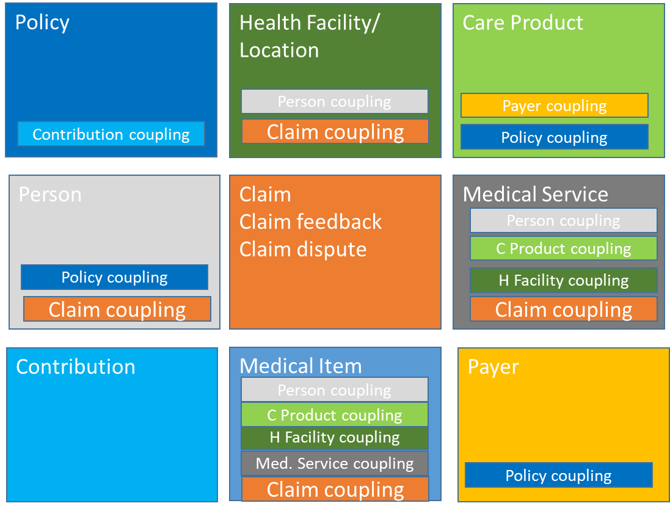
In that simplified example one can see that a change or removal a module is not that straight forward because other module may not makes sense without them.
Questions
- Will the loose coupling should still work if a module is replaced (like claim in the example above?)
- What will happen in case a module business functionality depends on a coupling?
  - E.g. What is the business value of a claim without med Service and Med Item?
- What happen if a coupling is missing in regards with the business process of a new module? Should this new module create a strong coupling
- In order to mitigate those issues, can we create abstract model for the business critical entity so whenever there is a business dependence a “elastic” coupling could be made with the abstract entity ?

