Request for a change

Request ID | XX
Title of the request | Support of health insurance for formal sector  (version 0-initial draft)
Relates to | Master Version
Submitted on
Assessed on
Approved on
Status | - Submitted x  - Assessed  - Approved  - Rejected  - Processed  - Implemented
Impact on costs
(man hours, man days)
Impact on schedule
Category of change | - Minor  - Major  - Principal
Comments of vendor
Revision historyVersion | Date | Author | Changes / remarks
0. | 15/07/2018 | Jiri Nemec | Initial draft

Description of the request

Introduction/Background
openIMIS was originally developed for support of health insurance of informal sector. Typical features of health insurance for informal sectors are:
- Families, individuals or small groups are targeted by a health insurance for informal sector;
- Policies span usually across a definite insurance period and they are renewed;
- Contributions rates are defined as pre-defined amounts;
- Payments of contributions are done usually in one or only a few instalments.
Health insurance for formal sector usually exhibits some features not yet supported by openIMIS:
- Targeted are smaller or major groups of insurees and their family dependents that are employed by a formal employer or belong to a formal association;
- Duration of policies that cover employees or members of an association is indefinite;
- An individual person (and his/her family dependents) is covered by a policy as long as he/she is employed by an employer or is member of an association;
- There are usually specific rules defining coverage of an individual person if he/she ceases to be employed or to be a member of an association;
- There are usually specific rules defining conditions of finishing of indefinite policies (e.g. stopping of payment of contributions);
- Contributions rates may be not pre-defined amount but may be defined as a percentage of an external value (wage of an employee, profit of insurees etc.);
- Contributions are paid regularly (usually monthly) ;
- Automatic link with external HR (human resources) systems of employers/associations is often required;
The features of health insurance for formal sector mentioned above can be used also for support of health insurance in informal sector. For example, insurance products with indefinite duration may be used also in informal sector .On the other hand, the majority of functionality already implemented in openIMIS can be used for formal sector as well – e. g. the whole subsystem of processing of claims.
The proposed solution of support of health insurance of formal sector has the following rather independent components:
1. Enriching the data model of openIMIS with a new entity Employer. Insurees are members of a family on one hand and some of them can be employed (linked) to an employer on the other hand.
2. Enriching of the scope of possible insurance product by products exhibiting one or several of the following features:
- Indefinite insurance period;
- Indefinite number of installments of contributions (paid regularly);
- Contributions rates defined as a not pre-determined value (e.g. defined as a percentage of a salary);
- Family insurance-coverage the whole family on behalf the link of a member to an employer;
- Grace period for duration of a policy with indefinite insurance period in case of stopping payment of contributions;
- Grace period for coverage of an insuree (family) in case of leaving an employer;
- Regular (monthly) calculation of value of a policy.
Insurance products with these features can be used in both informal and formal sectors-with families and employers as well.
3. Enriching of functionality of the payment module
- Acceptance and matching of regularly incoming payments of contributions
- Acceptance and matching of payments of contributions without pre-determined value
Again these features may be utilized both within informal and formal sectors.
4. Enrichment of the openIMIS API layer-provision of additional API functions for:
- Adding and deleting of an employers
- Adding and deleting of an employee to/from an employers
- Assigning of a policy to an employer
This enrichment will allows integration with HR systems of employers or professional associations.

Brief description of the proposed solution
The following paragraphs briefly describe adjustments needed for support of health insurance for formal sector. Details will be elaborated after an approval of the proposed solution.

Enriching of the data model and new functionality associated with enrolment

The new entity Employer will be incorporated in the data model of openIMIS-see Figure 1. The entity Employer stands for employers in the narrow meaning and also for any groups, associations etc. that can be covered by an insurance product as whole. Groups represented by the entity Employer differ to the groups represented by the entity Family as are known from the current version of openIMIS. Groups represented by the entity Family are identified with an insuree in the position Head of Family/Group whereas groups represented by the entity Employer exist independently to any of its insurees. .

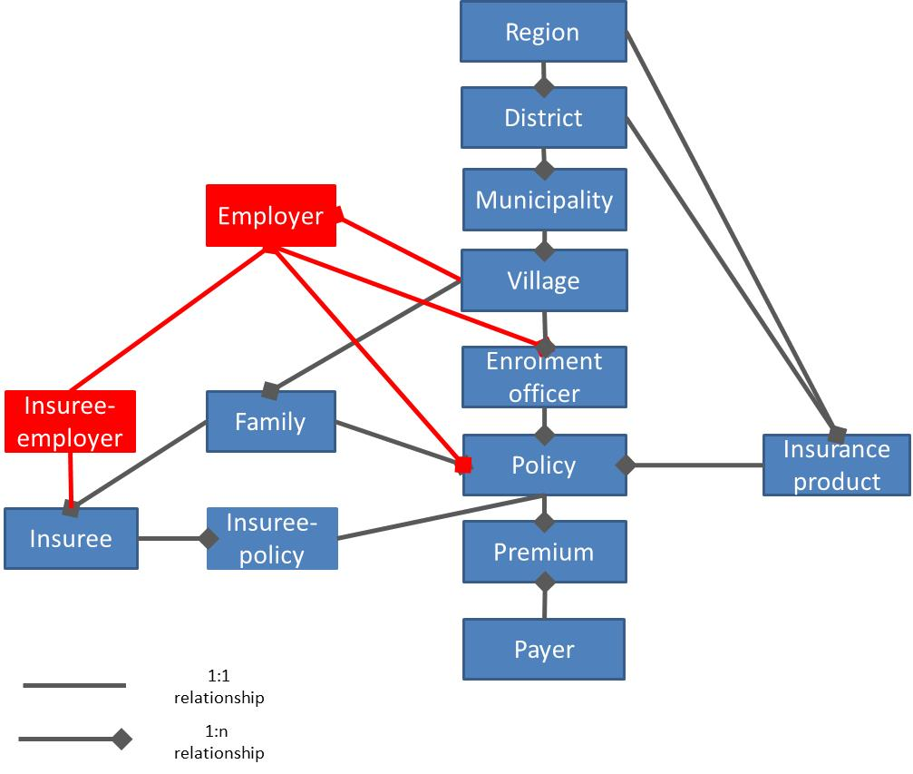
Figure 1 Adjusted data model of openIMIS (part insurees and policies)
Verbally, an employer resides in a village (a location at the lowest level). It can have one or several insurees (employees). Employees are at the same time members of their families. Employees of an employer can be covered by one or several policies assigned to the employer. An employee can be associated with several employers (e.g. he/she can have several employments). Several members of a family can be associated with one or several employers. An enrolment officer can be associated with an employer. Such enrolment officer can be regarded as a representative of an insurer at the employer.
An employer has the following attributes in openIMIS:
Name of entity: Employer
Name of attribute | Description | Values
Region | Region of residence of the employer/group | Reference to Region
District | District of residence of the employer/group | Reference to District
Municipality | Municipality of residence of the employer/group | Reference to Municipality
Village | Village of residence of the employer/group | Reference to Village
Address | Address of residence of the employer/group | Alphanumeric
Trade name | Trade name of the employer | Alphanumeric
Branch | Designation of an organizational part of the employer | Alphanumeric
Code | Code of the organizational part of the employer | Alphanumeric
Phone | Contact through a phone to the employer | Alphanumeric
Fax | Contact through a fax to the employer | Alphanumeric
Email | Contact through an email to the employer | Alphanumeric
Last name | Last name of a representative of the employer | Alpha
Other names | Other names of a representative of the employer | Alpha
Type | Type of the employer/group  (employer, association, etc.) | Alpha
Legal form | Legal form of the employer/group | Alpha
Classification | Classification of the area of activity of the employer/group | Alpha

The entity Insuree-employer is used as bridge between Insurees and Employers to mitigate n:m relationship of both entities. The structure is as follows:
Name of entity: Insuree-employer
Name of attribute | Description | Values
Employer | Employment of an insuree | Reference to Employer
Employee | Employed insuree | Reference to Insuree
Admission | Employment/membership from | Date
Dismissing | Employment/membership from | Date

The following functionality is related to the entity Employer and its relationships to other entities and it will be added to openIMIS on top of current functionality:
No. | Functionality | Description
1 | Create a new employer | Creates a new employer
2 | Searching for an employer | Searching for specific employers according to selected criteria
3 | Modification of an employer | Modifies an employer
4 | Deleting of an employer | Deletes an employer
5 | Associating of an insuree with an employer | Associates an insuree with an employer as its employee from a specific date
6 | De-associating of an insure from an employer | De-associates an insuree from an employer on a specific date

The following currently implemented functionality should be enhanced with new features:
No. | Functionality | Added feature
7 | Create a policy | Policy can be created also with an employer now (not only with a family)
8 | Create a new family | A new family can be created now also within the functionality Associating of an insuree with an employer
9 | Create a new insuree | A new insuree can be created now also within the functionality Associating of an insuree with an employer

Comments to the design: User interface of the new functionality should follow the pattern of families (a menu item Add Employer for adding a new employer, a menu item Employers for searching among employers. Clicking on a selected employer will show an EmployerOverview form that is analogical to the FamilyOverview form. Within the EmployerOverview form the functions of associating/de-associating of employees and associating of policies with employers can be accomplished. Attention has to be paid to integration with the functionality of creating of a new family and a new insure in case a newly associated employee is not yet in the openIMIS database.

Enriching of definition of insurance products and associated business logic

The following new features of insurance products can be defined with the entity Product:
No. | Feature | Description | Modification in the form Product
1 | Indefinite insurance period | There is no explicit expiry day associated with policies of given insurance product | None, just Insurance Period=0
2 | Indefinite number of installments | The number of instalments of payment of contributions is not pre-defined. Instead regular monthly payments during duration of a policy are assumed. | None, just Max Instalments = 0
3 | Contribution rates defined as not a predetermined value | Contributions are defined based on external data (e.g. salaries of employees) | None, just Lump Sum = 0,  Contribution Adult = 0, Contribution Child = 0
4 | Family Insurance | If an insuree is insured by a policy of his/her employer, the whole family of him/her is insured as well. | New data field  Family Insurance = (yes,no)
5 | Grace period for an insuree/employee | Additional duration of coverage of an insuree/employee after he/she is de-associated with an employer | New data field  Grace Period Insuree (in months)

The new features above are incorporated in an appropriate manner into the business logic of openIMIS and they have the following consequences on business logic of openIMIS:
No. | Condition | Description
1 | Policy value  Insurance Period = 0 Max Instalments=0  Lump Sum > 0 or Contribution Child/Adult >0 | The value of a policy calculated according to the current rules is considered as a monthly value.  The component of contributions based on registration and assembly fees is added only to the value of the policy for the first month.
2 | Policy value  Insurance Period = 0 Max Instalments>0  Lump Sum > 0 or Contribution Child/Adult >0 | The value of a policy calculated according to the current rules is considered as one time value of the policy until its end.
3 | Policy value  Insurance Period > 0 Max Instalments = 0  Lump Sum > 0 or Contribution Child/Adult >0 | The value of a policy calculated according to the current rules is considered as a monthly value.  The value of a policy calculated according to the current rules is considered as one time value of the policy until its end.
4 | Policy value  Insurance Period =0 Max Instalments = 0  Lump Sum =0 and Contribution Child/Adult =0 | The value of a policy calculated according to the current rules is considered as the value for the first month only.
5 | Coverage of an insuree  Family Insurance =yes | Insuree and all his/her family members are covered by all policies associated with their family, with all policies of employers the insuree is associated with and with all policies with Family Insurance set yes of employers to whom other members of the family are associated.
6 | Coverage of an insuree  Family Insurance =no | Insuree and all his/her family members are covered by all policies associated with their family is associated with and with all policies with Family Insurance set yes of employers to whom members of the family are associated.
7 | Balance of a policy  Insurance Period = 0 Max Instalments=0 | The balance of a policy in given month is the sum of all values of the policy for all months up to the current month minus the sum of all contributions paid up to now. There is no change of calculation of the balance for other options in comparison to the current openIMIS
8 | Ending of a policy Insurance Period = 0  Max Instalments=0  Grace Period Payment = 0 | The policy goes to the status Idle as soon as current month expires in which no instalment was paid and the balance of policy becomes positive.
9 | Ending of a policy Insurance Period = 0  Max Instalments=0  Grace Period Payment > 0 | The policy goes to the status Idle as soon as there is no instalment paid for Grace Period Payment months before the current month and the balance of policy becomes positive.
10 | Coverage of an insuree  Grace Period Insuree = 0 | Insuree and all his/her family members ( in case of policies with Family Insurance set yes) are covered by the policies of his/her employer only up to the date of his/her de-association from the employer.
11 | Coverage of an insuree  Grace Period Insuree >0 | Insuree and all his/her family members (in case of policies with Family Insurance set yes) are covered by the policies of his/her employer until the date of his/her de-association from the employer plus Grace Period Insuree.
12 | Distribution of contributions  Insurance Period = 0 | For policies with indefinite duration contributions are distributed according to actual payments in each month ( and not proportionally distributed across an insurance period as in case of policies with defined duration).

Remark: other combinations of attributes of insurance products shouldn’t represent any major deviation from the current openIMIS.

Enriching of functionality of the payment module
The payment module is just in process of its implementation (RfC 71). It needs some adjustments reflecting introduction of the entity Employer and the new features of insurance products. The adjustments are summarized in the following table:
No. | Adjustment
1 | Adding an input parameter to API function getControlNumber and getPaymentData distinguishing whether a policy relates to a family or to an employer and modifying internal searching for the policy accordingly
2 | Enriching the entity Control Number by the attribute whether the control number relates to a policy of a family or of an employer
3 | All adjustments of user interface related with the payment module will be done simultaneously for forms related to families and employers.
4 | A segment of the matching algorithm will be added for payments without participation of enrolment officers but not relating to renewals to address policies for insurance products with indefinite insurance periods
5 | A segment of the matching algorithm will be added for payments without participation of enrolment officers but not relating to renewals to address policies for insurance products with externally defined contribution rates

Enriching of API layer

Besides existing API functions in the openIMIS API layer (see the RfC 72 and 72.1-security of the API layer) the following API functions will be added:
No. | API function | Description
1 | Enter_Employer | Function enters a new employer
2 | Modify_Employer | Function modifies attributes of an employers
3 | Enter_Employee_Employer | Function associates a new employee with an employer from a specified date
4 | Remove_Employee_Employer | Function de-associates an employee from an employer from a specified date enters a member of a family/group
5 | Enter_Policy_Employer | Function enters a new policy for an employer
6 | Get_Employer | Function gets the data on an employer
7 | Get_Employee_Family | Function gets the data on an employee

By means of these additional API functions on top of existing API functions an automatic link between a HR system at an employer/associations and openIMIS can be built. It should be stressed the principle that an external (HR) system decides only about the fact whether a person is employed at the employer or is a member of the association and from or to what date. Whether the person is insured, how long etc. is decided in openIMIS based on parameters of insurance products used for policies associated to employers.

New amendments to the data model are in red

