Digital Public Good Alliance
DPG Communications Announcement Guide

WELCOME!

We’re thrilled to be adding your project as a new digital public good to the DPG Registry!
We are committed to lifting the discoverability of DPGs. This guide is meant to support any elective communications you choose to share as a new DPG and help to ensure your communications efforts are aligned and supported by providing examples, templates and explanations. Using the tools and channels below is the best way for the Digital Public Goods Alliance to recognize and amplify your communications.
If there is any additional support you require, please reach out to hello@digitalpublicgoods.net.
We’re excited to work with you!

Social Media
The DPGA is on Twitter and LinkedIn.
Twitter - @DPGAlliance, https://twitter.com/DPGAlliance
LinkedIn - https://www.linkedin.com/company/dpgalliance
Note: Where possible, social media should link out to a press release, description of the project or project website. Below are some examples.

- [Project name] has been reviewed by the @DPGAlliance and found to be a digital public good.
- We’re a #digitalpublicgood! Wondering what a DPG is? Check out @DPGAlliance.
- Today we are thrilled to be counted as a #digitalpublicgood alongside many other incredible #opensource projects working to achieve the #SDGs. Find out more: digitalpublicgoods.net/registry/

For example:
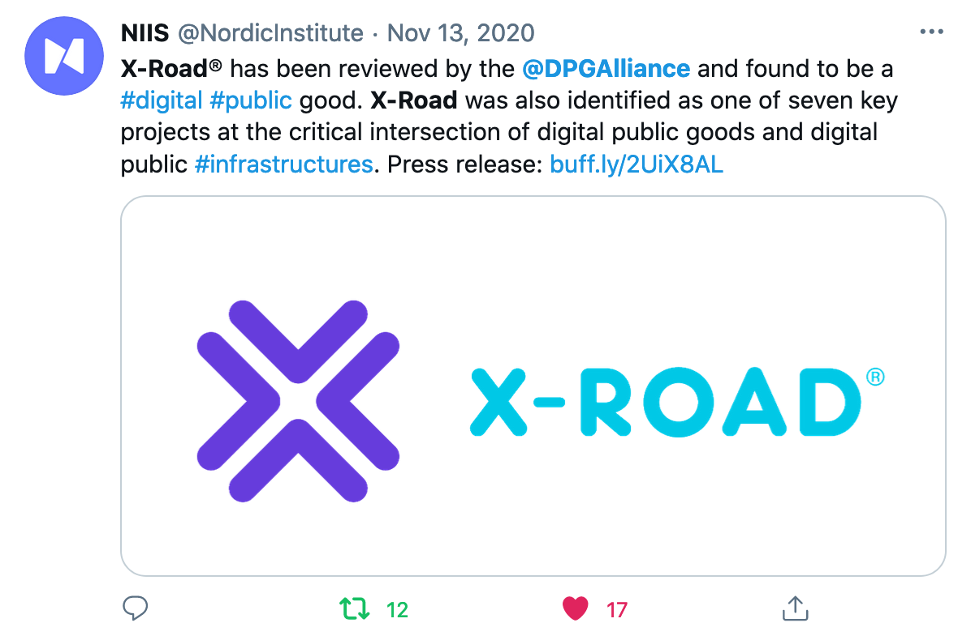

Press Release
Some projects have decided to pair their announcement with a press release. Below is a template that can be used in addition to examples of previous press releases.

--

Today, [project] was added to the Digital Public Goods Alliance DPG Registry. The goal of the DPGA and it’s registry is to promote digital public goods in order to create a more equitable world. Being recognized as a DPG increases the visibility, support for, and prominence of open projects that have the potential to tackle global challenges. To become a digital public good, all projects are required to meet the DPG Standard to ensure that projects truly encapsulate open source principles.

[Project] seeks to [insert background on project].

For us, being recognized as a digital public good - defined as open source software, open data, open AI models, open standards and open content that adhere to privacy and other applicable laws and best practices, do no harm, and help attain the SDGs - means [insert why becoming a DPG is valuable to your project].

For any inquiries on [project] please reach out to [name & email of individual responsible]. For more information on the Digital Public Goods Alliance please reach out to hello@digitalpublicgoods.net.

The Digital Public Goods Alliance is a multi-stakeholder initiative endorsed by the United Nations Secretary-General, working to accelerate the attainment of the Sustainable Development Goals in low- and middle-income countries by facilitating the discovery, development, use of, and investment in digital public goods.

---

Here are some previous examples:
- https://www.mynewsdesk.com/niis/pressreleases/x-road-identified-as-one-of-the-key-projects-by-the-digital-public-goods-alliance-3050491
- https://www.nibio.no/en/news/sharing-knowledge-vips-on-exclusive-un-list-for-open-source-digital-goods

Branding

Below is a link to the .png file of the DPGA logo for use in public references to the DPGA. In addition, there is a link to the icon that will now be found beside your project name on the DPG Registry that identifies it as a DPG.

The DPGA team would love to know when DPGs plan on sharing information about this announcement. Please email hello@digitalpublicgoods.net or your main contact to let us know so we can keep an eye out!

https://drive.google.com/file/d/15Yr2642MoLTEkQ1ZeDcw6QdHeTyMBAmg/view?usp=sharin
g
https://drive.google.com/file/d/1QswBD7zCmpq4JP_4ZXGpVVJ16T-qpexW/view?usp=sharing

Style Guide

Full Name | Digital Public Goods Alliance  Usage: The first time the name is mentioned in a blog or publication, or in titles and introductions.
Abbreviated Name | DPGA  Usage: Subsequent mentions of our name in blogs or publications. This should never be the *first* usage.  DO Eg. The Digital Public Goods Alliance has partnered with X to create…. Now the DPGA and X have a platform to work together on achieving the SDGs by 2030.  DO NOT Eg. The DPGAlliance; The Alliance
Tagline | “Promoting digital public goods to create a more equitable world.”
Alliance Members | The Secretariat of the Digital Public Goods Alliance is co-hosted by the Norwegian Agency for Development Cooperation (Norad) and UNICEF and governed by an Interim Strategy Group consisting of: iSPIRT; The Government of Norway; The Government of Sierra Leone; and UNICEF.  *Note: the listing of the ISG members is alphabetic.  *Note: Norad is represented on the Secretariat, The Government of Norway is represented on the ISG. Always use the full name (“Norwegian Agency for Development Cooperation”) the first time “Norad” is used.

