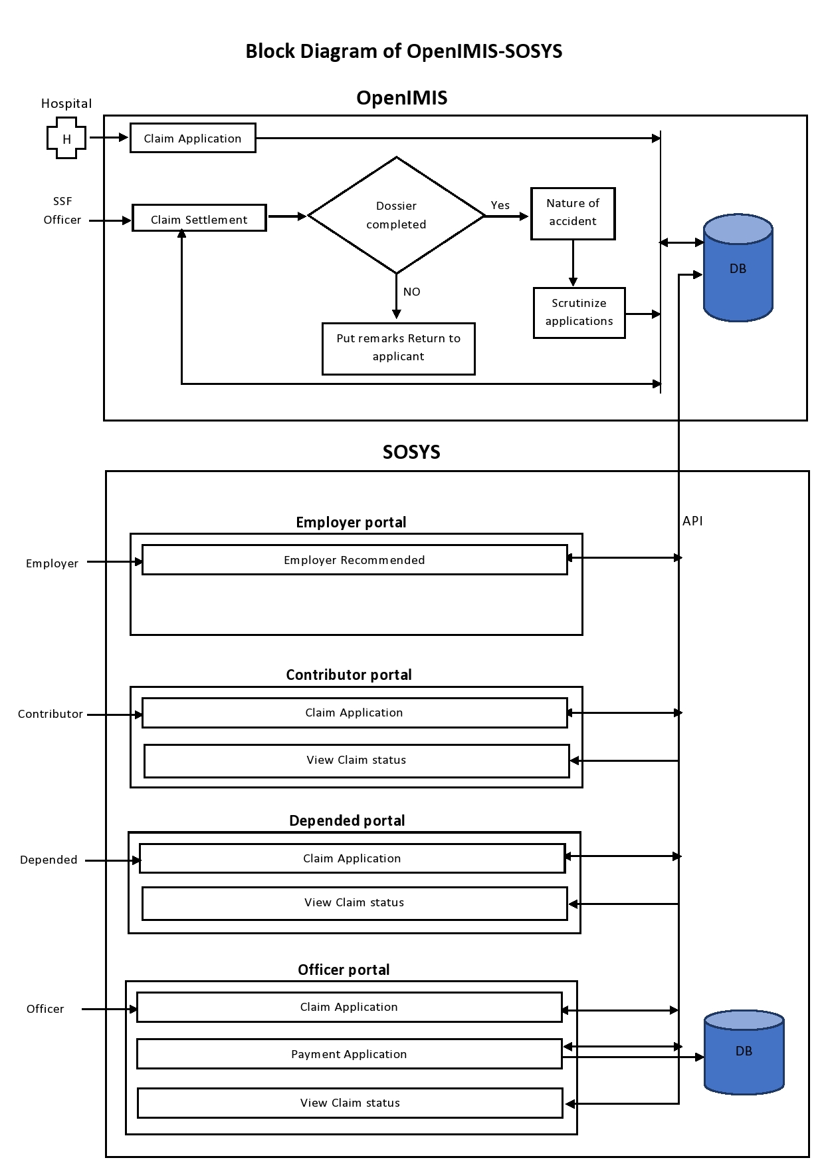

Use Cases:-
Use case Name | Claim Application
Description | This module is used to store the claim information into OpenIMIS Database.
Actor | - Hospital
Pre-Condition | - The user, which can perform this Entry, must be authenticated and authorized.
Post-Condition | - Claim information added successfully to the System.
Business Rule | - System must have a user with authority to enter this data.  - Check the contributor information into OpenIMIS before application submit, if not exits into it then fetch contributor information from SOSYS Database via API and save into OpneIMIS.  - Check contributor policy into SOSYS Database via API
Attributes | - SSFID  - Contributor Name  - Claim Id  - Claim Date  - Claim Amount  - Employer Id  - Employer Name  - Hospital code  - Bank Id  - Bank Branch Id  - Bank Account Number  - Bank Account Name  - And so on
Validation | - All Required field must be entered.

Use case Name | Employer Portal => Employer Recommended
Description | This module is used to recommend or verify the claim Application.
Actor | - Employer
Pre-Condition | - The user, which can perform this Entry, must be authenticated and authorized.
Post-Condition | - Claim information verify successfully to the System.
Business Rule | - System must have a user with authority to enter this data.  - Check the claim information.  - Approve or reject claim application.
Attributes | - SSFID  - Contributor Name  - Claim Id  - Claim Date  - Claim Amount  - Employer Id  - Employer Name  - Hospital code  - Bank Id  - Bank Branch Id  - Bank Account Number  - Bank Account Name  - And so on
Validation | - All Required field must be entered.

Use case Name | Claim Settlement Application
Description | This module is used to store the claim settlement information into OpenIMIS Database.
Actor | - SSF Officer
Pre-Condition | - The user, which can perform this Entry, must be authenticated and authorized.
Post-Condition | - Claim settlement information added successfully to the System.
Business Rule | - System must have a user with authority to enter this data.  - Check contributor policy and active into SOSYS Database via API  - Check dossier completed or not if not complete then exit and send message to applicant.  - If dossier completed then go to nature of accident that are:-  1. Damage to health  2. Work Accident  3. Accident  4. Occupational Disease  - If not Damage to heath then reject the application  - If damage to health then go to work Accident  - If work Accident then go to recognize work Accident  - If not work Accident then go to Accident  - If Accident then go to recognize Accident  - If not Accident then go to Occupational Disease  - If Occupational Disease then go to recognize the OD  Otherwise link to Health Insurance  - After recognize Nature of Accident, check Insurance case possible or not  - If not Insurance case possible then link to Health Insurance  - If insurance case possible then go to Scrutinize case components  - If case component not complete then link to Health Insurance  - If case component complete then go to Insurance case recognize  - If Insurance case not recognize then link to Health Insurance  - If Insurance case recognize then go to Payment application
Attributes | - SSFID  - Contributor Name  - Claim Id  - Claim Date  - Claim Amount  - Employer Id  - Employer Name  - Hospital code  - Bank Id  - Bank Branch Id  - Bank Account Number  - Bank Account Name  - And so on
Validation | - All Required field must be entered.

Use case Name | Contributor Portal => Claim Application
Description | This module is used to store the claim information into OpenIMIS Database via Api.
Actor | - Contributor
Pre-Condition | - The user, which can perform this Entry, must be authenticated and authorized.
Post-Condition | - Claim information added successfully into OpenIMIS System.
Business Rule | - System must have a user with authority to enter this data.  - Check the contributor information into OpenIMIS before application submit, if not exits into it then fetch contributor information from SOSYS Database via API and save into OpneIMIS.  - Check contributor policy into SOSYS Database
Attributes | - SSFID  - Contributor Name  - Claim Id  - Claim Date  - Claim Amount  - Employer Id  - Employer Name  - Hospital code  - Bank Id  - Bank Branch Id  - Bank Account Number  - Bank Account Name  - And so on
Validation | - All Required field must be entered.

Use case Name | Contributor Portal => View Claim Status
Description | This module is used to display the claim status.
Actor | - Contributor
Pre-Condition | - The user, which can perform this Entry, must be authenticated and authorized.
Post-Condition | - Claim information displayed successfully via reports
Business Rule | - System must have a user with authority to enter this data.  - Show the claim history.  - Search Criteria
Attributes | - SSFID  - Contributor Name  - Claim Id  - Claim Date  - Claim Amount  - Employer Id  - Employer Name  - Hospital code  - Hospital Name  - And so on

Use case Name | Dependent Portal => Claim Application
Description | This module is used to store the claim information into OpenIMIS Database via Api.
Actor | - Dependent
Pre-Condition | - The user, which can perform this Entry, must be authenticated and authorized.
Post-Condition | - Claim information added successfully into OpenIMIS System.
Business Rule | - System must have a user with authority to enter this data.  - Check the contributor information into OpenIMIS before application submit, if not exits into it then fetch contributor information from SOSYS Database via API and save into OpneIMIS.  - Check contributor policy into SOSYS Database
Attributes | - SSFID  - Contributor Name  - Claim Id  - Claim Date  - Claim Amount  - Employer Id  - Employer Name  - Hospital code  - Bank Id  - Bank Branch Id  - Bank Account Number  - Bank Account Name  - And so on
Validation | - All Required field must be entered.

Use case Name | Dependent Portal => View Claim Status
Description | This module is used to display the claim status.
Actor | - Dependent
Pre-Condition | - The user, which can perform this Entry, must be authenticated and authorized.
Post-Condition | - Claim information displayed successfully via reports
Business Rule | - System must have a user with authority to enter this data.  - Show the claim history.  - Search Criteria
Attributes | - SSFID  - Contributor Name  - Claim Id  - Claim Date  - Claim Amount  - Employer Id  - Employer Name  - Hospital code  - Hospital Name  - And so on

Use case Name | Officer Portal => Claim Application
Description | This module is used to store the claim information into OpenIMIS Database via Api.
Actor | - SSF Officer
Pre-Condition | - The user, which can perform this Entry, must be authenticated and authorized.
Post-Condition | - Claim information added successfully into OpenIMIS System.
Business Rule | - System must have a user with authority to enter this data.  - Check the contributor information into OpenIMIS before application submit, if not exits into it then fetch contributor information from SOSYS Database via API and save into OpneIMIS.  - Check contributor policy into SOSYS Database
Attributes | - SSFID  - Contributor Name  - Claim Id  - Claim Date  - Claim Amount  - Employer Id  - Employer Name  - Hospital code  - Bank Id  - Bank Branch Id  - Bank Account Number  - Bank Account Name  - And so on
Validation | - All Required field must be entered.
Use case Name | Officer Portal => View Claim Status
Description | This module is used to display the claim status.
Actor | - SSF Officer
Pre-Condition | - The user, which can perform this Entry, must be authenticated and authorized.
Post-Condition | - Claim information displayed successfully via reports
Business Rule | - System must have a user with authority to enter this data.  - Show the claim history.  - Search Criteria
Attributes | - SSFID  - Contributor Name  - Claim Id  - Claim Date  - Claim Amount  - Employer Id  - Employer Name  - Hospital code  - Hospital Name  - And so on

