User Manual – IMIS apps, relates to the versions 1.3.0 and newer
Introduction
The Insurance Management Information System (IMIS) is the web based software supporting running of health insurance schemes. It includes functionality for a setup to requirements of health insurance schemes, administration of policies and policy holders and for claim processing.
The web forms used in IMIS are not adjusted to small screens of mobile phones and this is one of reasons why IMIS provides applications on the Android platform that can be used effectively in the field for preparation and retrieving of data for/from the web IMIS. There are two applications available that provide essential functionality for enrolment officers (IMIS Policies) and for claim administrators (IMIS Claims).
Both applications allow autonomous preparation of data (enrolment and policy data by IMIS Policies and claim data by IMIS Claims) and their on-line or off-line transfer to/from web IMIS. Principally both applications can be used also in the environment with no or just occasional access to Internet.
This manual is a guide on the use and functionality of the software rather than in-depth technical reference. The Contents section, provide a reference to the page of each major chapter and the sub chapters within. By clicking on the content title (online version), the reader is re-directed to the position of the content title.
The following conventions are used:
- Hyperlink enable a quick link (using the online version) to the subject relating to the functionality,
- Item means an item in a drop down list,
- Label means a data field or a button,
- Name of Page means a name of page or a data field in a text without hyperlink.

At any time while using the online version, the following shortcuts are available:
Ctrl Home : Move to the top of the document
Ctrl End: move to the end of the document.
Page Up : Move Page Up
Page Down: Move Page Down

Table of Contents
1 The application IMIS Policies 4
1.1 Launching of IMIS Policies 4
1.2 Function Enquire 7
1.3 Function Acquire 10
1.4 Function Enrol 11
1.4.1 Editing or deleting of a family/group 17
1.4.2 Adding a new family/group 18
1.4.3 Adding a new member of a family/group 18
1.4.4 Assigning of a policy 22
1.4.5 Editing or deleting of a policy 24
1.4.6 Assigning of a new contribution to the policy 25
1.4.7 Editing or deleting of the contribution 28
1.5 Function Modify 28
1.6 Function Control Numbers 30
1.7 Function Renew 34
1.8 Function Feedback 38
1.9 Function Reports 41
1.10 Function Synchronize 45
1.11 Function Quit 47
1.12 Function About 47
2 The application IMIS Claims 48
2.1 Launching of IMIS Claims 48
2.2 Function Enquire 51
2.3 Function Map Services 53
2.4 Function Map Items 55
2.5 Function Refresh Mapping 56
2.6 Function Claim 57
2.7 Function Reports 61
2.8 Function Synchronize 62
2.9 Function Quit 64
2.10 Function About 64
3 Off-line mode of the applications 64
3.1 Off-line mode of IMIS Policies 65
3.1.1 Creation and transfer of off-line files to IMIS Policies 66
3.1.2 Creation and transfer of off-line files from IMIS Policies 67
3.2 Off-line mode of IMIS Claims 68
3.2.1 Creation and transfer of off-line files to IMIS Claims 69
3.2.2 Creation and transfer of off-line files from IMIS Claims 70

The application IMIS Policies

Launching of IMIS Policies

To launch the application IMIS Policies just click on the icon of the application. Users must have a valid code of an enrolment officer (present in the register of enrolment officers in the web IMIS) and they must have a valid User Name and Password provided by an administrator of the web IMIS for selected functionalities. The User Name data field in login pages is prefilled with enrolment officer code entered while launching the application. The reason is that the web IMIS can create automatically a user record simultaneously with an entry of a new enrolment officer into the register of enrolment officers. Such automatically created user has its User Name equal to the enrolment officer code. However, this prefilled User Name can re-written by any valid User Name in the application IMIS Policies.
The Initial Page will appear:
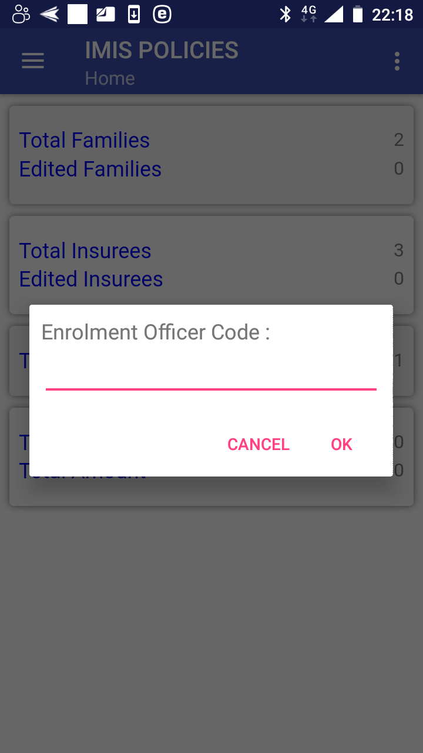

Image 1.1.1 (Initial Page)
Enter a valid enrolment officer code and click on the button OK. If a valid enrolment officer code is entered, the application will re-direct to the Home Page.

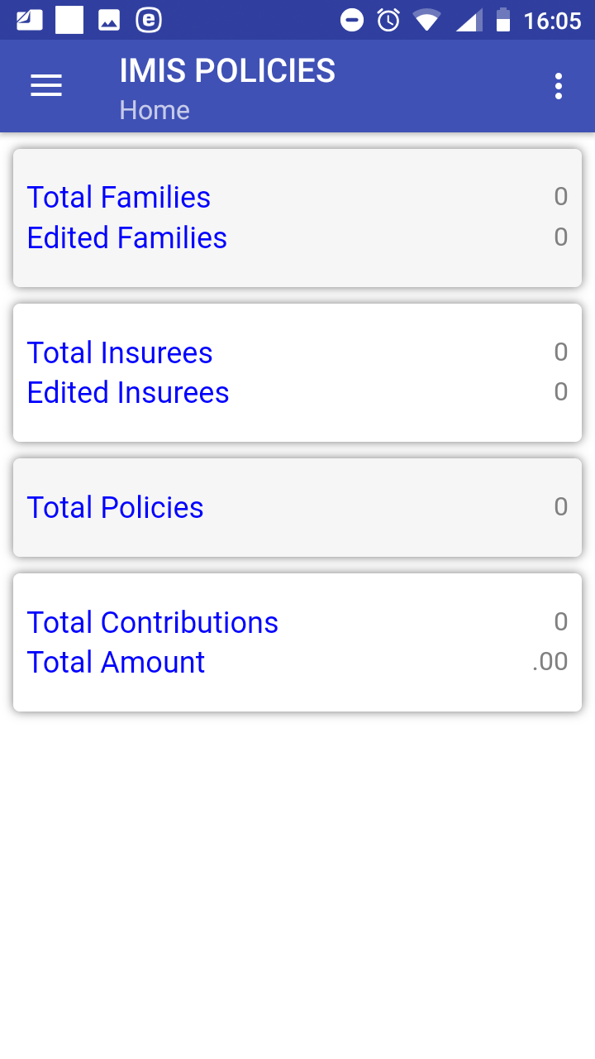

Image 1.1.2 (Home Page)
The statistics on the number of families/insurees/policies/contributions and on the amount of contributions appears that are currently managed by the application before their uploading to the web IMIS. The statistics is split into two sections in the part for families and insurees: the total numbers including both newly entered families/groups and insurees and downloaded (from the web IMIS) families/groups and only families/groups and insurees downloaded for editing.
Clicking on the <three dots vertically> icon in the upper right corner the menu for selection of language of the user interface appears.
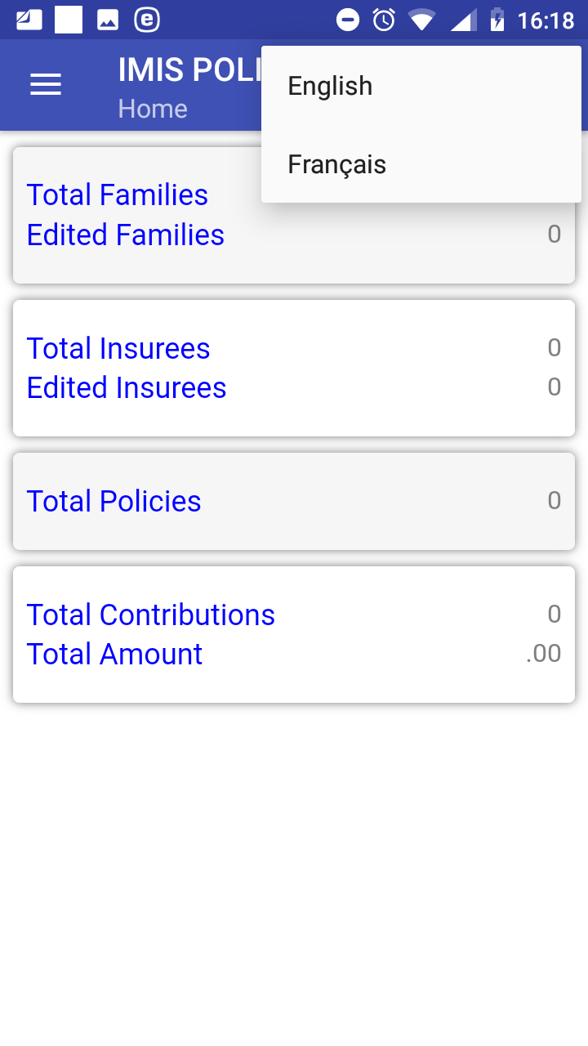

Image 1.1.3 (Menu for selection of a language)
Clicking on the <three bars horizontally> icon (the upper left corner of the Home Page) the main menu of the application appears.
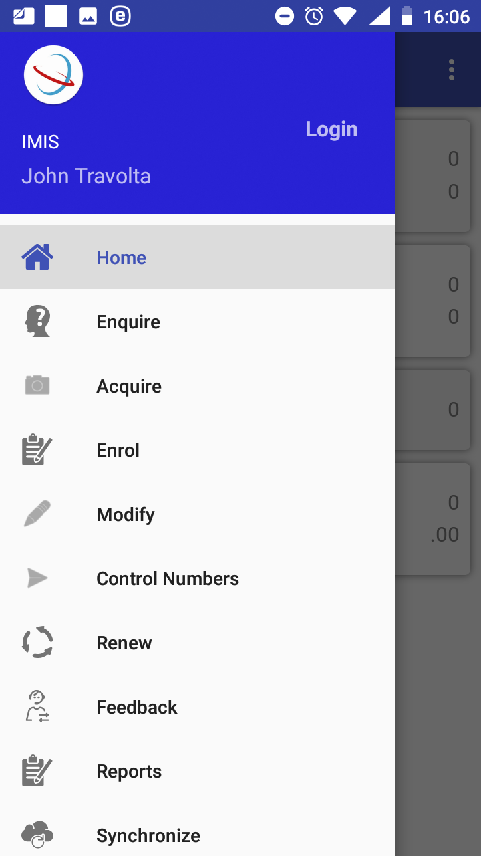

Image 1.1.4 (Main menu of the application)
The menu items stand for the following functionalities:
Home – return to the Home Page
Enquire – getting a photo and information on the coverage of an insuree
Acquire – taking a photo of an insure
Enrol – entering or editing data on families/insurees and entering data on new policies and contributions
Modify – downloading data of families/insurees from the web IMIS
Control Numbers – acquiring of control numbers for electronic payments of contributions
Renew – renewing of policies
Feedback –providing a feedback on provided health care
Reports – providing reports relevant to activities of an enrolment officer
Synchronize – uploading data to the web IMIS
Quit –quitting of the application
About – info on the version of the installed application

Function Enquire
The function Enquire is navigated to by clicking on the menu item Enquire in the main menu. The function Enquire provides a photo and information of insurance coverage of a specified insuree. A user must have a valid User Name and Password provided by an administrator of the web IMIS with an assigned role incorporating an access to the functionality Insurees and Familiies/Insurees/Enquire as the access to the functionality Enquire is guarded by the Login Page .

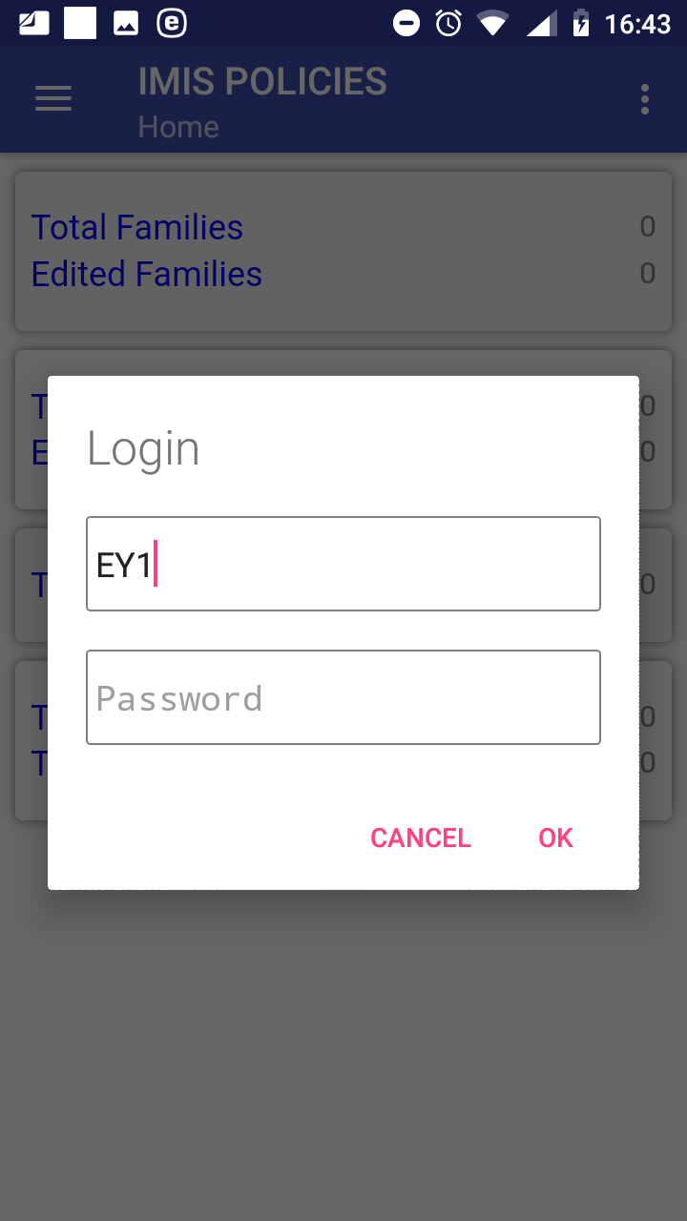

Image 1.2.1 (Enquire function –Login Page)
The User Name data field is pre-filled by the enrolment officer code with which the installation has been launched. However, the User Name data field can re-written by any valid User Name. This principle is valid all other login pages of the IMIS Policies application. If the application successfully logs in the Enquire Page appears with the following data field:
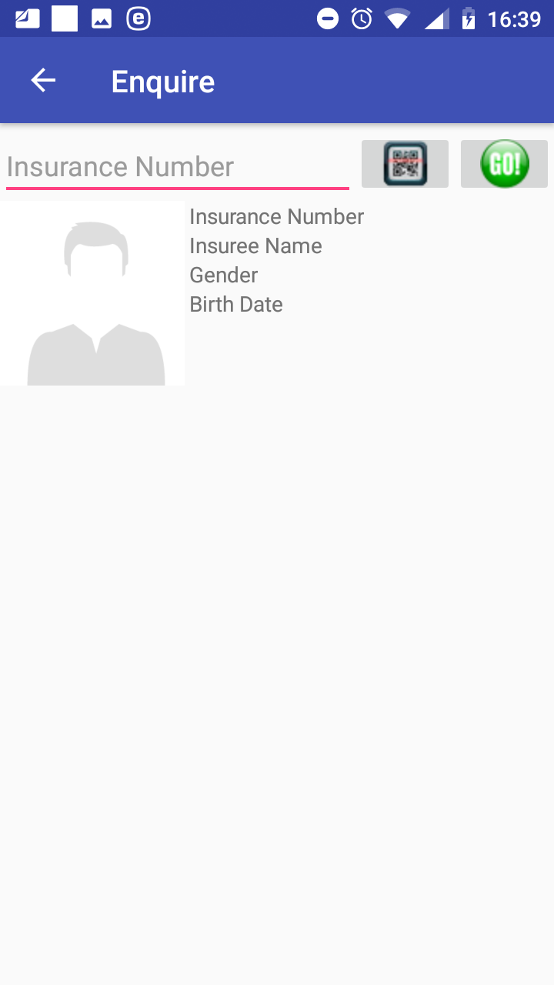

Image 1.2.2 (Enquire Page)

- Insurance Number
Either type in the insurance number of an insuree for whom identification and coverage data are to be retrieved or obtain the insurance number by scanning of a QR code by clicking on the QR button.
Click on the button GO! for retrieving the identification and coverage data.
If the insuree with the insurance number has been already entered in the web IMIS the following data appear (Image 1.2.3) :
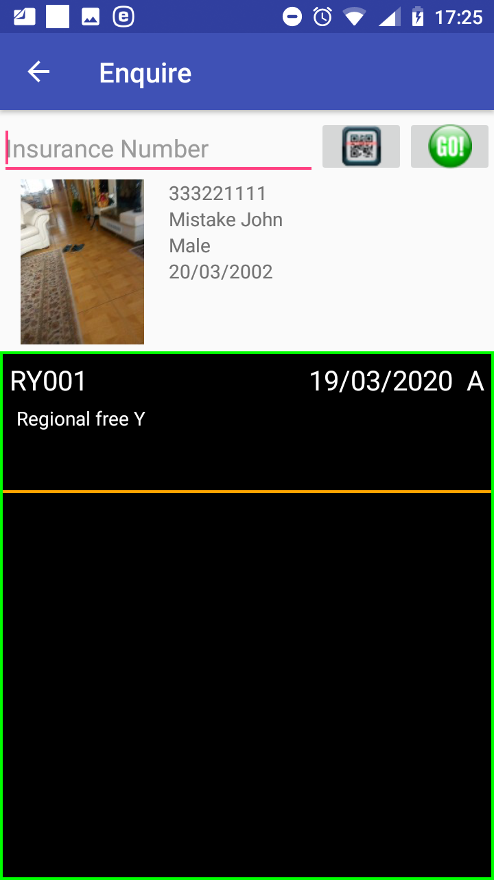

Image 1.2.3 (Enquiry Page-provided data on an insuree)
  - Photo of the insuree provided the photo has been stored in the web IMIS
  - Insurance Number
  - Insuree Name
  - Gender
  - Birth Date

For each policy by which the insuree is covered the following data are shown:
  - Insurance Product Code
  - Insurance Product Name
  - Expiry Date of the Policy
  - Status of the Policy
Click on the icon <- in the upper part of the Enquire Page to return to the Home Page.

Function Acquire
The function Acquire is navigated to by clicking on the menu item Acquire in the main menu. The function Acquire allows to take a photo of an insuree and to save the photo for subsequent assignment to the data on the insuree. The Acquire Page appears immediately:

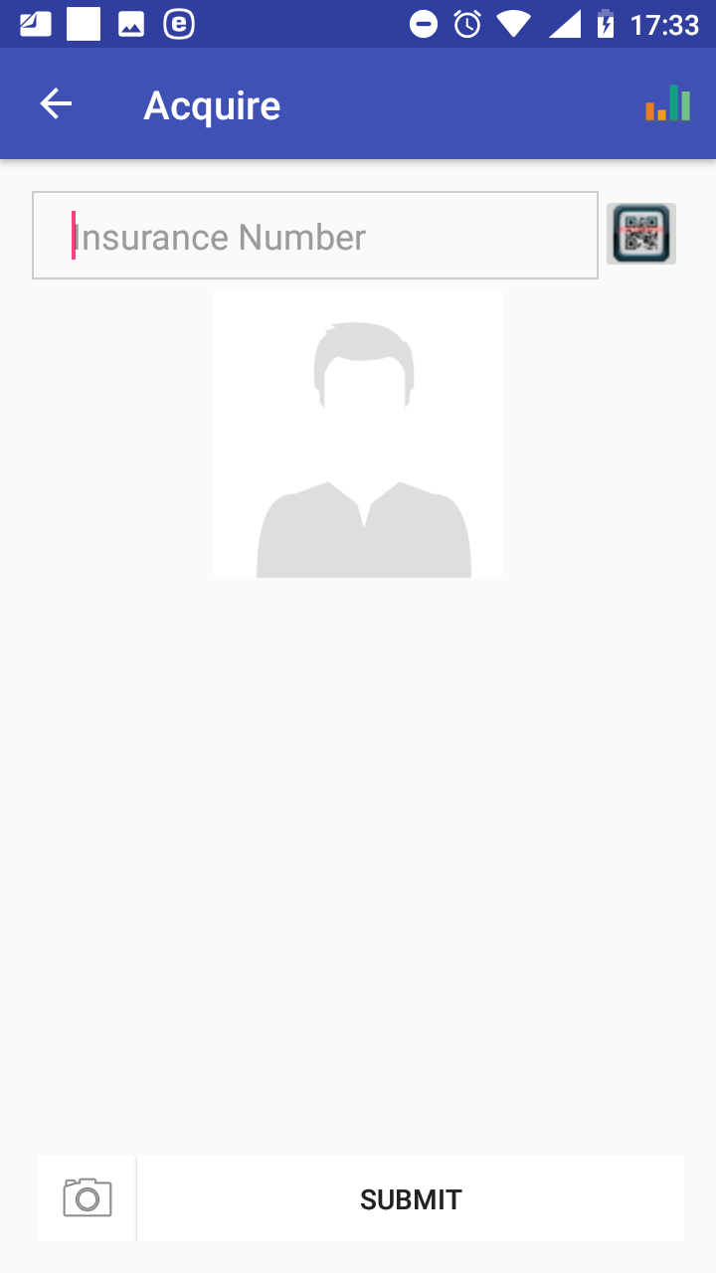

Image 1.3.1 (Acquire Page)
- Insurance Number
Either type in the insurance number of the insuree for whom a photo should be taken or obtain the insurance number by scanning of a QR code by clicking on the QR button.
Click on the icon Photo for taking a photo in left bottom corner of the page. The Photo Page appears.

Image 1.3.2 (Photo Page)
Subsequently click on the button Photo for taking and the icon Check for accepting of the taken photo. Finally click on button Submit on to the Acquire Page save the acquired photo for further processing in the application.
Click on the icon <- in the upper part of the Acquire Page to return to the Home Page.

Function Enrol
The function Enrol is navigated to by clicking on the menu item Enrol in the main menu. The function Enrol allows to enter data on new families/insurees/policies/contributions and/or modify data on families/insurees downloaded from the web IMIS. The Families Page appears immediately:

Image 1.4.1 (Families Page)
To add a new family click on the icon +. The Add new family Page appears.
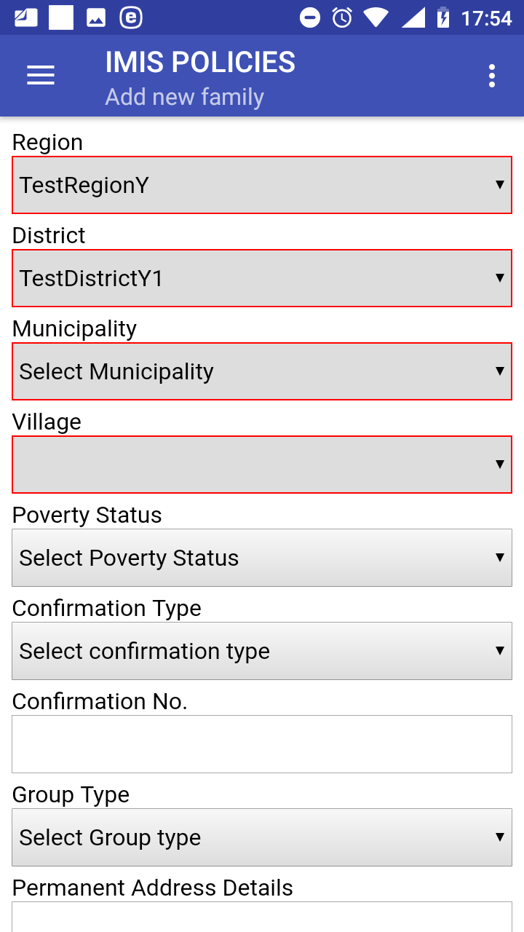

Image 1.4.2 (Add new family Page)
The following data fields appear:
- Region
The region of residence of a new family/group. The data field is initialized by the region of activity of the enrolment officer in accordance with the register of enrolment officers in the web IMIS. Mandatory.
- District
The district of the residence of the new family/group. The data field is initialized by the district of activity of the enrolment officer in accordance with the register of enrolment officers in the web IMIS. Mandatory.
- Municipality
The municipality of the residence of the new family/group. The data field is initialized by the municipality of activity of the enrolment officer in accordance with the register of enrolment officers in the web IMIS. If the enrolment officer is active in more municipalities of the district then the drop down list associated with the data field is modified accordingly. Mandatory.
- Village
The village of residence of the new family/group. The data field is initialized by the village of activity of the enrolment officer in accordance with the register of enrolment officers in the web IMIS. If the enrolment officer is active in more villages of the municipality then the drop down list associated with the data field is modified accordingly. Mandatory.
- Poverty Status
Select one of the offered options from the drop down list associated with the data field. Optional.
- Confirmation Type
Select one of the offered options for the type of confirmation document from the drop down list associated with the data field. Optional.
- Confirmation No.
Enter an identification of a confirmation document. Optional.
- Group Type.
Select one of the offered options for the type of the group from the drop down list associated with the data field. Optional.
- Permanent Address Details.
Enter further details to the address of residence of the family/group. Optional.
Click on the button Next to navigate to the Add/Edit Insuree Page.

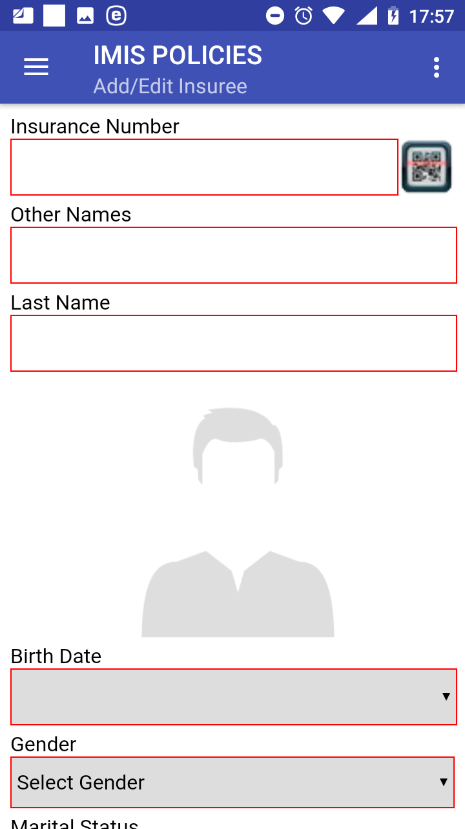

Image 1.4.3 (Add/Edit Insuree Page)
The following data fields appear:
- Insurance Number
Either enter the insurance number of the head of the family/group or obtain the insurance number by scanning of a QR code by clicking on the QR button. Mandatory.
- Other Names
Enter other names of the head of the family/group. Mandatory.
- Last Name
Enter a last name of the head of the family/group. Mandatory.
- Photo area
Either previously acquired photo of the head of the family/group is inserted automatically based on the equality of the Insurance Number here and of the Insurance Number from the Acquire Page or tap in the photo area and choose a photo from your folder in the device. A photo must be assigned otherwise the family/group cannot be uploaded to the web IMIS. Mandatory.
- Birth Date
Tap on the data field and select a birth date of the head of the family/group in the date selector. Mandatory.
- Gender
Select the gender of the head of the family/group from the drop down list. Mandatory.
- Marital Status
Select the marital status of the head of the family/group from the drop down list. Optional.
- Beneficiary Card
Select from the drop down list whether a beneficiary card was given to the head of the family/group. Optional.
- Current Region
Region of a current residence of the head of the family/group if it differs from the permanent residence. Optional.
- Current District
District of a current residence of the head of the family/group if it differs from the permanent residence. Optional.
- Current Municipality
Municipality of a current residence of the head of the family/group if it differs from the permanent residence. Optional.
- Current Village
Village of a current residence of the head of the family/group if it differs from the permanent residence. Optional.
- Current Address Details
Address details of a current residence of the head of the family/group if it differs from the permanent residence. Optional.
- Profession
Select one of the offered options for profession of the head of the family/group. Optional.
- Education
Select one of the offered options for education of the head of the family/group. Optional.
- Phone Number
Enter a phone number of the head of the family/group. Optional.
- Email
Enter an email of the head of the family/group. Optional.
- Identification Type
Select one of the offered options for the type of an identity document of the head of the family/group. Optional.
- Identification Number
Enter an identification of identity document of the head of the family/group. Optional.
- Region of FSP
Region of a First Service Point of the head of the family/group. Optional.
- District of FSP
District of the First Service Point of the head of the family/group. Optional.
- Level of FSP
Select the level of a health facility that serves as the First Service Point of the head of the family/group. Optional.
- First Service Point
Select the health facility that serves as the First Service Point of the head of the family/group. Optional.
Click on the button Save to save the data of the head of the family/group in the memory of the device. The Family and Insurees Page is displayed after a successful saving:
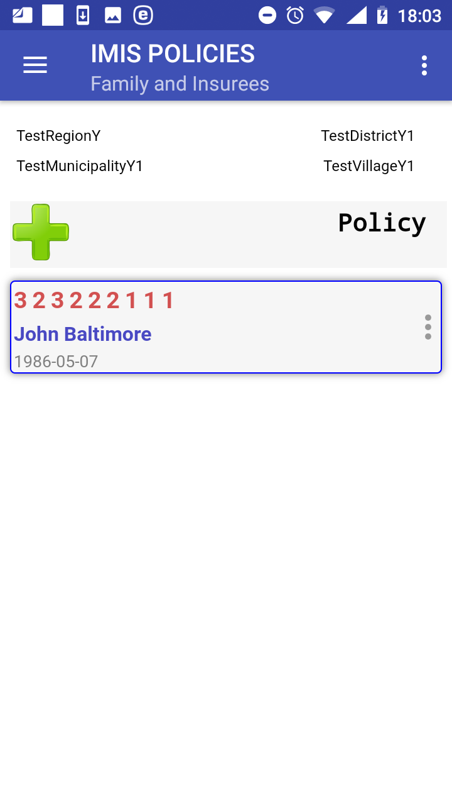

Image 1.4.4 (Family and Insurees Page)
There are four options now:
a) Editing or deleting of the head of family/group.
b) Adding a new family/group
c) Adding a new member to the family/group.
d) Assigning of a new policy to the family/group.

Editing or deleting of a family/group
By clicking on the icon <three vertical dots> with the head of the family/group in the Family and Insurees Page a menu appears with options of editing of the data of the head of the family or of deleting of the head of the family/group.
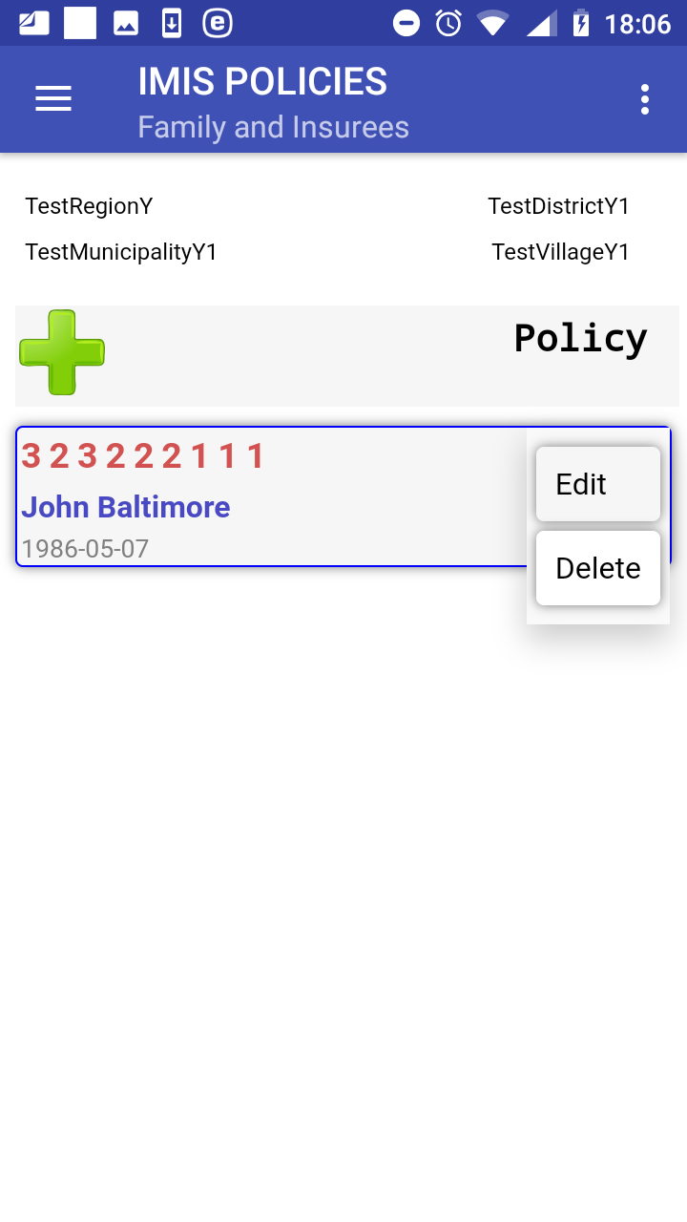

Image 1.4.5 (Family and Insurees Page-the menu associated with the head)
Selecting the item Delete an alert box appears saying that the head of a family/group cannot be deleted in this situation. This possible only in the context of the Families Page where it is considered as deleting of the whole family/group.
Selecting the item Edit the Add/Edit Insuree Page appears with the data of the head of a family/group that should be edited.
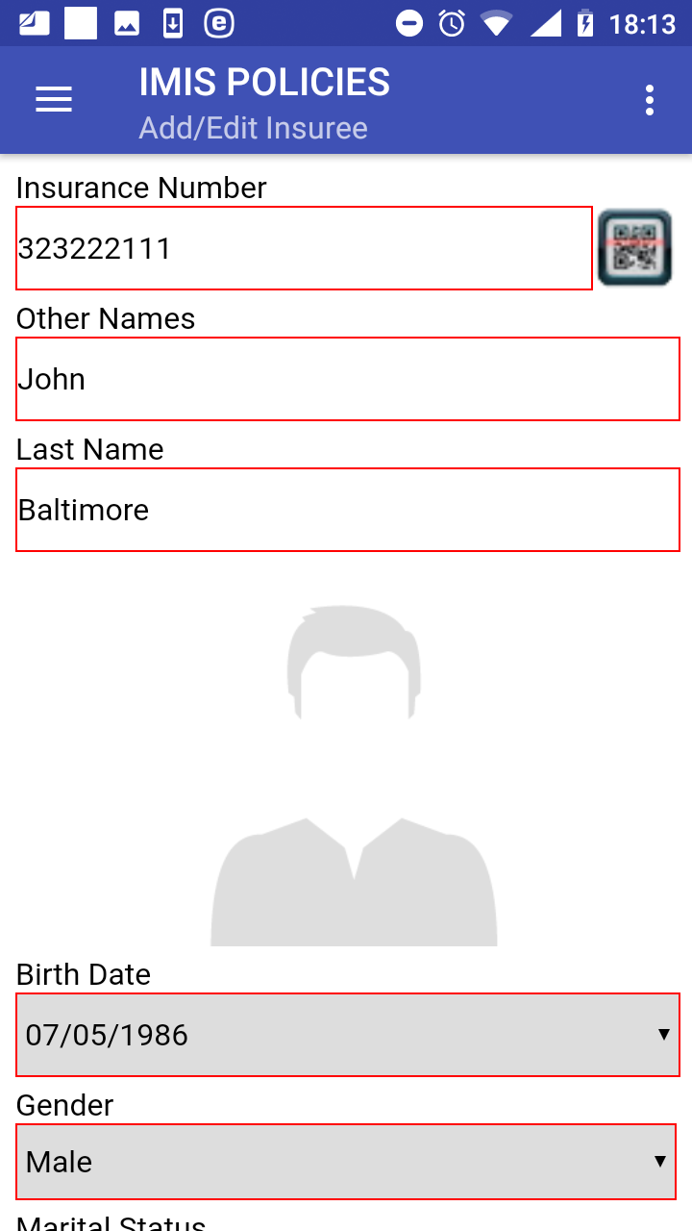

Image 1.4.6 (Add/Edit Insuree Page)
Click on the button Save to save the edited data of the head of the family/group in the memory of the local device. The Family and Insurees Page is displayed after a successful saving.

Adding a new family/group
Clicking on the <three bars horizontally> icon (the upper left corner of the Family and Insurees Page ) the main menu of the application appears. Select Enrol to navigate to the Families Page.

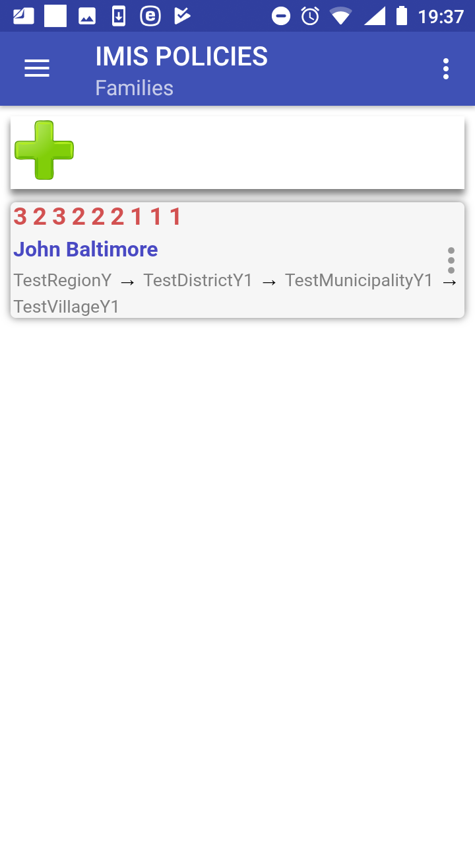

Image 1.4.7 (Families Page)
By clicking on the icon + in the Families Page the Add new family Page appears and a new head of a family/group can be added.

Adding a new member of a family/group
By clicking on the icon + in the Family and Insurees Page the Add/Edit Insuree Page appears and a new member of the family/group can be added.
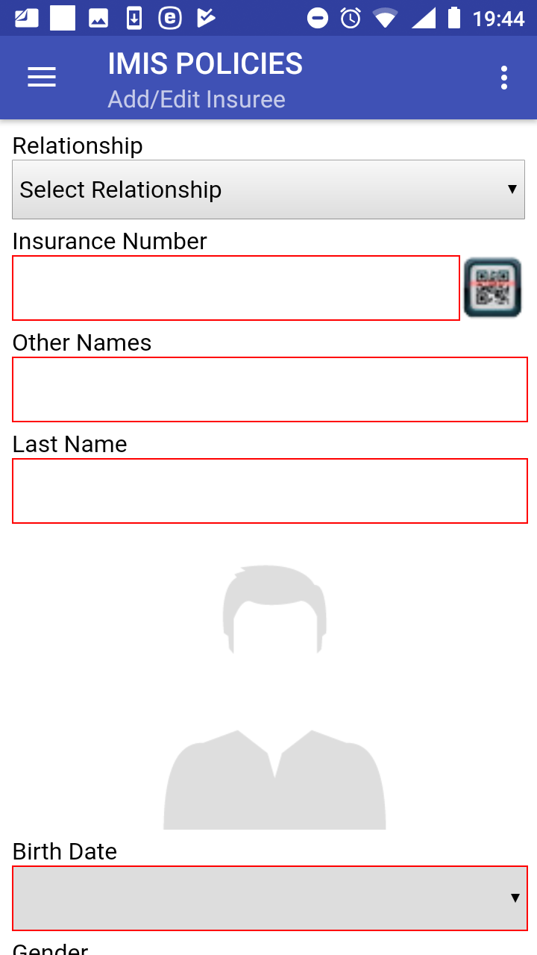

Image 1.4.8 (Add/Edit Insuree Page)
The following data fields appear:
- Relationship
Select one of the offered relationships of the member to the head of the family/group. Mandatory.
- Insurance Number
Either enter the insurance number of the member of the family/group or obtain the insurance number by scanning of a QR code by clicking on the QR button. Mandatory.
- Other Names
Enter other names of the member of the family/group. Mandatory.
- Last Name
Enter the last name of the member of the family/group. Mandatory.
- Photo area
Either previously acquired photo of the member of the family/group is inserted automatically based on the equality of the Insurance Number here and of the Insurance Number from the Acquire Page or tap in the photo area and choose a photo from your folder in the device. A photo must be assigned otherwise the family/group cannot be uploaded to the web IMIS. Mandatory.
- Birth Date
Tap on the data field and select a birth date of the member of the family/group in the date selector. Mandatory.
- Gender
Select a gender of the member of the family/group from the drop down list. Mandatory.
- Marital Status
Select the marital status of the member of the family/group from the drop down list. Optional.
- Beneficiary Card
Select from the drop down list whether a beneficiary card was given to the member of the family/group. Optional.
- Current Region
Region of a current residence of the member of the family/group if it differs from the permanent residence of the member of the family/group. Optional.
- Current District
District of a current residence of the member of the family/group if it differs from the permanent residence of the member of the family/group. Optional.
- Current Municipality
Municipality of a current residence of the member of the family/group if it differs from the permanent residence of the member of the family/group. Optional.
- Current Village
Village of a current residence of the member of the family/group if it differs from the permanent residence of the member of the family/group. Optional.
- Current Address Details
Address details of a current residence of the member of the family/group if it differs from the permanent residence of the member of the family/group. Optional.
- Profession
Select one of the offered options for profession of the member of the family/group. Optional.
- Education
Select one of the offered options for education of the member of the family/group. Optional.
- Phone Number
Enter a phone number of the member of the family/group. Optional.
- Email
Enter an email of the member of the family/group. Optional.
- Identification Type
Select one of the offered options for the type of an identity document of the member of the family/group. Optional.
- Identification Number
Enter an identification of identity document of the member of the family/group. Optional.
- Region of FSP
Region of a First Service Point of the member of the family/group. Optional.
- District of FSP
District of the First Service Point of the member of the family/group. Optional.
- Level of FSP
Select the level of a health facility that serves as the First Service Point of the member of the family/group. Optional.
- First Service Point
Select the health facility that serves as the First Service Point of the member of the family/group. Optional.
Click on the button Save to save the data on the member of the family/group in the memory of the device. The Family and Insurees Page is displayed after a successful saving:
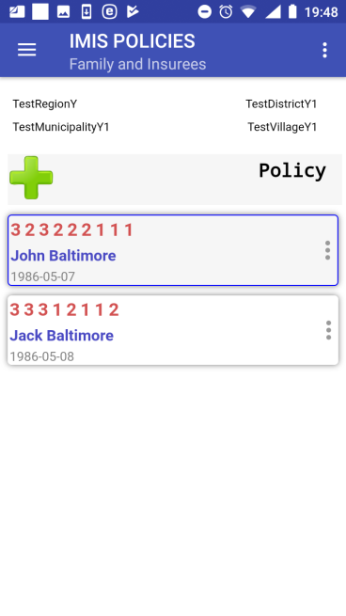

Image 1.4.9 (Family and Insurees Page)

There are three options now:
a) Adding again a new member the family/group (just click on the icon + in the Family and Insurees Page).
b) Editing or deleting of a member (just click on the icon <three vertical dots> with a member in the Family and Insurees Page a menu appears with options of editing of the data of the member or of deleting of a member of the family/group.
c) Assigning a new policy to the family/group.

Assigning of a policy
By clicking on the button Policy the Family and Policies Page appears and a new policy can by assigned to the family/group.

Image 1.4.10 (Family and Policies Page)
Click on the icon + to navigate to the Add/Edit Policies Page:
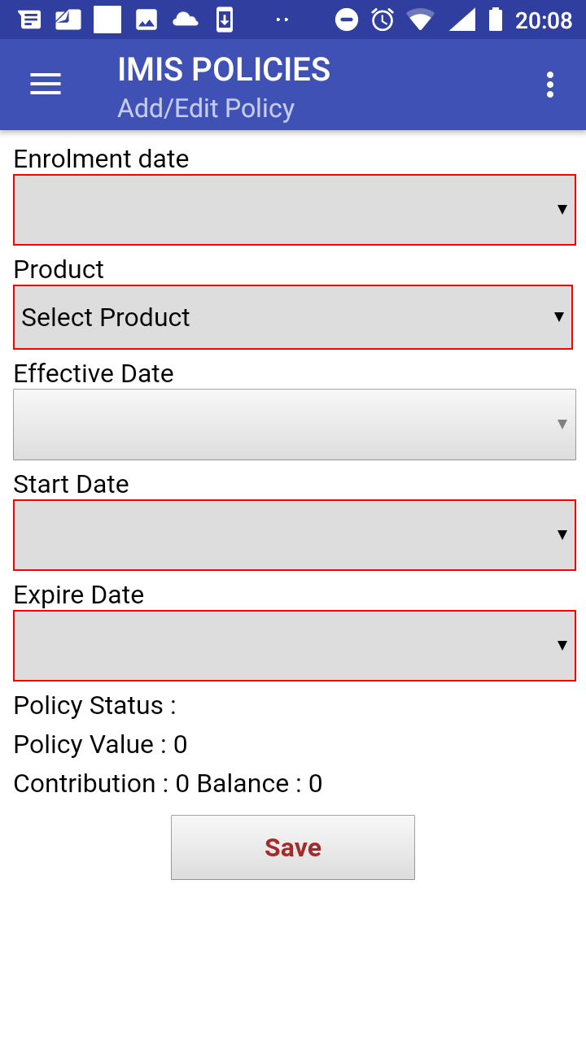

Image 1.4.11 (Add/Edit Policies Page)
The following data fields appear:
- Enrolment Date
Tap on the data field and select an enrolment date for the policy in the date selector. Mandatory.
- Product
Select one of the offered insurance products for the policy. Mandatory.
- Effective date
Read-only calculated data field. Contains the date of effective starting of the policy taking into account all features of the selected insurance products and the date of payment of a contribution.
- Start Date
Assumed starting date of the policy without taking into account the date of payment of the contribution. Calculated data field based on the enrolment date and the selected insurance product that can be modified. Mandatory.
- Expiry Date
Assumed expiry date of the policy without taking into account the date of payment of the contribution. Calculated data field based on the starting date and the selected insurance product that can be modified. Mandatory.
- Policy Status
Read-only data field. Assigned policy status on the device. Actual policy status can change in the web IMIS after uploading.
- Policy Value
Read-only data field. Calculated policy value that should be covered by contributions.
- Contribution
Read-only data field. Calculated value of already assigned contributions.
- Balance
Read-only data field. Calculated value of the balance Policy Value - Contribution
Click on the button Save to save the data on the policy in the memory of the device. The Family and Policies Page is displayed after a successful saving.
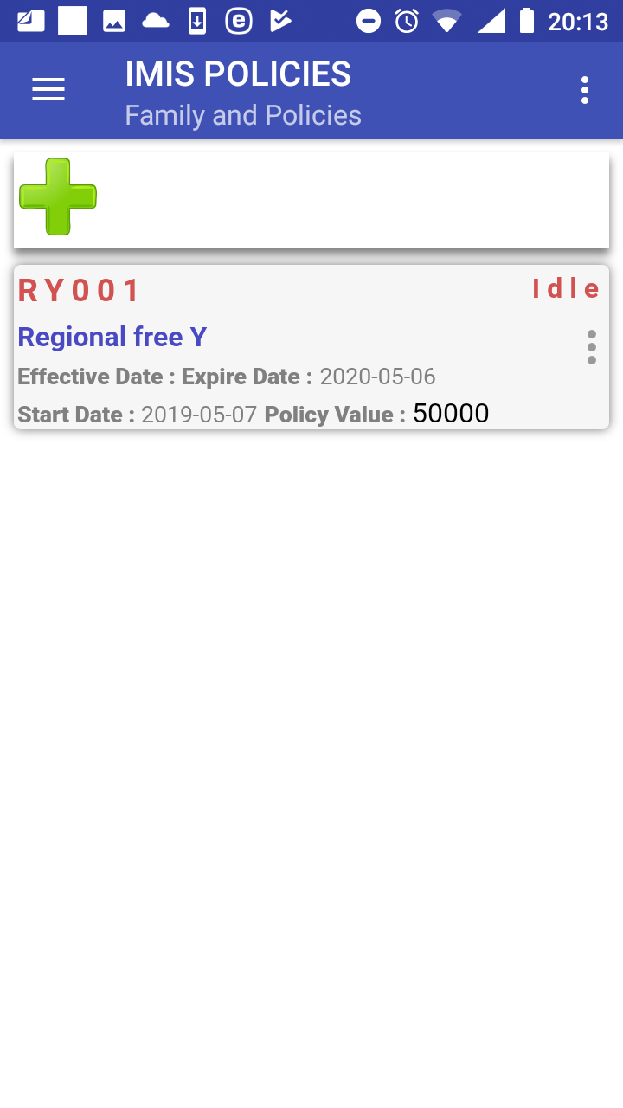

Image 1.4.12 (Family and Policies Page)
There are three options now:
a) Assigning a new policy to the family/group (just by clicking on the icon + in the Family and Policies Page the Add/Edit Policy Page appears and the new policy can be assigned).
b) Editing or deleting of the policy.
c) Assigning a new contribution to the policy.

Editing or deleting of a policy
By clicking on the icon <three vertical dots> with the policy in the Family and Policies Page a menu appears with options of editing of the data of the policy or of deleting of the policy.
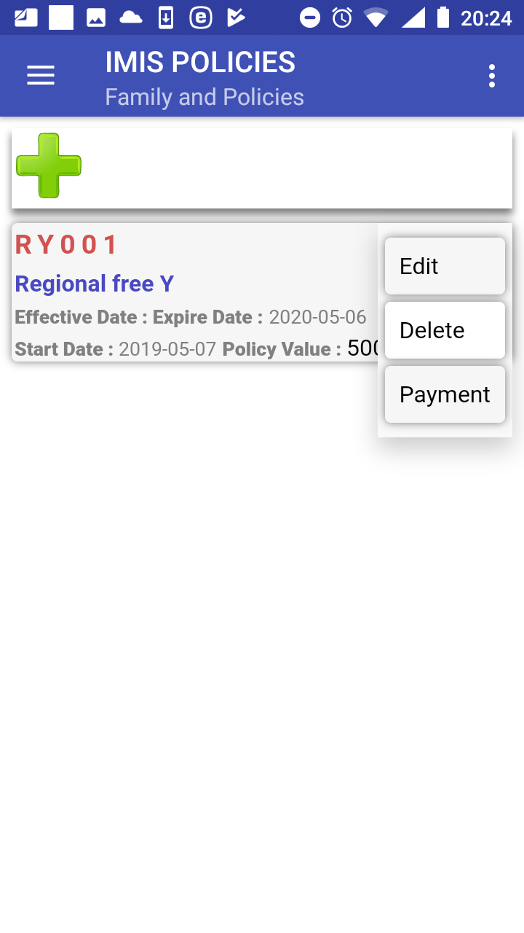

Image 1.4.13 (Families and Policies Page-the menu associated with the policy)
By selecting Edit the Add/Edit Policy Page appears and the data of the policy can be edited. By selecting Delete the Confirmation Box appears that asks for a confirmation of the deleting. Deleting a policy means also deleting of all contributions associated with the policy.
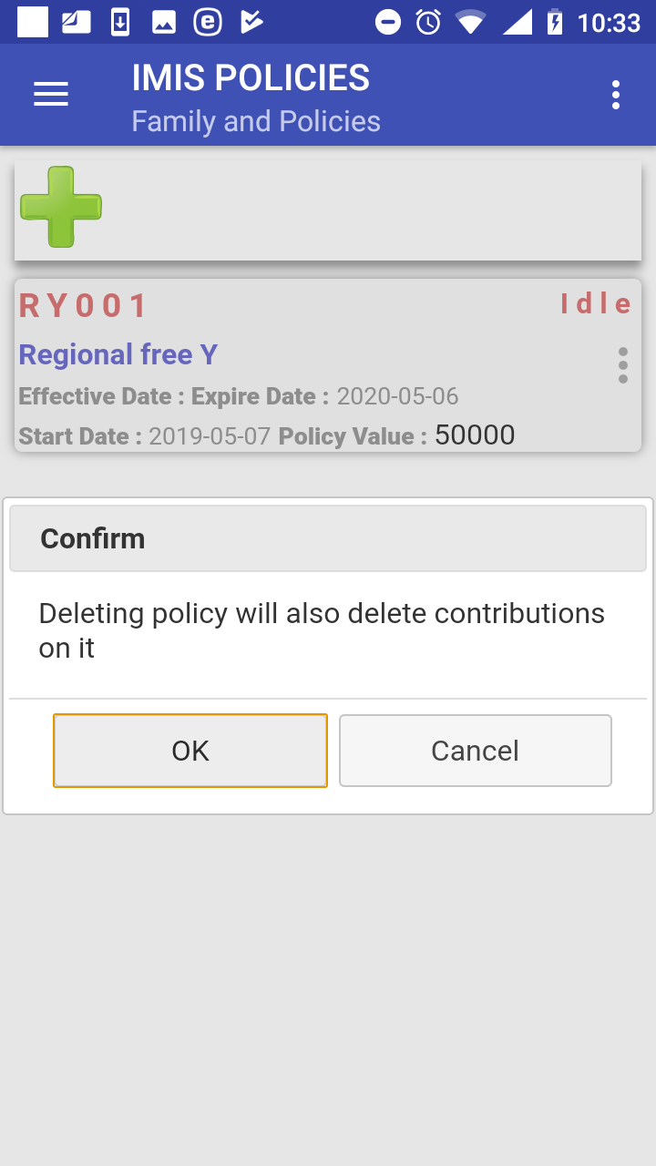

Image 1.4.14 (Families and Policies Page-confirmation of deleting)
The Family and Policies Page is displayed after a successful deleting.

Assigning of a new contribution to the policy
By clicking on the icon <three vertical dots> with the policy in the Family and Policies Page a menu appears with options of editing of the data of the policy, of deleting of the policy and assigning a contribution (Payment). Select Payment. The Contribution Page appears:

Image 1.4.15 (Contribution Page)
Click on the + icon to add a new contribution. The Add/Edit Contribution Page appears with the following data fields:
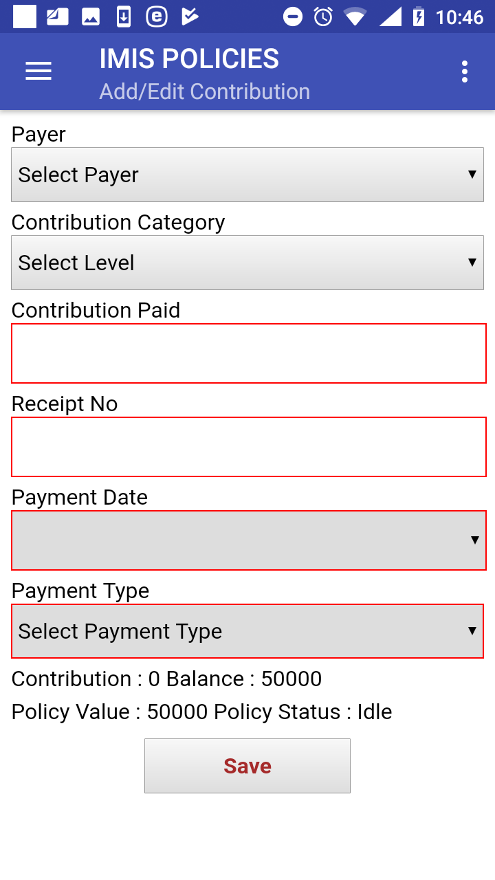

Image 1.4.16 (Add/Edit Contribution Page)
- Payer
Either leave it blank or select one of the offered payers of the contribution. Optional.
- Contribution Category
Select one of the offered categories for the contribution. Mandatory.
- Contribution Paid
The amount of the contribution. If the Contribution and Others is selected in the data field Contribution Category then the data field Contribution Paid is prefilled by the amount still to be paid to reach the policy value. Mandatory.
- Receipt No
An identification of the receipt issued for the paid contribution. Mandatory.
- Payment Date
Tap on the data field and select a payment date of the contribution in the date selector. Mandatory.
- Payment Type
Select one of the offered types of payment of the contribution. Mandatory.
- Policy Status
Read-only data field. Assigned policy status in the device. Actual policy status can change in the web IMIS after uploading.
- Policy Value
Read-only data field. Calculated policy value that should be covered by contributions.
- Contribution
Read-only data field. Calculated value of already assigned contributions.
- Balance
Read-only data field. Calculated value of the balance Policy Value – Contribution
Click on the button Save to save the data on the contribution in the memory of the device. The Contribution Page is displayed after a successful saving:
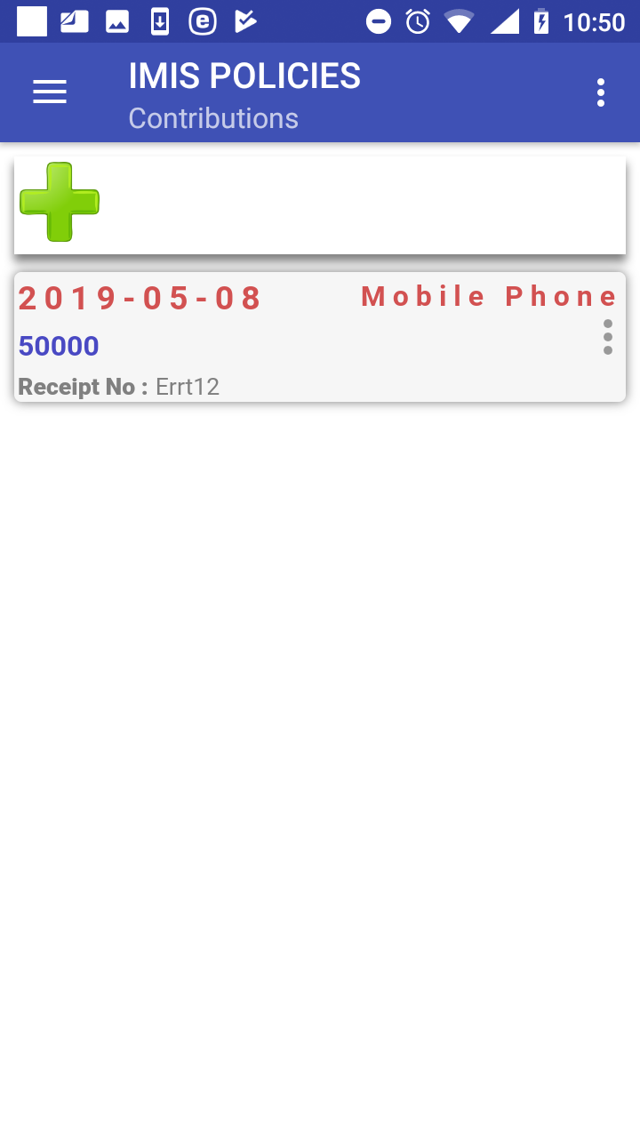

Image 1.4.17 (Contribution Page)
There are three options now:
a) Assigning a new contribution to the same policy (just by clicking on the icon + the Add/Edit Contribution Page appears and a new contribution can be added)
b) Editing or deleting of the contribution.
c) Adding of a new family or editing existing ones.

Editing or deleting of the contribution
By clicking on the icon <three vertical dots> with the contribution in the Contribution Page a menu appears with options of editing of the data of the contribution and of deleting of the contribution.
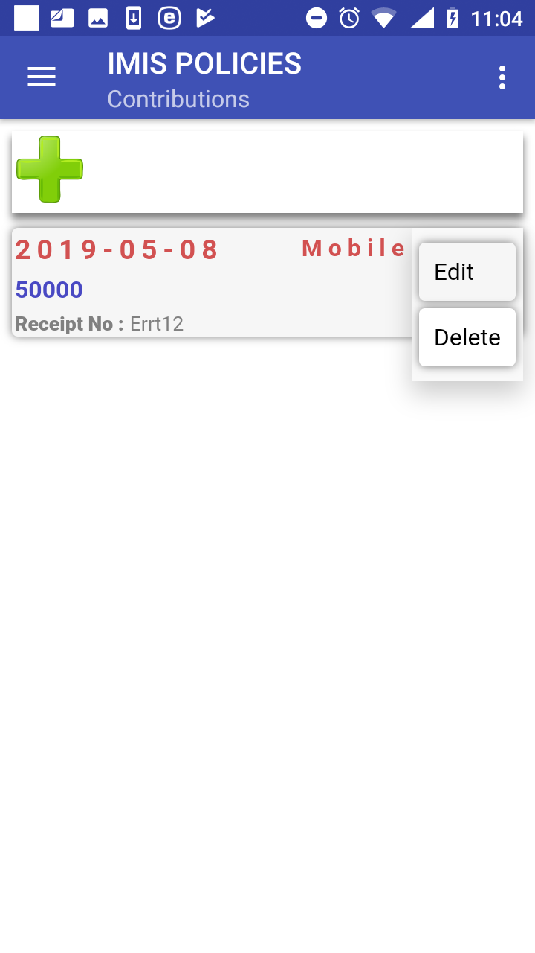

Image 1.4.18 (Contribution Page-the menu associated with the contribution)
By selecting Edit the Add/Edit Contribution Page appears and the data of the contribution can be edited. By selecting Delete the contribution is deleted without a confirmation prompt.

Function Modify
The function Modify is navigated to by clicking on the menu item Modify in the main menu. The function Modify allows to download data on families/insurees from the web IMIS for their further editing or using for association with policies. A user must have a valid User Name and Password provided by an administrator of the web IMIS with an assigned role incorporating an access to the functionality Insurees and Families/Family +Insurees/Edit as an access to the functionality Modify is guarded by the Login Page
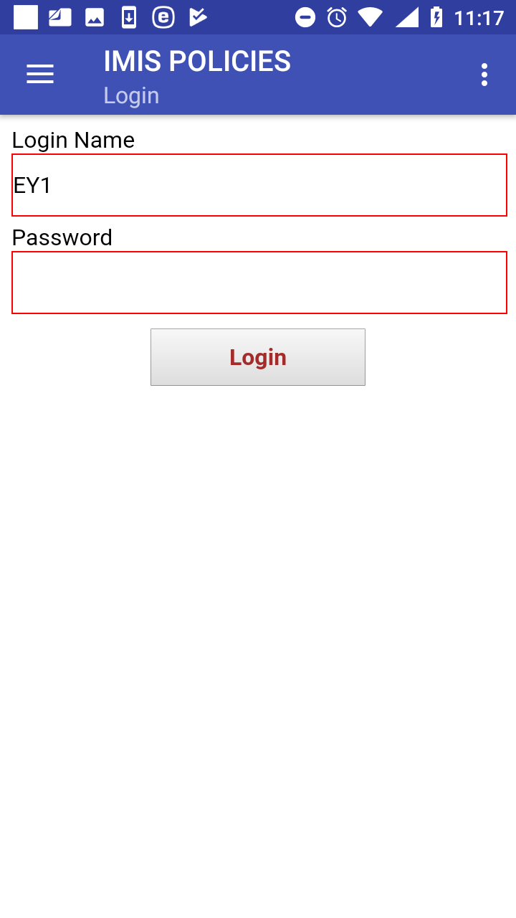

Image 1.5.1 (Modify function-Login Page)
If login is successful the Search Page appears:
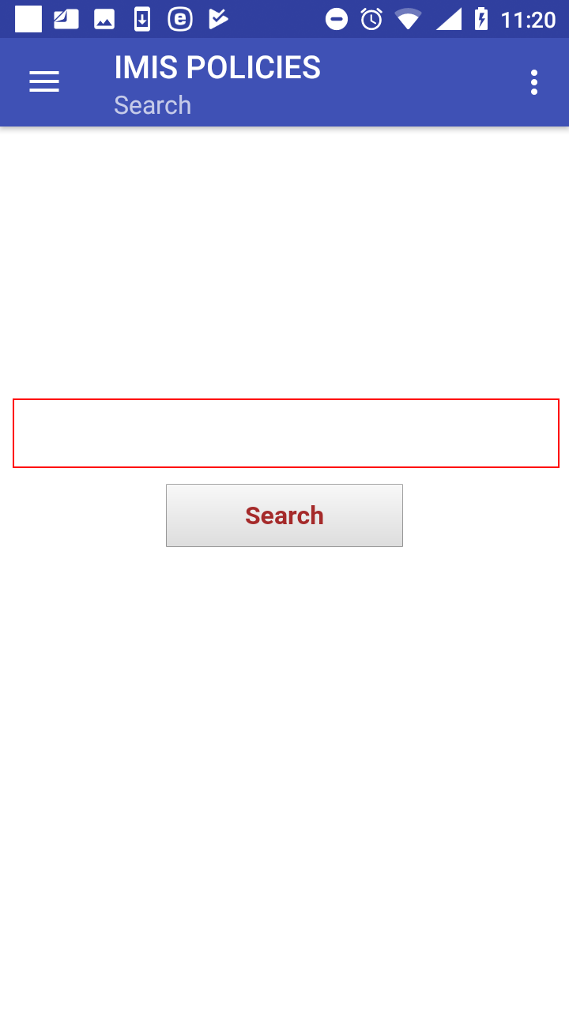

Image 1.5.2 (Search Page)
Enter the insurance number of any member of a family/group having a residence in the district where the enrolment officer is acting and click on the button Search. If the family/group with a member having the entered insurance number is found in the web IMIS, the Family Page appears with the retrieved family.
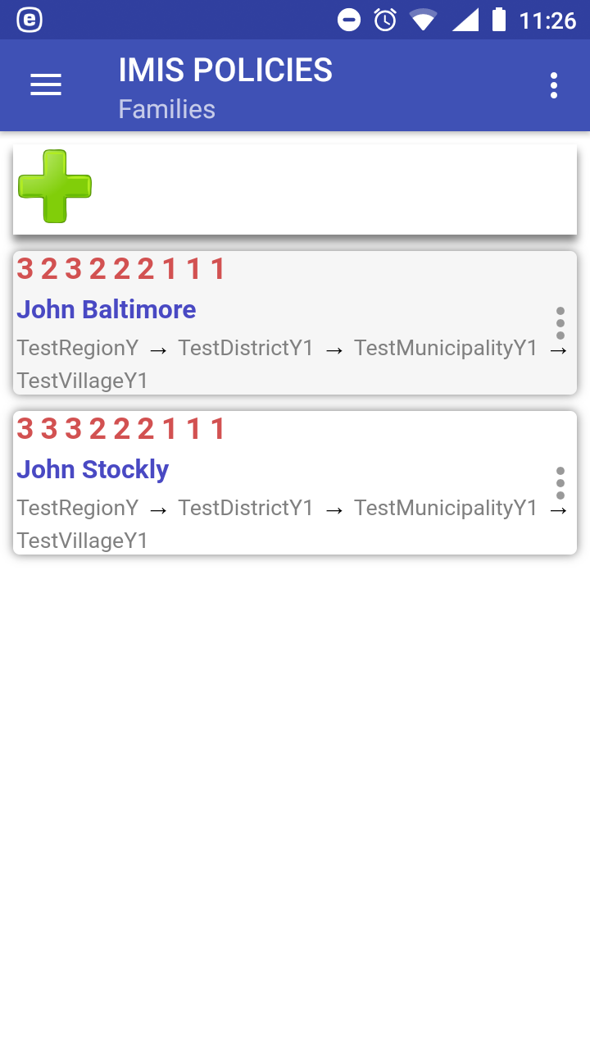

Image 1.5.3 (Family Page with the retrieved family)
From now on, any operations like editing of members and deleting members of the family/group, associating new policies and contributions can be accomplished in the same way as for newly entered families as described with the function Enrol.

Function Control Numbers
The function Control Numbers is navigated to by clicking on the menu item Control Numbers in the main menu. The function Control Number allows sending requests for assigning of control numbers for intended payments of contributions and getting assigned control numbers. A user must have a valid User Name and Password provided by an administrator of the web IMIS with an assigned role incorporating an access to the functionality Insurees and Families/Payment/Add as an access to the functionality Control Numbers is guarded by the by the Login Page.
The Overviews Page appears after selecting Control Numbers in the main menu:

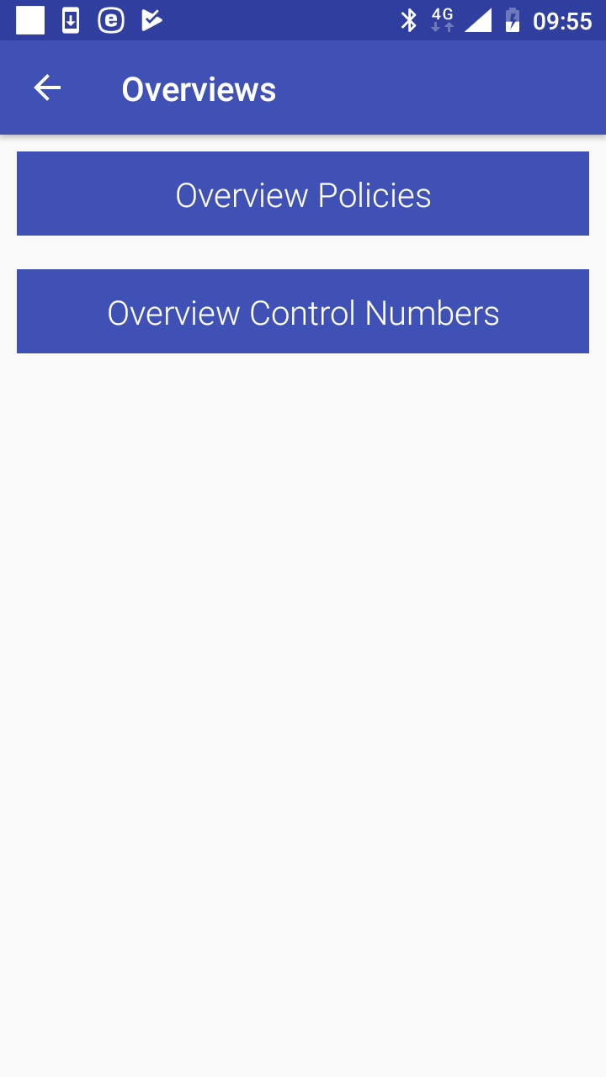

Image 1.6.1 (Overviews Page)
Click on the button Overview Policies to move to the Search Policies Page with search criteria for policies in the memory of the device:
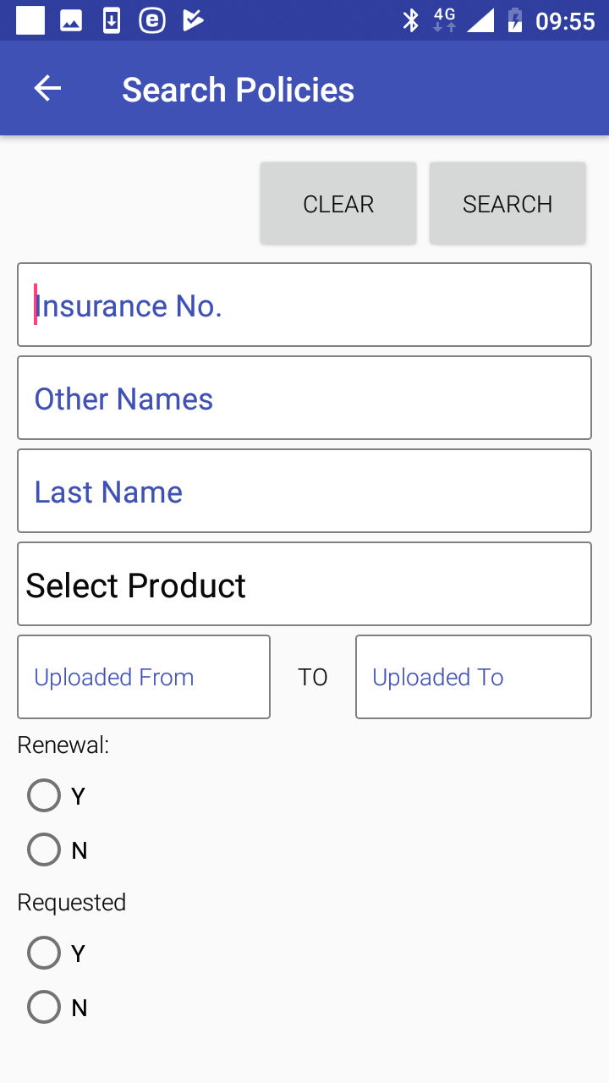

Image 1.6.2 (Search Policies Page)
The application keeps track of all policies that were created within the application and/or uploaded unless the track of a policy is explicitly deleted by a user (see below). This feature allows to send requests for assigning control numbers for one or several policies simultaneously to the web IMIS before or after the policies are uploaded (after uploading is a preferred option).
The following search criteria are at disposal:
- Insurance No.
Enter an insurance number (or a subset of) of the head of family/group holding searched policies.
- Other Names
Enter another name (or a subset of) of the head of family/group holding searched policies.
- Last Names
Enter a last name (or a subset of) of the head of family/group holding searched policies.
- Insurance Product
Select from the list of available insurance products of searched policies.
- Uploaded From
Select from the date selector the lowest date of uploading to the web IMIS of searched policies.
- Uploaded To
Select from the date selector the highest date of uploading to the web IMIS of searched policies.
- Renewal Y/N
Select whether only renewed or only new policies are search for. Optional.
- Requested Y/N
Select whether only policies for which a control number has been requested or only policies for which a control number hasn’t been requested yet. Optional.
Click on the button Clear to clear all search criteria entered.
Click on the button Search to get a list of policies satisfying the search criteria. The Policies Page with the list of policies satisfying the search criteria appears:

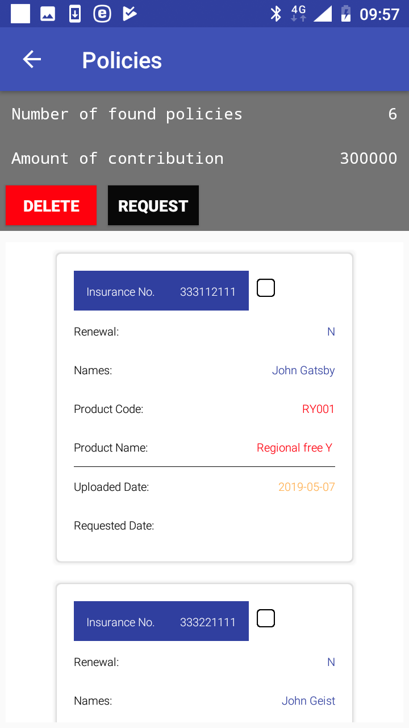

Image 1.6.3 (Policies Page)
The following data are included with each policy:
- Insurance No.
Read-only data field. The insurance number of the head of a family/group holding a policy.
- Renewal
Read-only data field. An indication whether it is a new policy (N) or a renewal (Y).
- Names
Read-only data field. The full name (the other and the full name) of the head of the family/group holding the policy.
- Product Code
Read-only data field. The code of the insurance product of the policy.
- Product Name
Read-only data field. The name of the insurance product of the policy.
- Uploaded Date
Read-only data field. The date of uploading of the policy if it has been uploaded.
- Requested Date
Read-only data field. The date of requesting a control number for the policy if it has been requested.
- Checkbox
Check the box if the policy should be included in a subsequent operation (Delete, Request).
Click on the button Delete if the selected policies should be deleted from the list of policies.
Click on the button Request if assignment of a control number for the selected policies should be performed. The Request Control Number Page appears.
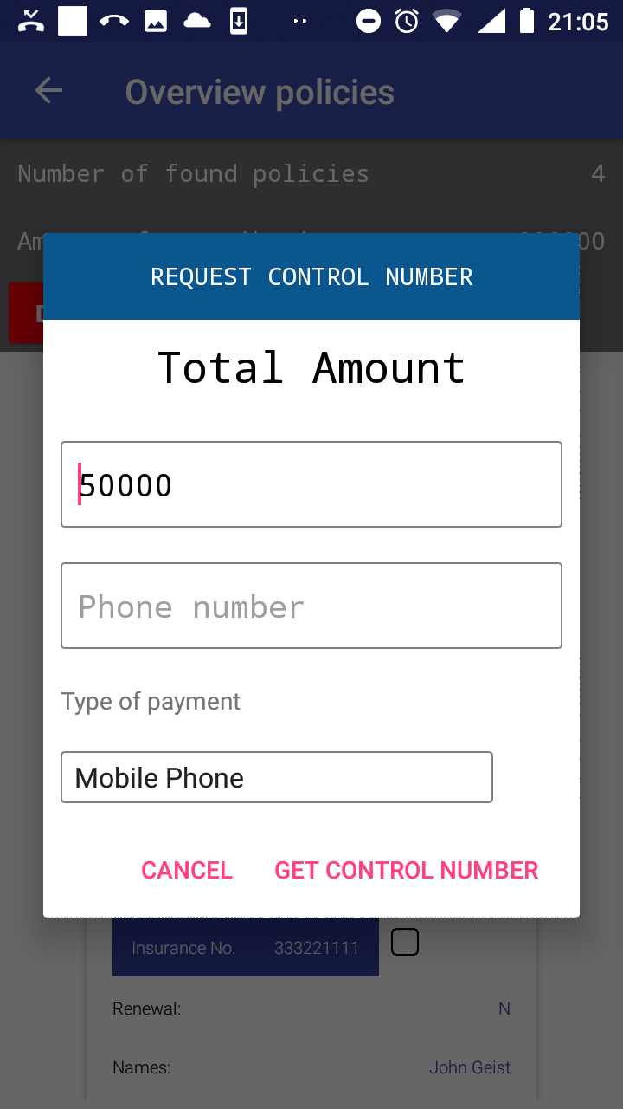

Image 1.6.4 (Request Control Number Page)
The following data items are included:
- Total Amount
The total amount of contributions associated with the selected policies for the request.
- Phone Number
The phone number of the requester/user where a SMS with the assigned control number should be sent.
- Type of Payment
Select one of the two relevant types of payment (Mobile Phone, Bank Transfer).

Click on button Get Control Number. The Login Page appears:

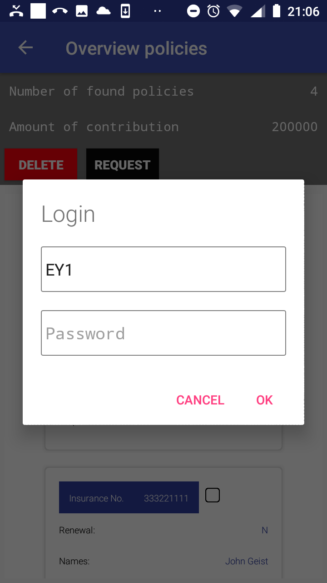

Image 1.6.5 (Request Control Number – Login Page)
If the application successfully logs in the Policies Page appears again.
Click on the icon <- in the upper part of the Policies Page to return to the Search Policies Page.
Click on the button Overview Control Numbers to move to the Search Control Numbers Page with search criteria for assigned control numbers:
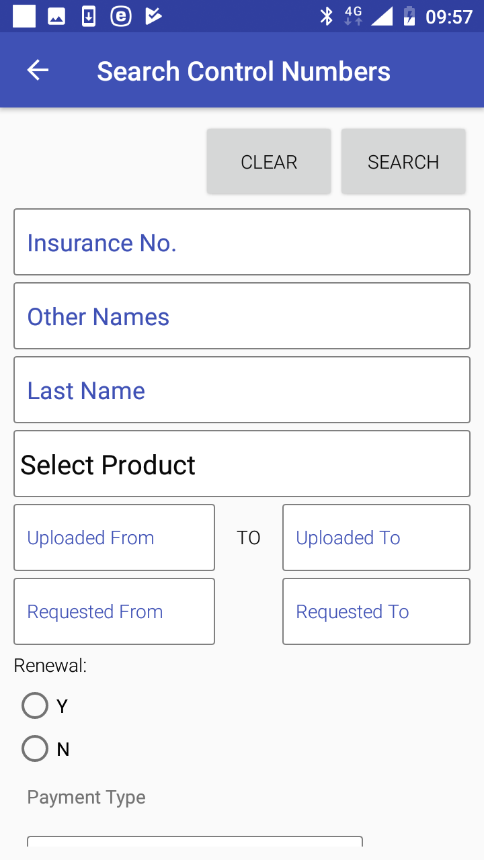

Image 1.6.4 (Search Control Numbers Page)
Searching is done based on policies to which control numbers are assigned. The following search criteria are at disposal:
- Insurance No.
Enter an insurance number (or a subset of) of the head of family/group holding searched policies.
- Other Names
Enter another name (or a subset of) of the head of family/group holding searched policies.
- Last Names
Enter a last name (or a subset of) of the head of family/group holding searched policies.
- Insurance Product
Select from the list of available insurance products of policies of which control numbers are searched for.
- Uploaded From
Select from the date selector the lowest date of uploading to the web IMIS of searched policies.
- Uploaded To
Select from the date selector the highest date of uploading to the web IMIS of searched policies.
- Renewal Y/N
Select whether only renewed or only new policies are search for. Optional.
- Payment Type
Select one of possible type of payment (Bank Transfer, Mobile Phone). Optional.

Click on the button Clear to clear all search criteria entered.
Click on the button Search to get a list of policies satisfying the search criteria and assigned control numbers. The Control Numbers Page with the list of policies satisfying the search criteria and assigned control numbers appears:

Image 1.6.5 (Control Numbers Page)
Click on the icon <- in the upper part of the Control Numbers Page to return to the Search Control Numbers Page .

Function Renew
The function Renew is navigated to by clicking on the menu item Renew in the main menu. The function Renew allows getting of prompts for renewing of policies from the web IMIS and posting of renewals for selected policies. A user must have a valid User Name and Password provided by an administrator of the web IMIS with an assigned role incorporating an access to the functionality Insurees and Familiies/Policy/Renew as an access to the functionality Renew is guarded by the Login Page.
The Renewals Page with the generic prompt (Unlisted Renewal Policies) appears after selecting Renew in the main menu. The generic prompt allows to the user to renew any policy, not only policies offered by prompts transferred from the web IMIS.
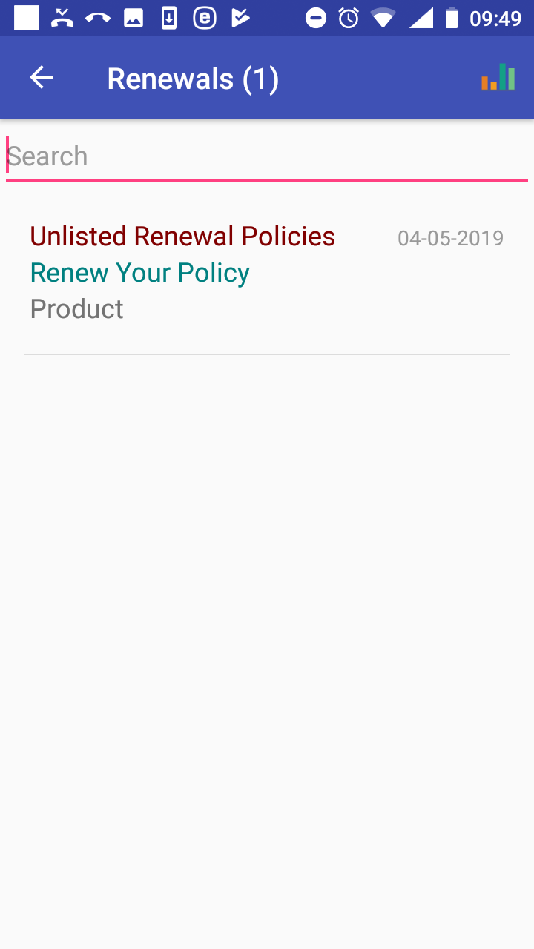

Image 1.7.1 (Renewals Page)
Swapping around the Renewals Page leads to the Login Page and after a successful login shows renewal prompts transferred from the web IMIS.
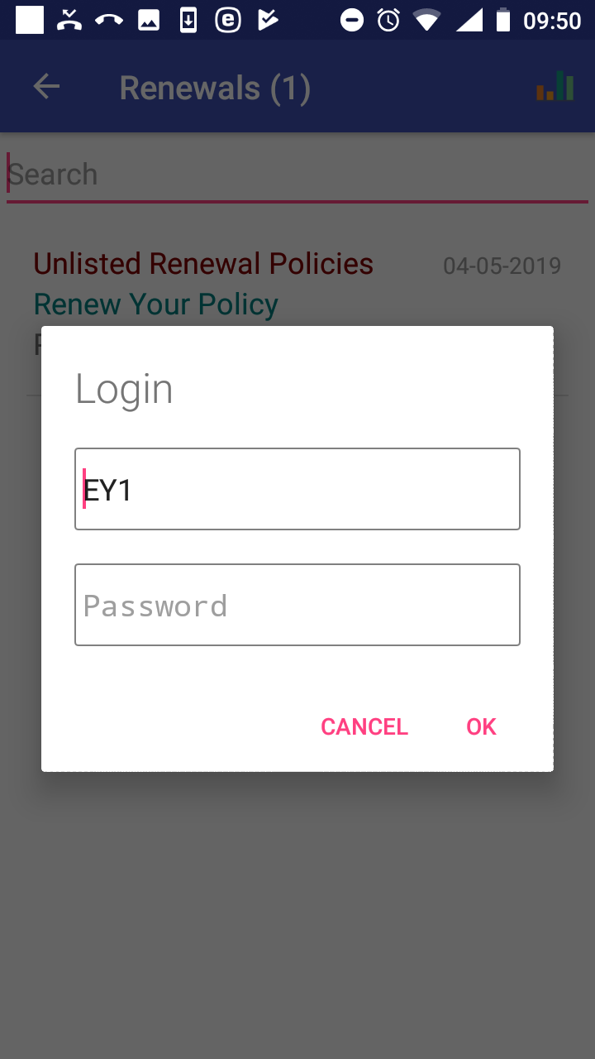

Image 1.7.2 (Renewals Page-Login Page)
The following rules apply for selecting of policies for which renewal prompts are displayed:
- A policy is maintained by the enrolment officer with the enrolment officer code entered while launching the application.
- The expiry date of a policy is in the past or within the fortnight from the current day
- There is no policy for the same family/group and for the same insurance product active after the expiry date of the policy to be prompted.
The Renewal Page with prompts appears after the swap and the successful login.
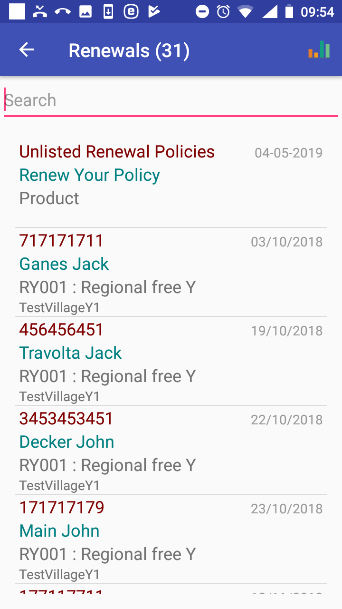

Image 1.7.3 (Renewals Page with displayed prompts)
Each renewal prompt contains the following data items:
- Insurance Number
The insurance number of the head of a family/group who holds the policy to be renewed.
- Name and Other Names
The full name of the head of the family/group.
- Insurance Product
The code and the name of an insurance product with which the policy should be renewed.
- Village
The village of residence of the family/group.
- Period
The period in which health care was provided.
The list of prompts can be temporarily reduced by entering a string in the Search field. Clicking on a selected prompt results in displaying of the Renew Page.
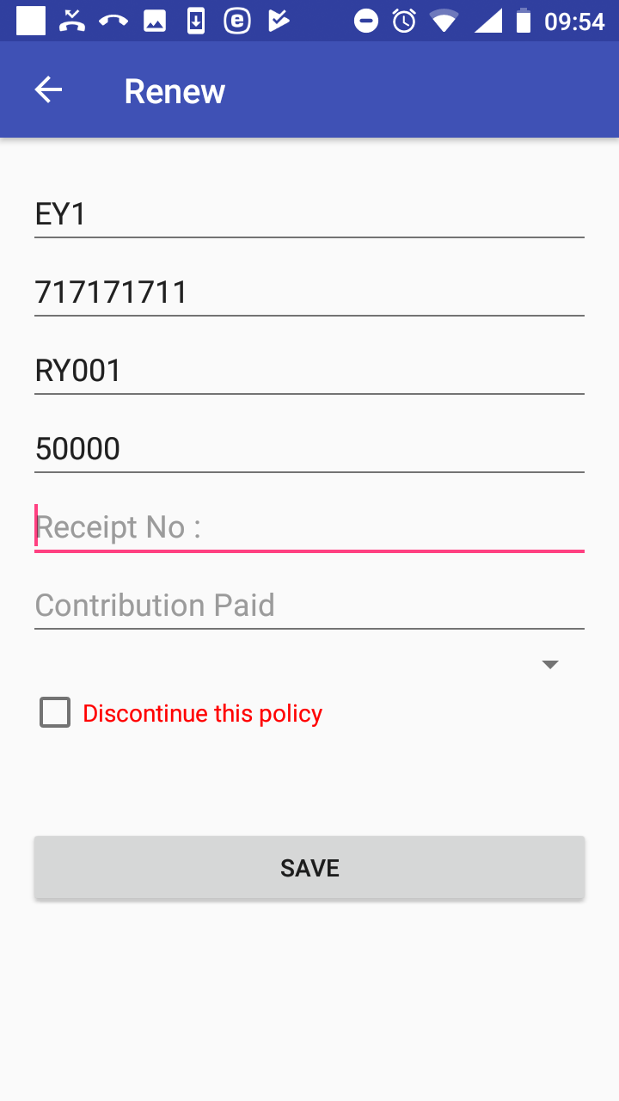

Image 1.7.4 (Renew Page - a specific prompt)
The following data fields are displayed:
- Enrolment Officer Code
Read-only data field. Pre-filled by the code of an enrolment officer with which the application is launched.
- Insurance Number
Read-only data field for a specific prompt. Pre-filled by the insurance number from the prompt. For the generic prompt, enter the insurance number for the policy to be renewed. Mandatory.
- Select Insurance Product
Read-only data field for a specific prompt. Pre-filled by the insurance product from the prompt. For the generic prompt, select from the drop down list the insurance product with which the policy renewed. Mandatory.
- Value of Renewed policy
Read-only data field for a specific prompt. Pre-filled by the value of the renewed policy that should be covered by a contribution. This data field is not given for the generic prompt.
- Receipt No.
Read-only data field for a specific prompt. Pre-filled by the value of the renewed policy that should be covered by a contribution. This data field is not given for the generic prompt.
- Contribution Paid.
The amount of contribution actually paid for the renewal. Mandatory..
- Select Payer
Select a payer of the contribution from the drop down list. Optional.
- Discontinue This Policy
Check the box if the policy should be not be renewed and it should be excluded from the list of renewal prompts. If checked the Renewals Page is displayed again and the corresponding prompt is removed from the list. This check box is not at disposal for the generic prompt.
Click on the button Save to save (post) the renewal data for this policy into the memory of the device. Subsequently it can be uploaded to the web IMIS by the function Synchronize. The Renewals Page is displayed after saving with the prompt just saved being removed.
Click on the icon <- in the upper part of the Renewals Page to return to the Home Page .

Function Feedback
The function Feedback is navigated to by clicking on the menu item Feedback in the main menu. The function Feedback allows getting of prompts for feedbacks on claims from the web IMIS and saving (posting) of feedbacks. A user must have a valid User Name and Password provided by an administrator of the web IMIS with an assigned role incorporating an access to the functionality Claims/Claim/Feedback as an access to the functionality Renew is guarded by the Login Page .
The Feedbacks Page appears after selecting Feedbacks in the main menu.

Image 1.8.1 (Feedbacks Page)
Swapping around the Feedbacks Page leads to the Login Page and after a successful login shows feedback prompts transferred from the web IMIS.
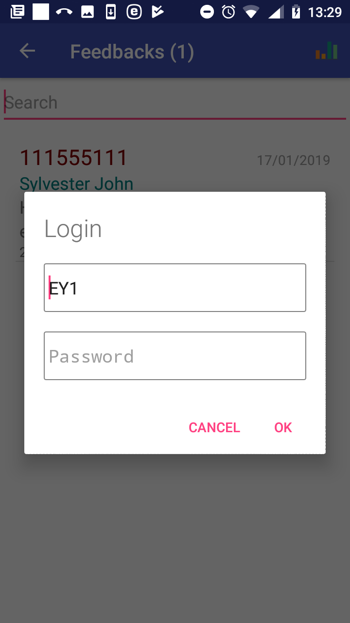

Image 1.8.2 (Feedbacks Page-Login Page)
The Feedbacks Page with prompts for acquiring feedbacks appears after the swap and the successful login.
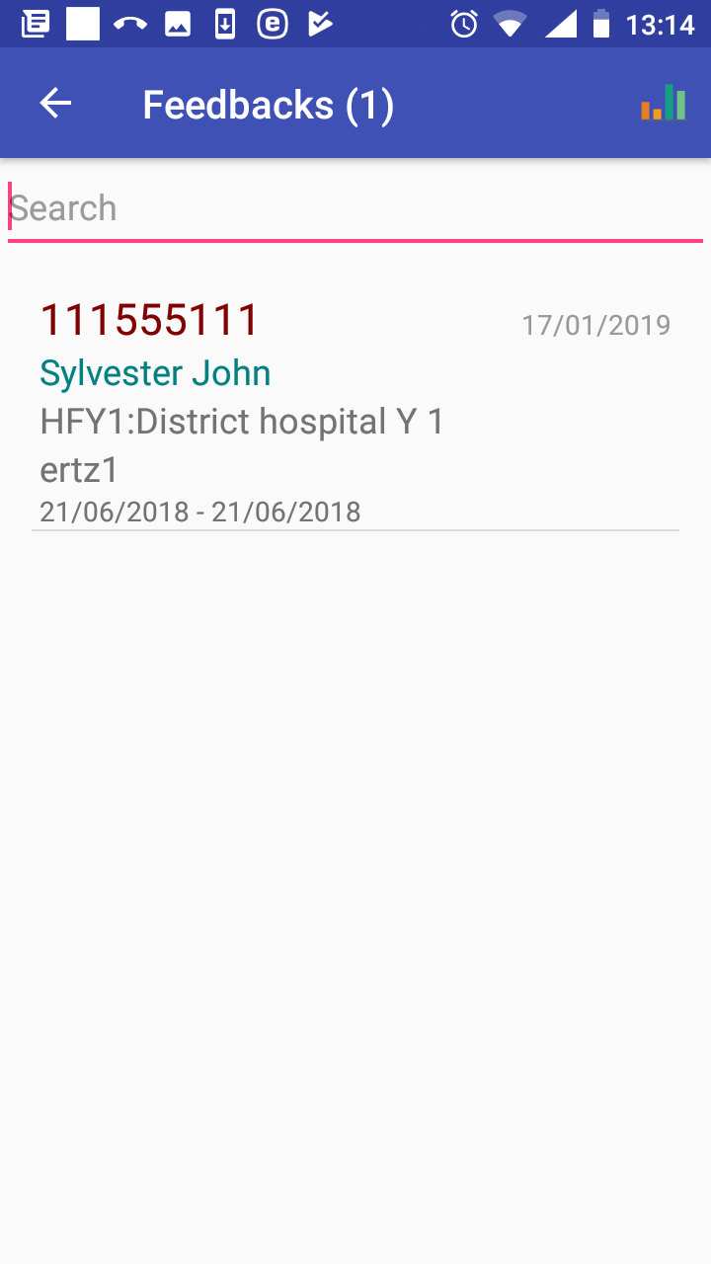

Image 1.8.3 (Feedbacks Page with displayed prompts)
The list of prompts can be temporarily reduced by entering a string in the Search field. Each feedback prompt contains the following data items:
- Insurance Number
The insurance number of a patient.
- Name and Other Names
The full name of the patient.
- Code and Name of Health Facility
The identification of a health facility that provided health care for which the feedback is asked.
- Code of Claim
The identification of a claim for which the feedback is asked.
- Period
The period in which health care was provided.
Clicking on a selected prompt results in displaying of the Feedback Page.
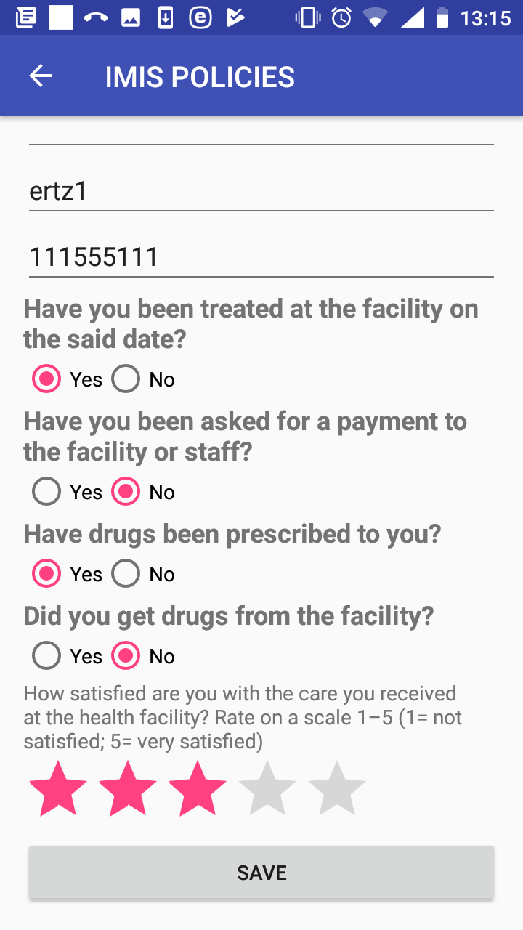

Image 1.8.4 (Feedback Page)
The following data fields are displayed:
- Enrolment Officer Code
The read-only data field. The code of the enrolment officer giving the feedback. The data field is populated by the code of the enrolment officer that launched the application.
- Code of Claim
The read-only data field. The identification of a claim for which the feedback is asked.
- Insurance Number
The read-only data field. The insurance number of the patient of a claim from whom the feedback is asked for.
- Feedback Questions
    - Have you been teated at the health facility on the said date?
    - Have you been asked for a payment to the health facility or staff?
    - Have been drugs prescribed to you?
    - Did you get drugs from the health facility?
Check the box either Yes or No.
- Overall Satisfaction Scale
Rate by clicking on an appropriate asterisk.
Click on the button Save to save (post) the feedback data for the claim into the memory of the device. Subsequently it can be uploaded to the web IMIS by the function Synchronize. The Feedbacks Page is displayed after saving with the prompt just saved being removed.
Click on the icon <- in the upper part of the Feedbacks Page to return to the Home Page .

Function Reports
The function Reports is navigated to by clicking on the menu item Reports in the main menu. The function Reports provides basic statistics on the numbers families/insurees/policies associated with the enrolment officer. The Report Page appears immediately:
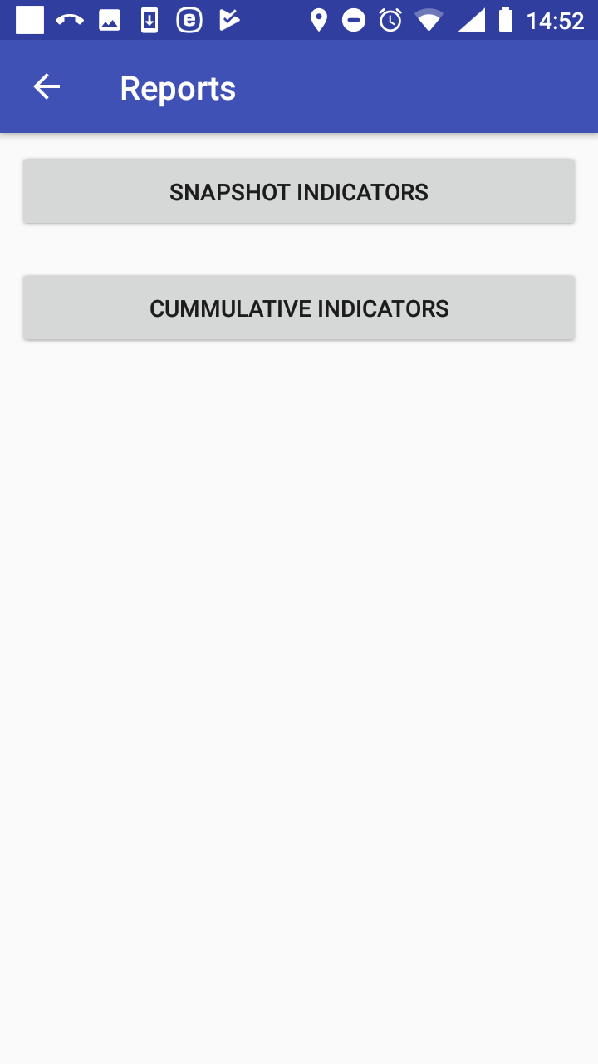

Image 1.9.1 (Reports Page)
Click on the button Snapshot Indicators to get data from the web IMIS on the date of reporting. The Snapshot Indicators Page appears:

Image 1.9.2 (Snapshot Indicators Page)
- Pick Date
Enter the date for which the snapshot statistics are required.
Click on the button Get to display the statistics in the Snapshot Indicators Page.
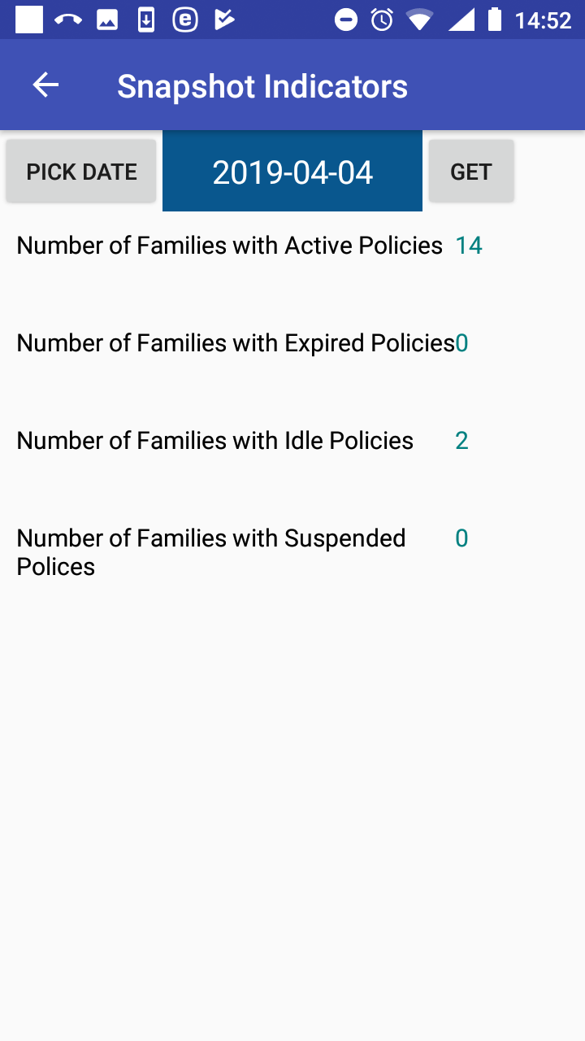

Image 1.9.3 (Snapshot Indicators Page with statistics)
The following indicators are provided on the date of creating of the report:
- Number of Families with Active Policies
The number of families/groups having at least one active policy managed by the enrolment officer for which the expiry date is after or on the date of creating of the report.
- Number of Families with Expired Policies
The number of families/groups having at least one expired policy managed by the enrolment officer for which there is no active follow-up policy of the same insurance product or its converted product entered into the web IMIS by the date of creating of the report.
- Number of Families with Idle Policies
The number of families/groups having at least one idle policy managed by the enrolment officer for which the date of expiry is after or on date of creating of the report and there is no active follow-up policy of the same insurance product or its converted product entered into the web IMIS by the date of creating of the report.
- Number of Families with Suspended Policies
The number of families/groups having at least one suspended policy managed by the enrolment officer for which the date of expiry is after or on date of creating of the report and there is no active follow-up policy of the same insurance product or its converted product entered into the web IMIS by the date of creating of the report.

Click on the icon <- in the upper part of the Snapshot Indicators Page to return to the Reports Page

Click on the button Cumulative Indicators to get data from the web IMIS on the date of reporting. The Cumulative Indicators Page appears:

Image 1.9.4 (Cumulative Indicators Page)
- Date From
Enter the starting date for which the cumulative statistics are required.
- Date To
Enter the last date for which the cumulative statistics are required.
Click on the button Get to display the statistics in the Cumulative Indicators Page.
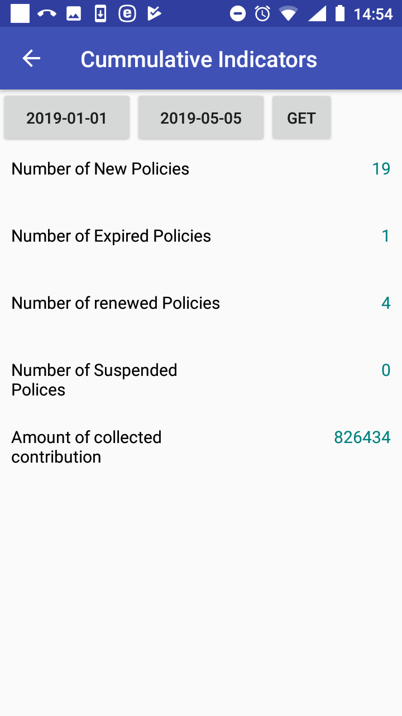

Image 1.9.5 (Cumulative Indicators Page with statistics)
The following cumulative indicators are provided for the specified period:
- Number of New Policies
The number of policies managed by the enrolment officer that were enrolled within the specified period irrespective of their status.
- Number of Renewed Policies
The number of policies managed by the enrolment officer that were renewed by the renewal functionality within the specified period irrespective of their status.
- Number of Expired Policies
The number of policies managed by the enrolment officer that expired within the specified period and they have no active follow-up policy of the same insurance product or its converted product entered into IMIS by the date of creating of the report.
- Number of Suspended Policies
The number of policies managed by the enrolment officer that were suspended within the specified period.
- Amount of Collected Contributions
The amount of contributions collected within the specified period for all policies managed by the enrolment officer.

Remark 1: All statistics are taken from the web IMIS irrespective whether policies originated in the application or were entered via the web IMIS.
Remark 2: The enrolment officer means the officer with the enrolment officer code that was entered while launching the application and all of its predecessors that he/she substituted directly or indirectly.

Click on the icon <- in the upper part of the Cumulative Indictors Page to return to the Reports Page

Function Synchronize
The function Synchronize is navigated to by clicking on the menu item Synchronize in the main menu. The function Synchronize uploads posted enrolments/renewals/feedbacks to the web IMIS. For on-line uploading a user must have a valid User Name and Password provided by an administrator of the web IMIS with an assigned role incorporating an access to the functionality Insurees and Familiies/Family +Insuree+Policy+Contribution/Add+Edit as an access to the functionality Synchronize is guarded by the Login Page for on-line uploads.
The Synchronize Page appears immediately:
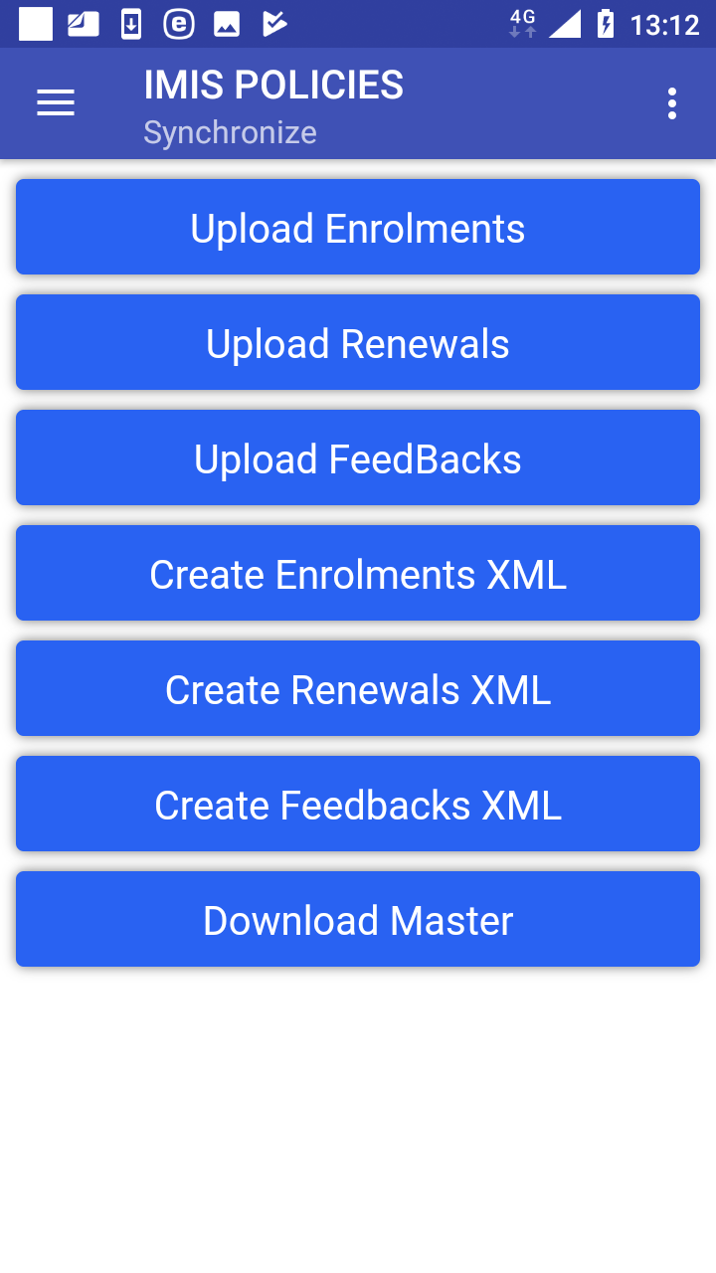

Image 1.10.1 (Synchronize Page)
Clicking on any of the buttons Upload Enrolments, Upload Renewals, Upload Feedbacks the Login Page appears.

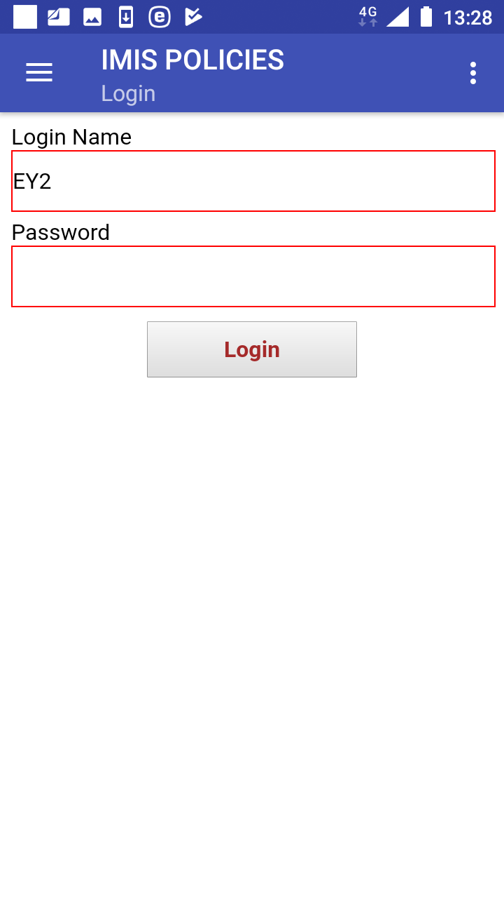

Image 1.10.2 (Synchronize Page – Login Page)
If the application successfully logs in the Synchronize Page appears again with the following buttons:

- Upload Enrolments
Uploads all enrolments including policies/contributions that haven’t been uploaded yet. It is required that each uploaded insuree has to have a foto associated with him/her.
- Upload Renewals
Uploads all renewals that haven’t been uploaded yet.
- Upload Feedbacks
Uploads all feedbacks that haven’t been uploaded yet.
- Download Master
Updates the master data in the device from the web IMIS. This update doesn’t require a login; nevertheless after the update entering of the enrolment officer code is required.

Another buttons in the Synchronize Page relate to the off-line mode of the application and they are described elsewhere.

Function Quit
The function Quit is navigated to by clicking on the menu item Quit in the main menu. The function Quit quits the application after Quit Confirmation.
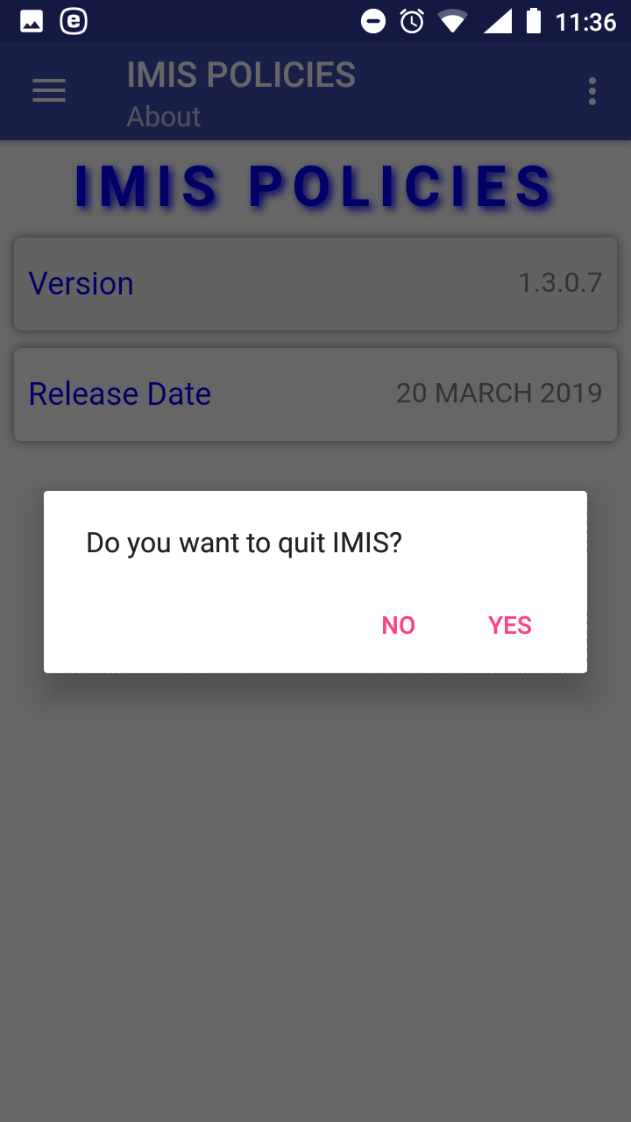

Image 1.11.1 (Quit confirmation prompt)

Function About
The function About is navigated to by clicking on the menu item About in the main menu. The function About provides information about the application itself. The About Page appears immediately:
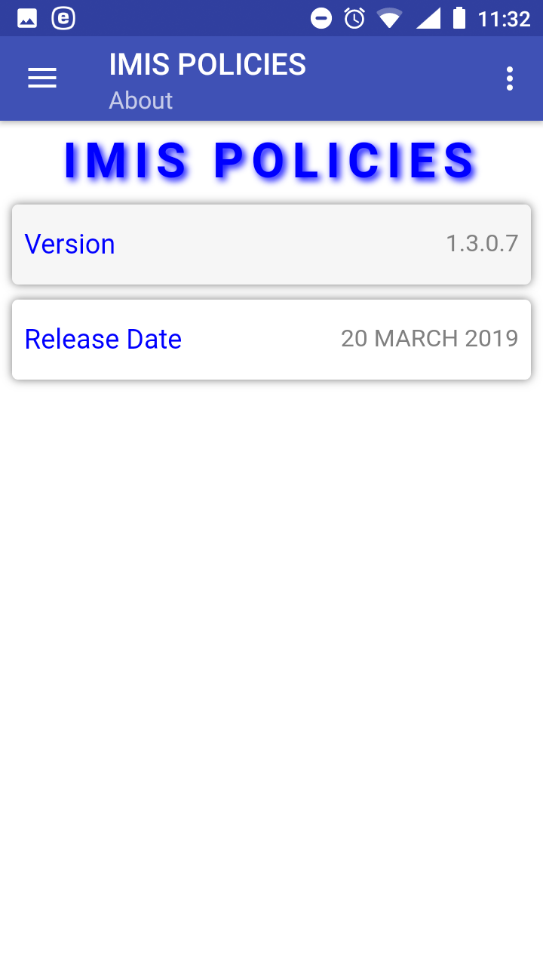

Image 1.12.1 (About Page)
Click on the icon <- in the upper part of the About Page to return to the Home Page.

The application IMIS Claims

Launching of IMIS Claims

To launch the application IMIS Claims just click on the icon of the application. Users must have a valid code of a claim administrator (entered in the register of claim administrators in the web IMIS) and for selected functionalities must have a valid User Name and Password provided by an administrator of the web IMIS. The User Name data field in login pages is pre-filled with claim administrator code entered while launching the application. The reason is that the web IMIS can create automatically a user record simultaneously with an entry of a new claim administrator into the register of claim administrators. Such automatically created user has its User Name equal to the claim administrator code. However, this pre-filled User Name can re-written by any valid User Name.
The Initial Page appears:

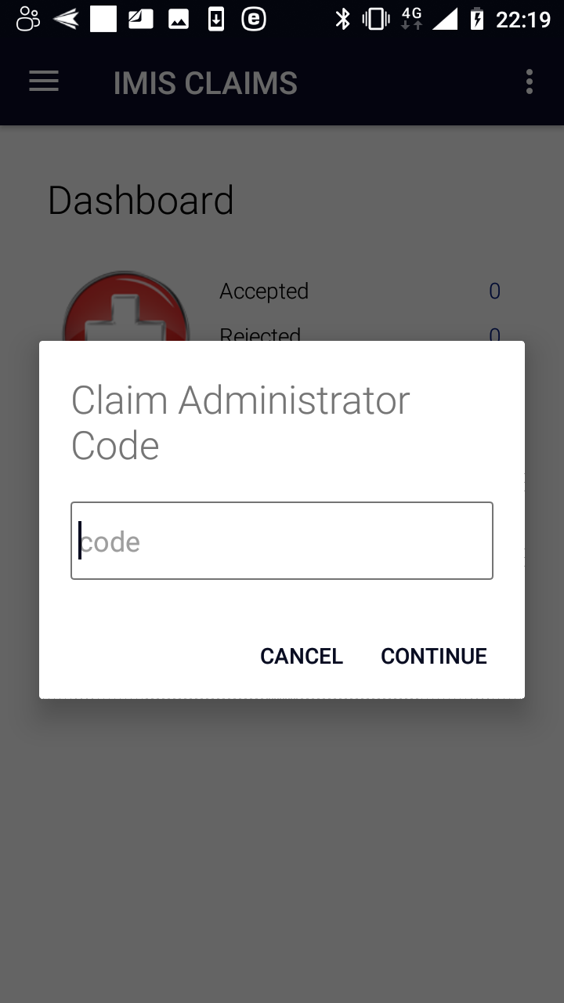

Image 2.1.1 (Initial Page)
Enter a valid claim administrator code and click on the button Continue. If a valid claim administrator code is entered, the application will re-direct to the Home Page

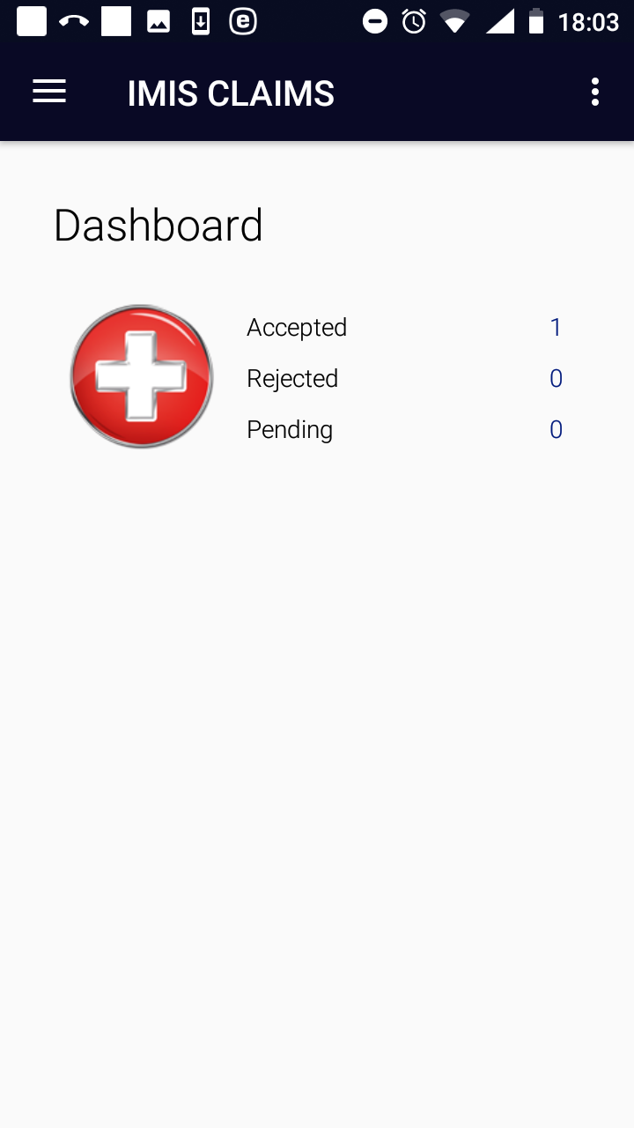

Image 2.1.2 (Home Page)
The statistics on the number of claims appears on the Home Page. The statistics is split into the number of claims that were uploaded and accepted by the web IMIS (Accepted), the number of claims uploaded but rejected (Rejected) and the number of claims saved (posted) but not uploaded yet (Pending) Quitting of the applications resets the statistics.
Clicking on the <three dots vertically> icon in the upper right corner the menu for selection of language of the user interface appears.
Clicking on the <three bars horizontally> icon in the upper left corner the main menu of the application appears:
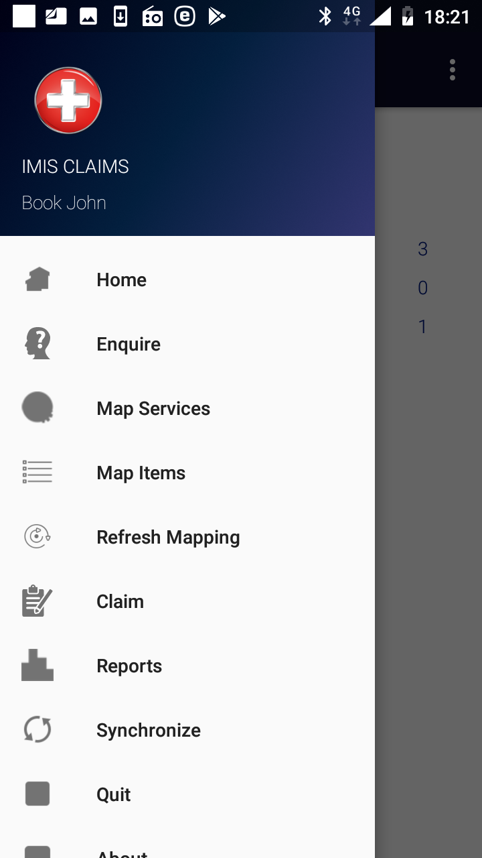

Image 2.1.3 (Main menu of the application)
The menu items stand for the following functionalities:
Home – return to the Home Page
Enquire – getting a photo and information on the coverage of an insure
Map Services – creation of a selected list of medical services guiding entry of services in claims
Map Items – creation of a selected list of medical items guiding entry of items in claims
Refresh Mapping – automatic creation of selected lists of medical services/items according to pricelists valid for the health facility for which the claim administrator is acting
Claim – entering and posting of claims
Reports – creation of reports relating to activities of the claim administrator
Synchronize – uploading data to the web IMIS
Quit –quitting of the application
About – info on the version of the installed application

Function Enquire
The function Enquire is navigated to by clicking on the menu item Enquire in the main menu. The function Enquire provides a photo and information of insurance coverage of a specified insuree. A user must have a valid User Name and Password provided by an administrator of the web IMIS with an assigned role incorporating an access to the functionality Insurees and Familiies/Insurees/Enquire as an access to the functionality Enquire is guarded by the Login Page .

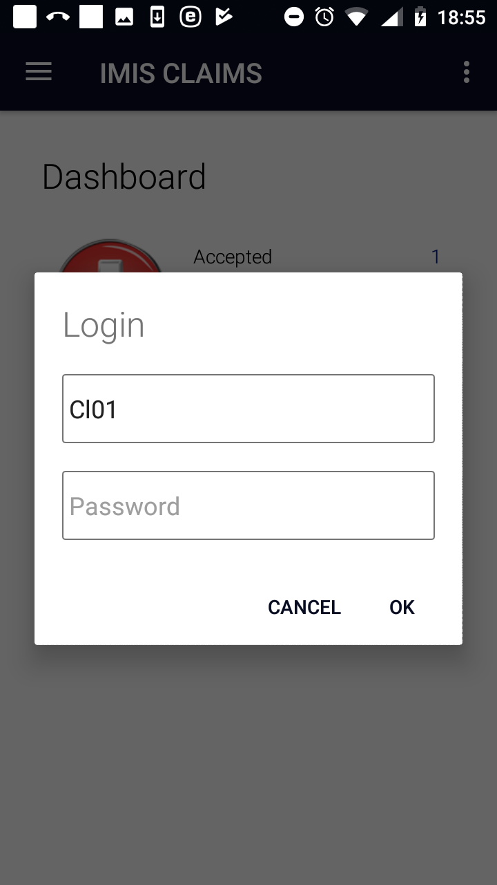

Image 2.2.1 (Enquire function –Login Page)
If the application successfully logs in successfully the Enquire Page appears:
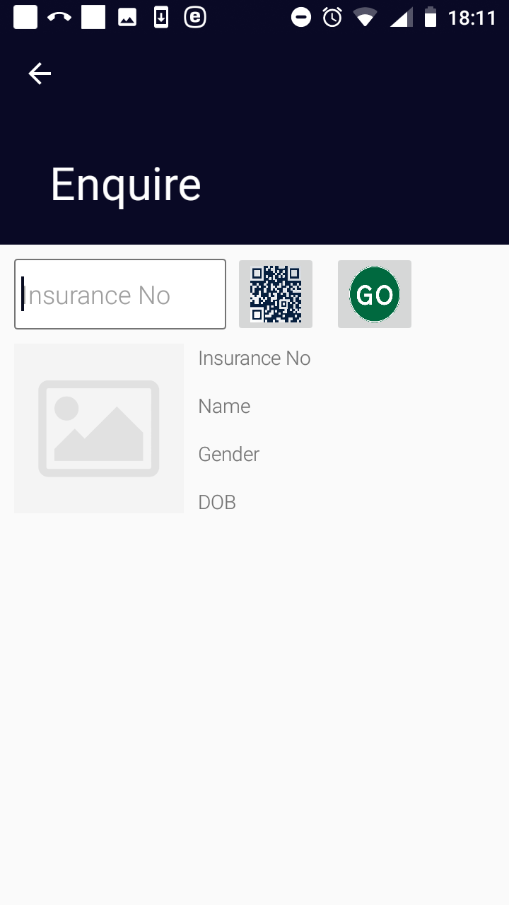

Image 2.2.2 (Enquire Page)
- Insurance Number
Either type in the insurance number of the insuree for whom identification and coverage data are to be retrieved or obtain the insurance number by scanning of a QR code by clicking on the QR button.
Click on the button GO! for retrieving the identification and coverage data.
If the insuree with the insurance number has been already entered in the web IMIS the following data appear on the Enquiry Page :
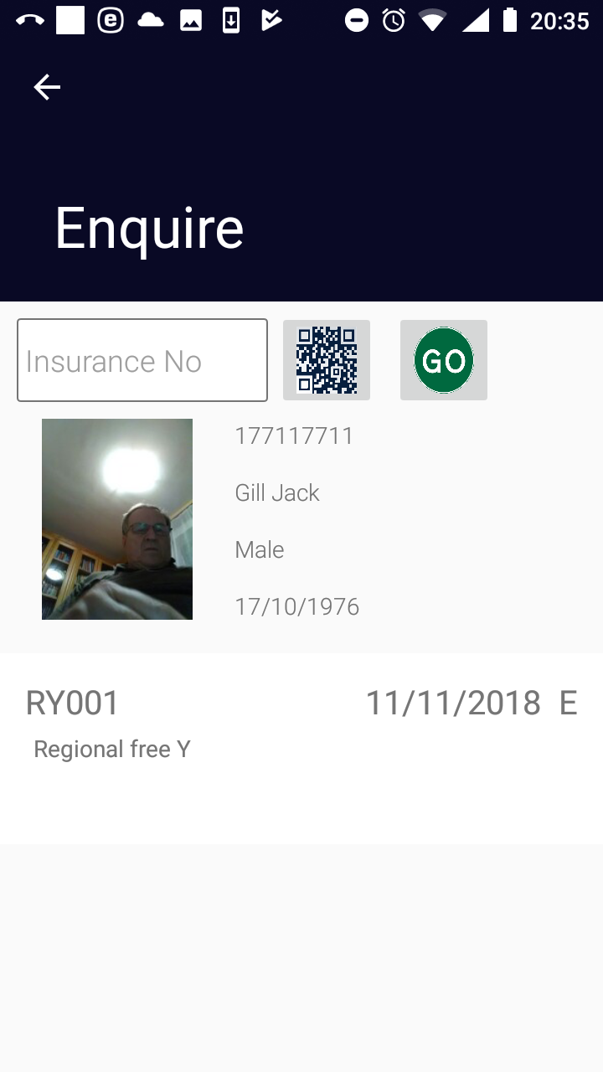

Image 2.2.3 (Enquiry Page-provided data on an insuree)
  - Photo of the insuree if the photo has been stored in the web IMIS
  - Insurance Number
  - Insuree Name
  - Gender
  - Birth Date

For each policy by which the insuree is covered the following data are shown:
  - Insurance Product Code
  - Insurance Product Name
  - Expiry Date of the Policy
  - Status of the Policy

Click on the icon <- in the upper part of the Enquire Page to return to the Home Page .

Function Map Services
The function Map Services is navigated to by clicking on the menu item Map Services in the main menu. The function Map Services allows customization of the list of medical services that will be used for entering of claims within the application. It could be regarded as manual creation of a payment list of medical services for purpose of the set-up of the application. The Map Services Page appears immediately:

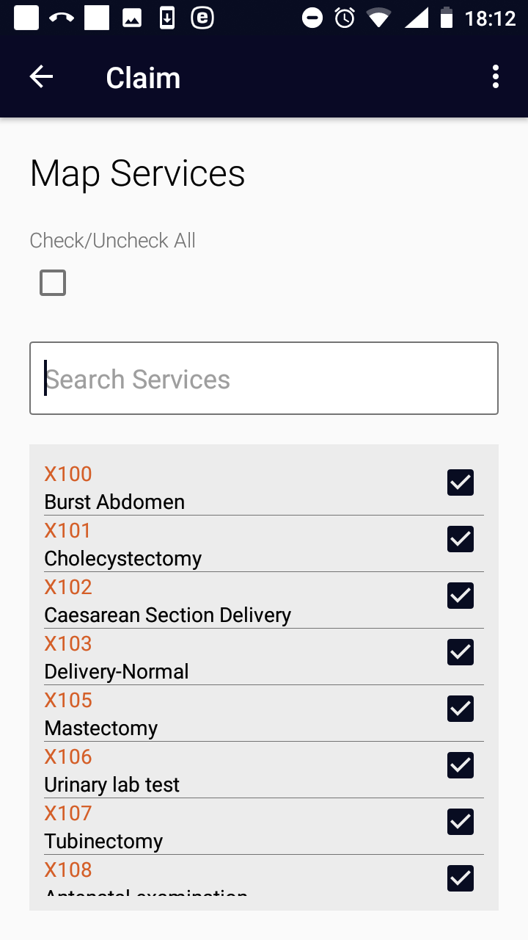

Image 2.3.1 (Map Services Page)
The Map Services Page lists all medical services from the register of medical services in the web IMIS with adjacent checking boxes. The displayed list can be constraint to only services containing a substring in their title and/or code in the box Search Services.
A customized list of services can be created either
a) checking of check boxes adjacent to selected medical services
or
b) reducing the total list of medical services by entering a substring into the box Search Services and checking the check box Check/Uncheck All.
Saving of the customized list of medical services is done by clicking on the <three dots vertically> icon in the upper right corner and clicking on the menu item Save. A confirmation box appears.
Click on the icon <- in the upper part of the Map Services Page to return to the Home Page.

Function Map Items
The function Map Items is navigated to by clicking on the menu item Map Items in the main menu. The function Map Items allows customization of the list of medical items that will be used for entering of claims within the application. It could be regarded as manual creation of a payment list of medical items for purpose of the set-up of the application. The Map Items Page appears immediately:

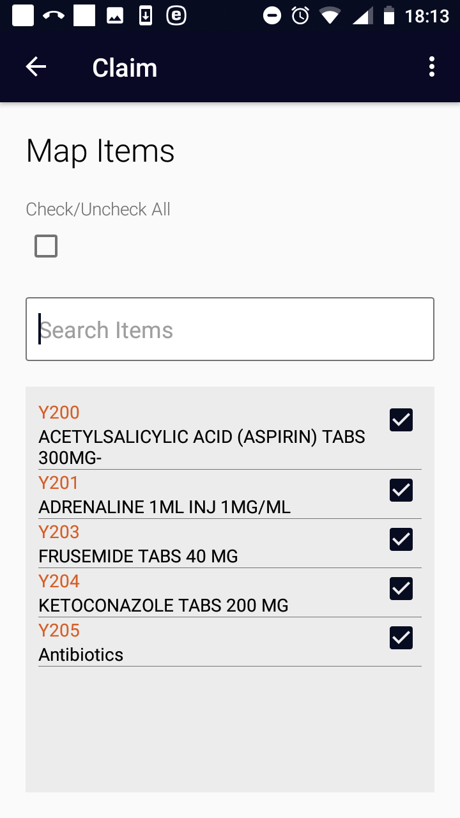

Image 2.4.1 (Map Items Page)
The Map Items Page lists all medical items from the register of medical items in the web IMIS with adjacent checking boxes. The displayed list can be constraint to only items containing a substring in their title and/or code in the box Search Items.
A customized list of items can be created either
a) checking of check boxes adjacent to selected medical items
or
b) reducing the total list of medical items by entering a substring into the box Search Items and checking the check box Check/Uncheck All.
Saving of the customized list of medical items is done by clicking on the <three dots vertically> icon in the upper right corner and clicking on the menu item Save. A confirmation box appears.
Click on the icon <- in the upper part of the Map Items Page to return to the Home Page.

Function Refresh Mapping
The function Refresh Mapping is navigated to by clicking on the menu item Refresh Mapping in the main menu. The function Refresh Mapping reflects valid payment lists of medical services/items from the web IMIS belonging to the health facility for which the claim administrator is acting to the lists of medical services/items used for entering of claims within the application. Subsequently, these lists can be further adjusted by the functions Map Services and Map Items. The confirmation prompt appears immediately:
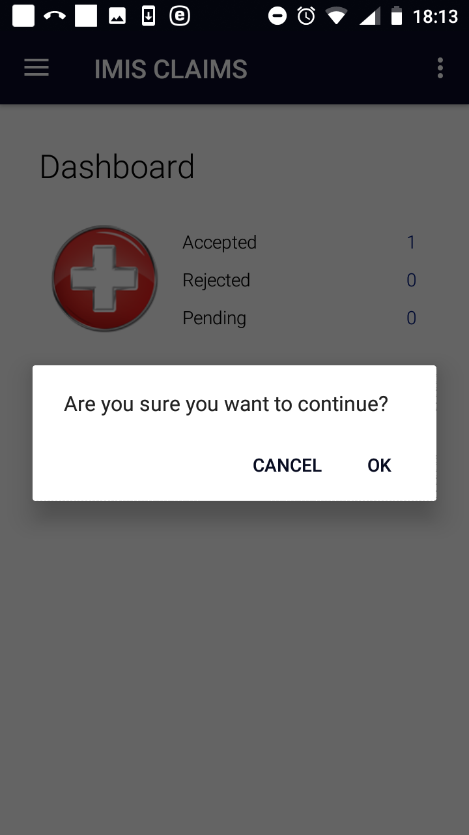

Image 2.5.1 (Confirmation Prompt-refreshing mapping)
Confirmation or refusing of refreshing of the mapping appears at the bottom of Home Page which is subsequently displayed.

Function Claim
The function Claim is navigated to by clicking on the menu item Claim in the main menu. The function Claim allows creating of claims and posting them in the memory before uploading them to the web IMIS. The Claim Page appears immediately:
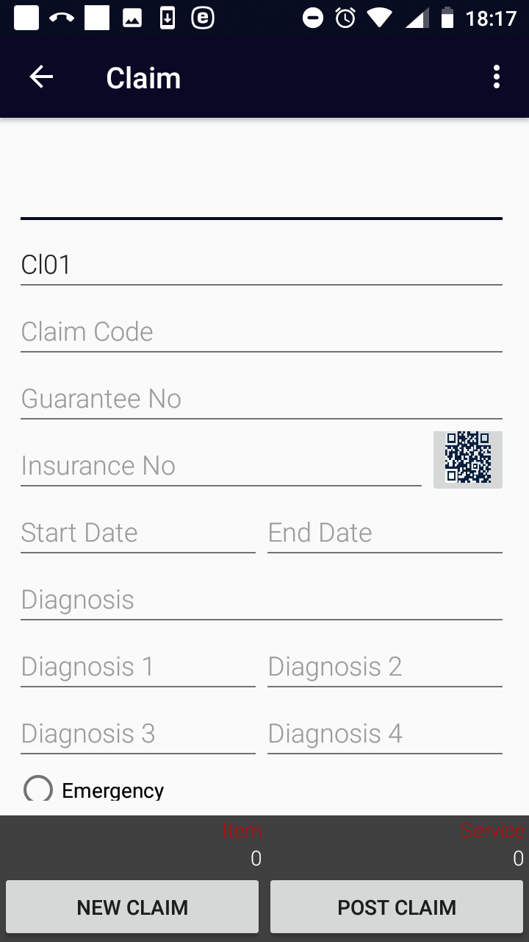

Image 2.6.1 (Claim Page)
The following data fields appear in the Claim Page:
- Health Facility Code
The code of the health facility for which the claim is created. The data field is prefilled by the code of the health facility for which the claim administrator is acting. Mandatory.
- Claim Admin
The code of the claim administrator that is responsible for creation of the claim. The data field is prefilled by the code of the claim administrator with which the application is launched. Mandatory.
- Claim Code
The code of the claim that is created. Mandatory.
- Guarantee No
The identification of an guarantee document associated with the claim. Optional.
- Insurance Number
Either type in the insurance number of the insuree for whom the claim is created or obtain the insurance number by scanning of a QR code by clicking on the QR button. Mandatory.
- Start Date
Tap on the data field and select a starting date of a contact of the insuree with the health facility for which the claim is created in the date selector. Mandatory.
- End Date
Tap on the data field and select an ending date of a contact of the insuree with the health facility for which the claim is created in the date selector. By default it is pre-filled with the starting date. Optional.
- Diagnosis
Select a main diagnosis from the drop down list of available diagnoses. Mandatory.
- Diagnosis 1-4
Select a secondary diagnosis (up to four ones) from the drop down list of available diagnoses. Optional.
- Visit Type
Select just one of the options: Emergency, Referral , Other. Mandatory.
Clicking on the <three dots vertically> icon in the upper right corner of the Claim Page the menu for selection of whether medical services/items should be entered.
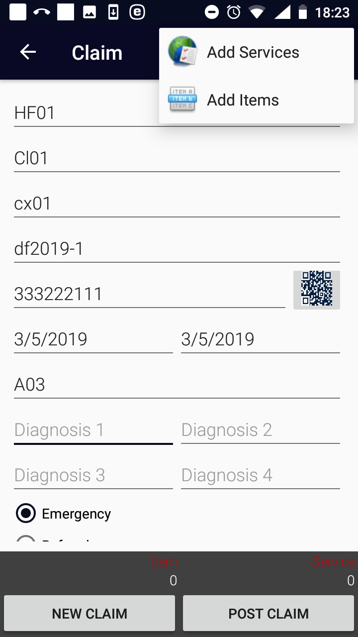

Image 2.6.2 (Claim Page – the menu for selection of the list of medical services/items)
Clicking on the menu item Add Services the Add Services Page and the following data fields appear.
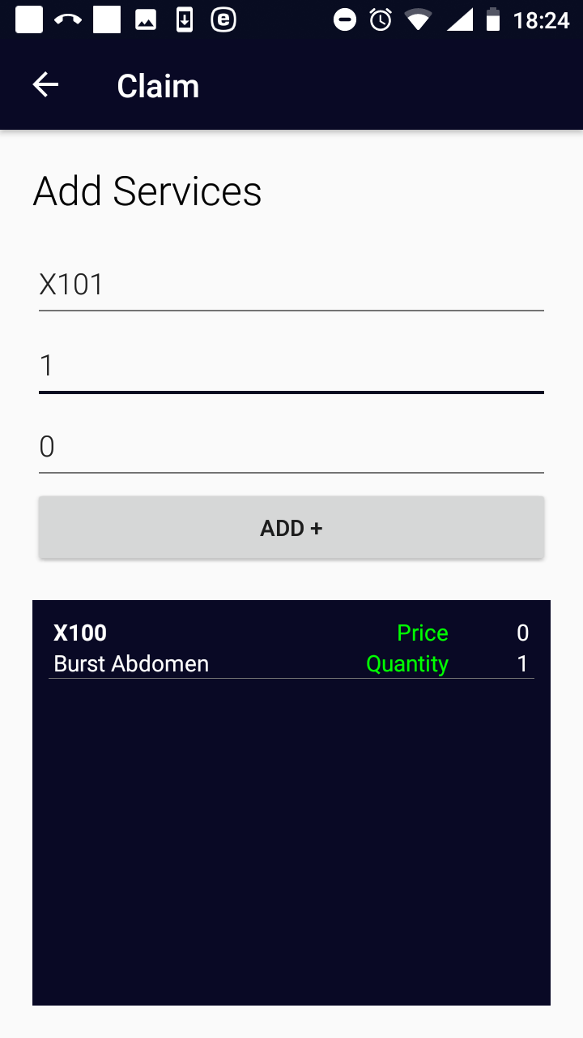

Image 2.6.3 (Add Services Page)
- Select Service
Click on the data field and write a letter that is present in the code or the name of a medical service that should be included. A list of available services (that is prepared within the function Map Services or Refresh Mapping) appears. Select an appropriate medical service from the list. Mandatory.
- Quantity
Enter the number of the medical service that should be included in the claim. The default is 1. Mandatory.
- Amount
Enter the price of the medical service that should be included in the claim. The price should be entered only if the medical service is designated in the corresponding definition of an insurance product in the web IMIS as a medical service with a price given by a health facility. Optional.
Click on the button ADD+ to the medical service to the claim. Click on the icon <- in the upper part of the Add Services Page to return to the Claim Page.
Clicking on the menu item Add Items the Add Items Page and the following data fields appear.
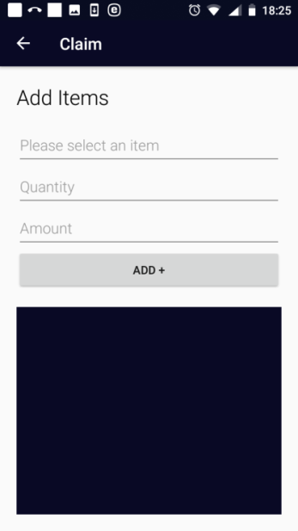

Image 2.6.4 (Add Items Page)
- Select Item
Click on the data field and write a letter that is present in the code or the name of a medical item that should be included. A list of available items (that is prepared within the function Map Items or Refresh Mapping) appears. Select an appropriate medical item from the list. Mandatory.
- Quantity
Enter the number of the medical item that should be included in the claim. The default is 1. Mandatory.
- Amount
Enter the price of the medical item that should be included in the claim. The price should be entered only if the medical item is designated in the corresponding definition of an insurance product in the web IMIS as a medical item with a price given by a health facility. Optional.
Click on the button ADD+ to add the medical item to the claim.
Click on the icon <- in the upper part of the Add Items Page to return to the Claim Page.

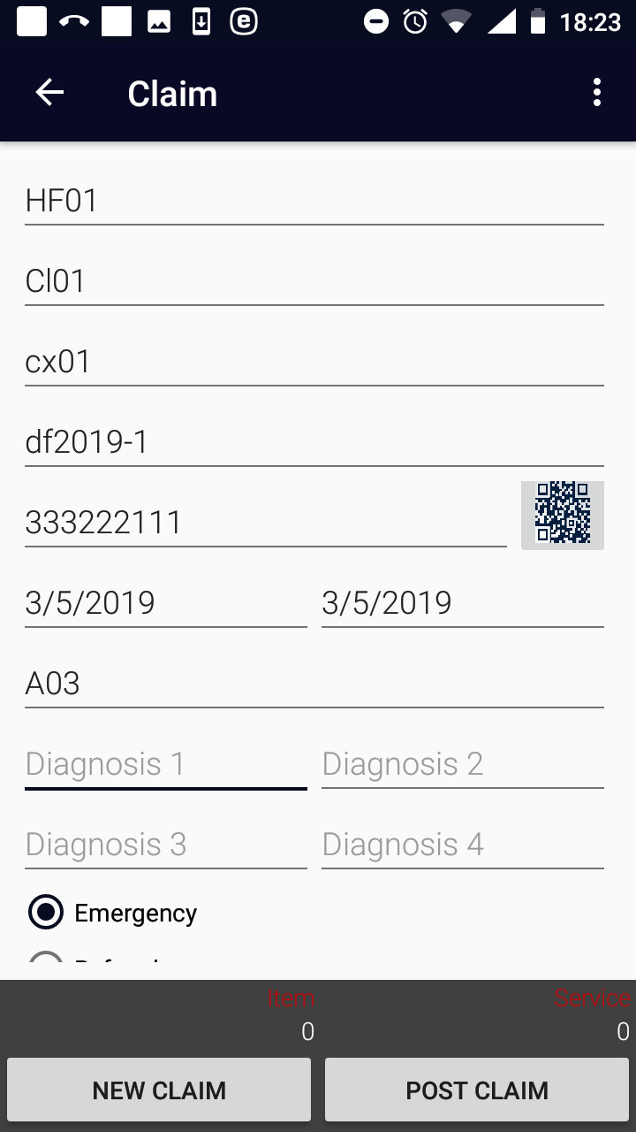

Image 2.6.5 (Claim Page)
Click on the button Post Claim to save just created claim in the memory of the device.
Click on the button New Claim to clear the data fields (with exception Health Facility Code and Claim Admin) and to prepare the Claim Page to an entry of another claim.
Click on the icon <- in the upper part of the Claim Page to return to the Home Page .

Function Reports
The function Reports is navigated to by clicking on the menu item Reports in the main menu. The function Reports provides basic statistics on the numbers of accepted, rejected and not yet uploaded (pending) claims in the memory of the device (without respect to a claim administrator). The Report Page appears immediately:
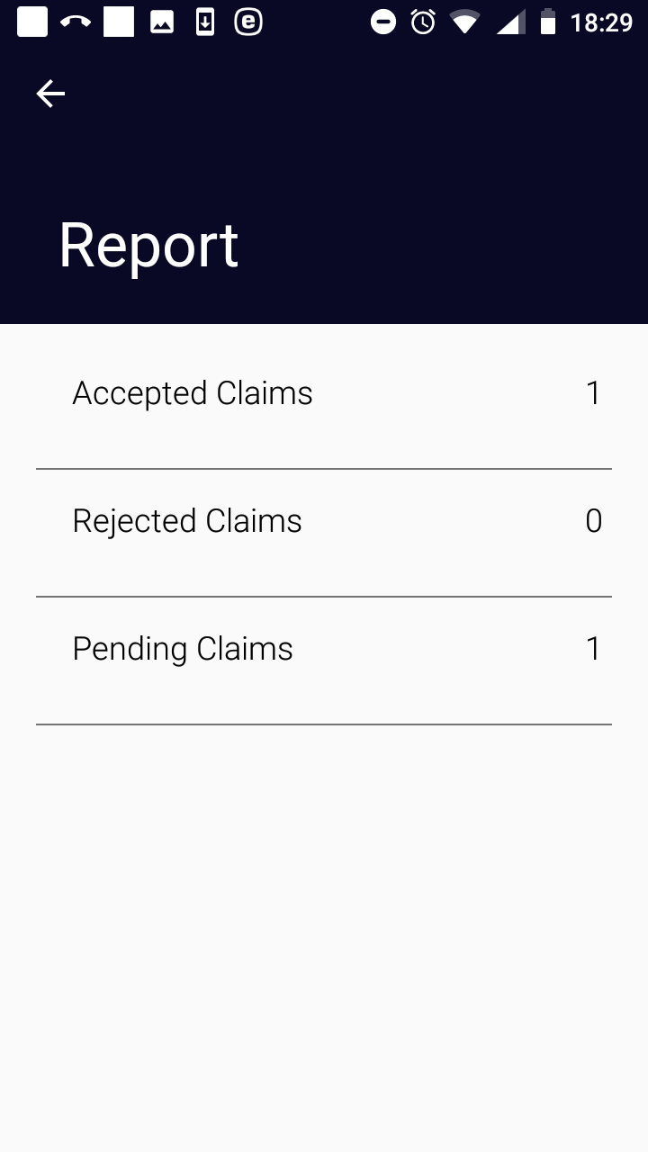

Image 2.7.1 (Report Page)

Function Synchronize
The function Synchronize is navigated to by clicking on the menu item Synchronize in the main menu. The function Synchronize uploads posted claims to the web IMIS. For on-line uploading a user must have a valid User Name and Password provided by an administrator of the web IMIS with an assigned role incorporating an access to the functionality Claims/Claim/Add as an access to the functionality Synchronize is guarded by the Login Page for on-line uploads.
The Synchronize Page appears immediately:
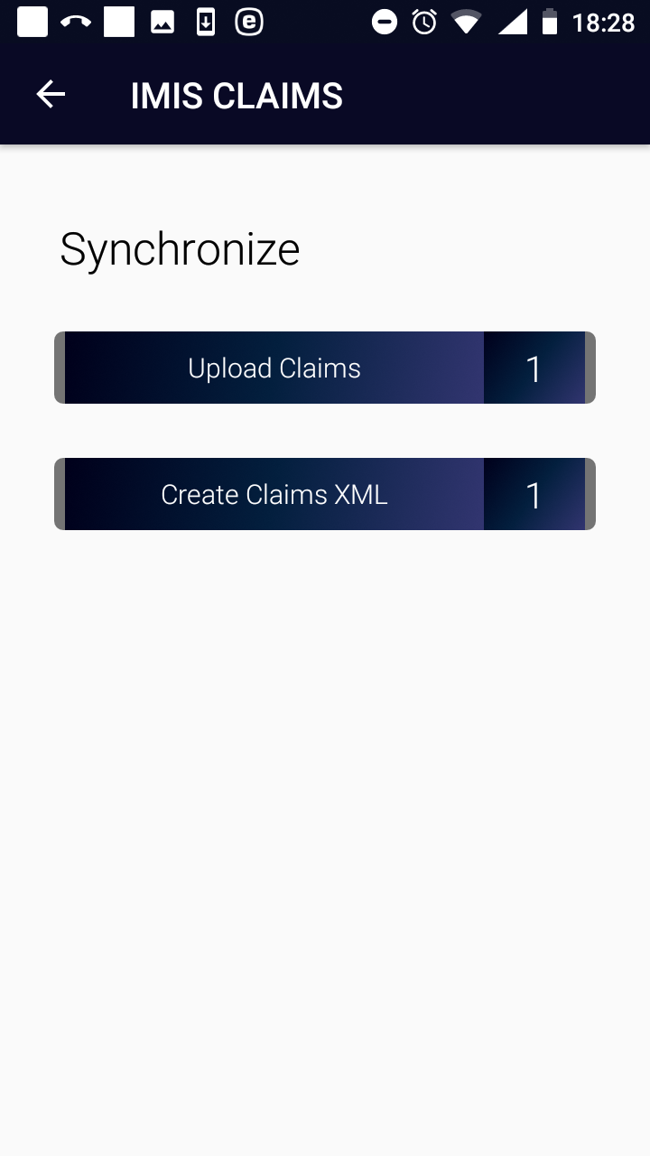

Image 2.8.1 (Synchronize Page)
There are two buttons:
Upload Claims for on-line uploading of saved claims to the web IMIS.
Create Claims XML for generation of a file (in the XML format) for off-line uploading of saved claims to the web IMIS-see the off-line mode of IMIS Claims.
On-line uploading of claims is guarded by the Login Page:
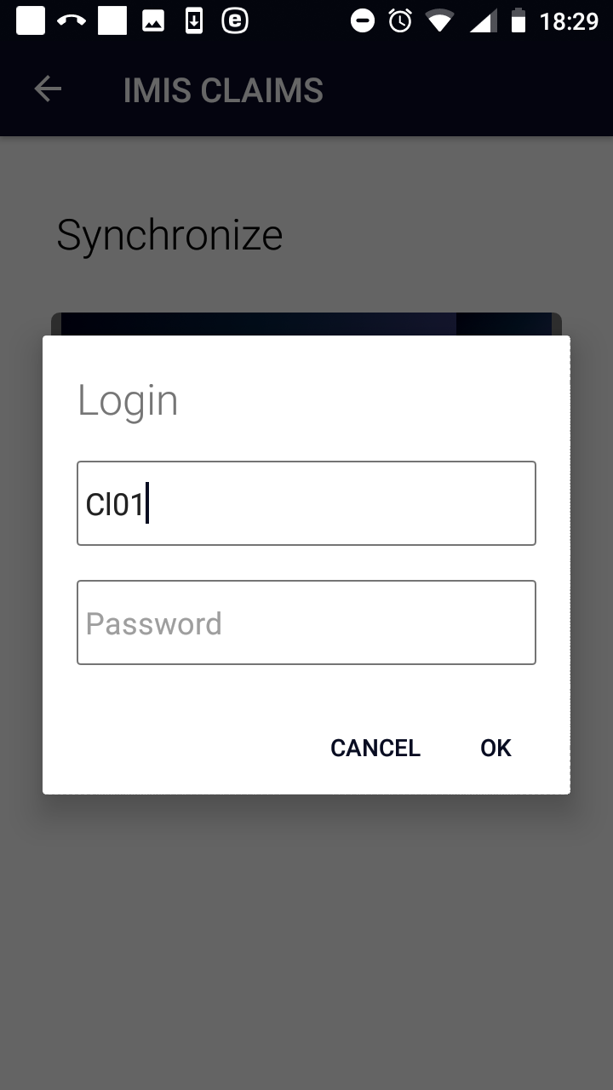

Image 2.8.2 (Synchronize Page-Login Page)
If the login process is successful then click on the Upload Claims button to upload claims to the web IMIS. Claims that are successfully uploaded are saved in the folder IMIS/Accepted Claims. Unseccussfully uploaded claimes are saved in the folder IMIS/Rejected Claims.

Function Quit
The function Quit is navigated to by clicking on the menu item Quit in the main menu. . The function Quit quits the application after Quit Confirmation.

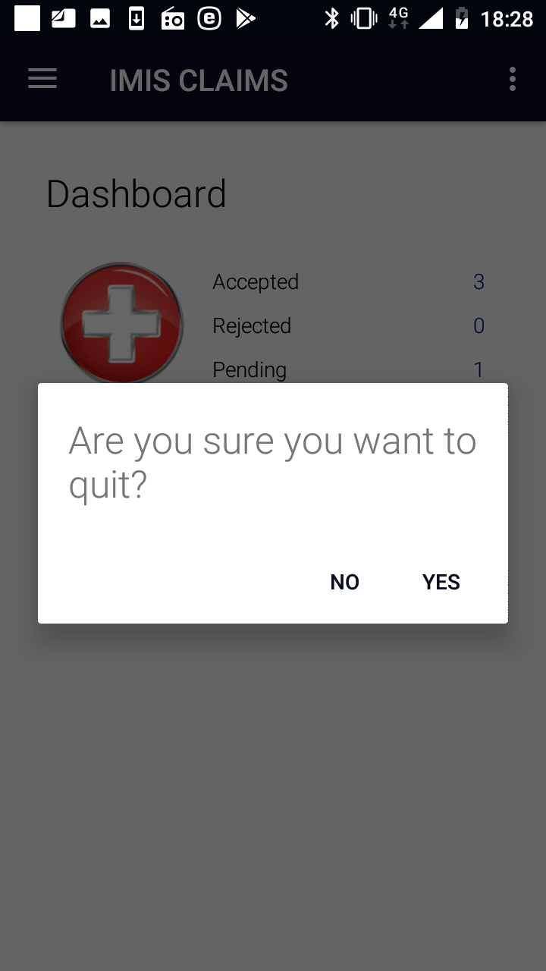

Image 2.9.1 (Quit Confirmation)

Function About
The function About is navigated to by clicking on the menu item About in the main menu. The function About provides information about the application itself. The About Page appears immediately:

Image 2.10.1 (About Page)
Click on the icon <- in the upper part of the About Page to return to the Home Page.

Off-line mode of the applications
The applications IMIS Policies and IMIS Claims require for certain functions Internet connectivity for communication with the web IMIS. Other functions of both applications can be used autonomously without availability of Internet connectivity. There is a possibility to move to a place where Internet connectivity is ensured only for time when functions requiring Internet connectivity are used (e.g. initialization of an application, synchronization etc.) and use autonomous functions in settings without Internet connectivity. However, this may not be practical or even possible in all situations. Therefore, there is a possibility to substitute on-line connection for some functions by off-line transfer of files from/to the web IMIS. Thus, utilization of the application in an environment without Internet connectivity is guaranteed.

Off-line mode of IMIS Policies
The following table gives an overview of functions according to their requirements towards Internet connectivity and possible off-line substitutions.
IMIS Policies
Functionality | connectivity required /autonomous | Off-line substitution
Initial launching | connectivity required | yes, by off-line transfer of the Master Data
Enquire | connectivity required | not available
Acquire | autonomous | not needed
Enrol | autonomous | not needed
Modify | connectivity required | not available
Control Numbers | connectivity required | not available
Renew | connectivity required | yes, by off-line transfer of the Renewal Data
Feedback | connectivity required | yes, by off-line transfer of the Feedback Data
Reports | connectivity required | not available
Synchronize | connectivity required | yes, off-line synchronization by XML files
Quit | autonomous | not needed
About | autonomous | not needed

Creation and transfer of off-line files to IMIS Policies
The off-line files for IMIS Policies is created in the web IMIS by selecting of the Tools/Extracts menu item. The form IMISExtracts is displayed.

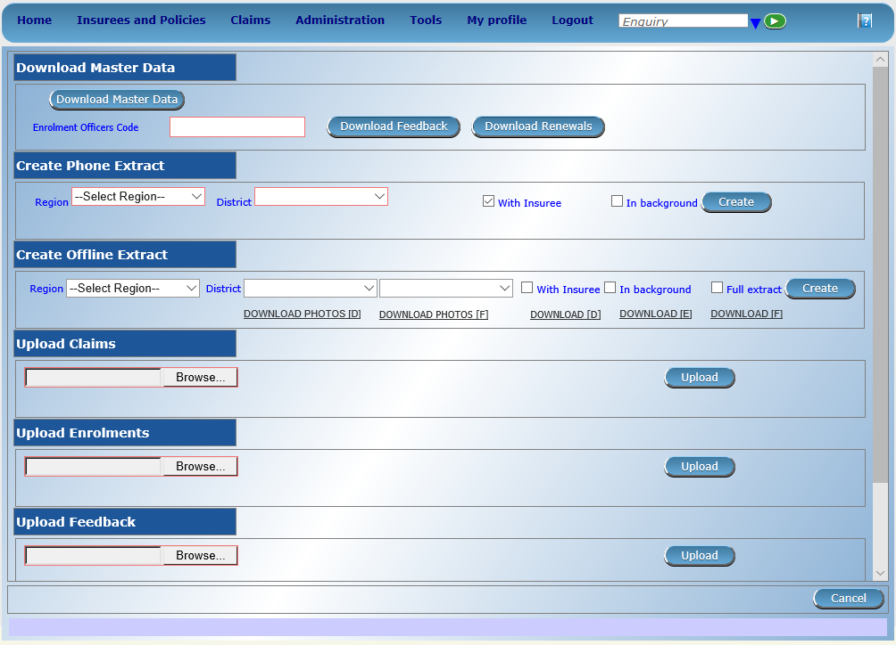

Image 3.1.1 (IMISExtracts Form)
The Download Master Section is used for creation of the off-line files for IMIS Policies.
- Enrolment Officer Code
The code of an enrolment officer for whom the off-line files should be generated.

Click on the button:
- Download Master Data
The file MasterData.rar is generated.
- Download Renewals
The file Renewals_<enrolment officer code>.RAR is generated. It contains renewal prompts associated with the enrolment officer at the time.
- Download Feedbacks
The file Feedbacks_<enrolment officer code>.RAR is generated. It contains feedback prompts associated with the enrolment officer at the time.

The off-line files should be transferred to the device and stored in any folder (Renewals_<code>, Feedbacks_<code>) and in the folder IMIS/Database (MasterData). The off-line files Renewals_<code> and Feedbacks_<code> are selected by the user after swapping in the Renewals Page and Feedbacks Page .

Creation and transfer of off-line files from IMIS Policies
Use the function Synchronize and the following buttons:

Image 3.1.2 (Synchronize Page)
- Create Enrolments XML
Creates a file with all enrolments including policies/contributions that haven’t been uploaded or included in a generated file yet. It is required that each insuree has to have a photo associated with him/her. The name of the file is Enrolment_<enrolment officer code>_<date of creating>_<time of creating>.rar and it is stored in the folder IMIS/Enrolment.
- Create Renewals XML
Creates a file with all renewals that haven’t been uploaded or included in a generated file yet. The name of the file is MasterRenewal.rar and it is stored in the folder IMIS.
- Create Feedbacks XML
Creates a file with all feedbacks that haven’t been uploaded or included in a generated file yet. The name of the file is MasterFeedback.rar and it is stored in the folder IMIS.

The off-line files should be transferred to a client device of the web IMIS and uploaded to the web IMIS by means of the IMISExtracts form – in the sections Upload Enrolment, Upload Renewal, Upload Feedback.

Off-line mode of IMIS Claims

The following table gives an overview of functions according to their requirements towards Internet connectivity and possible off-line substitutions.
IMIS Claims
Functionality | connectivity required /autonomous | Off-line substitution
Initial launching | connectivity required | yes, by off-line transfer of a phone extract
Enquire | connectivity required | yes, by off-line transfer of a phone extract
Map Services | autonomous | not needed
Map Items | autonomous | not needed
Refresh Mapping | connectivity required | not available
Claim | autonomous | not needed
Reports | autonomous | not needed
Synchronize | connectivity required | yes, off-line synchronization by XML files
Quit | autonomous | not needed
About | autonomous | not needed

Creation and transfer of off-line files to IMIS Claims
The off-line files for IMIS Claims is created in the web IMIS by selecting of the Tools/Extracts menu item. The form IMISExtracts is displayed.

Image 3.2.1 (IMISExtracts Form)
The Create Phone Extract section is used for creation of the off-line file for IMIS Claims.
- Region
The region in which a health facility is located for which claims should be created.
- District
The district in which the health facility is located for which claims should be created.
- With Insurees
Check if the off-line file should contain data on insures (for the function Enquiry).
- In background
Check if the off-line file should be created in background.

Click on the button:
- Create
The file IMISData.db3 is generated and it can be downloaded by clicking on the button Download which is dynamically created in the section

The off-line file IMISData.db3 should be transferred to the device and stored in the folder IMIS.

Creation and transfer of off-line files from IMIS Claims
Use the function Synchronize and the following buttons:
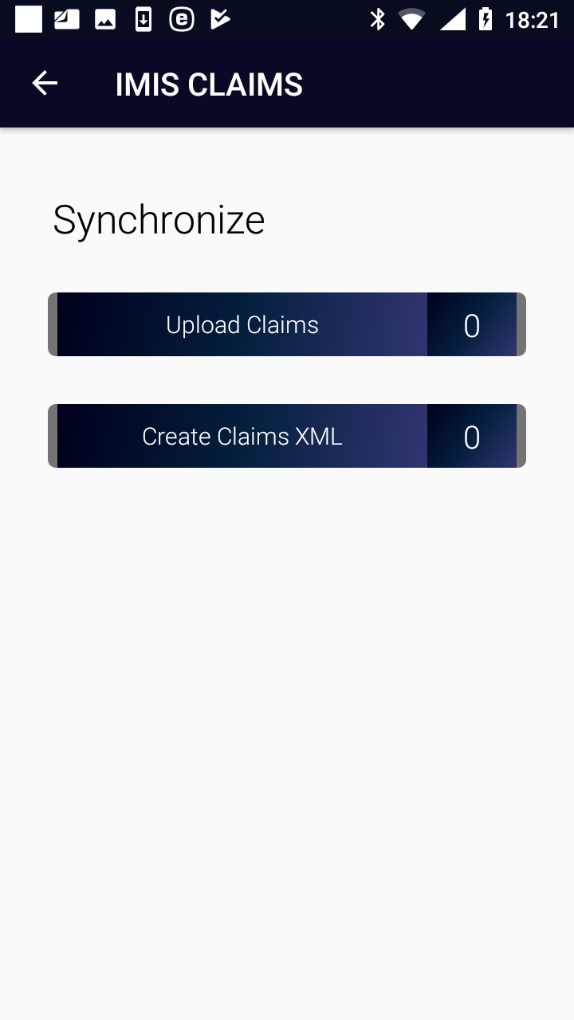

Image 3.2.1 (Synchronize Page)
- Create Claims XML
Creates a file with all claims that haven’t been uploaded or included in a generated file yet.. The name of the file is Claims_<claim adminstrator code>_<date of creating>_<time of creating>.rar and it is stored in the folder IMIS in the device.
.

The off-line files should be transferred to a client device of the web IMIS and uploaded to the web IMIS by means of the IMISExtracts form – in the section Upload Claims.

