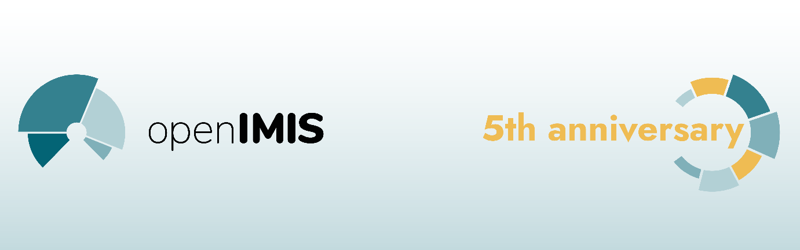

openIMIS Newsletter February 2021

openIMIS is turning five, let`s celebrate! Starting from April 2021 we are planning a variety of events and as part of the anniversary campaign, we would like to look back on what we have achieved throughout the years. Rather than just capturing technical advances and numbers related to the software, lets also focus on those who brought us there – the community. Show us your highlights and memories linked to openIMIS. Whether these document funny situations, bold strikes in implementations at place or your eye-opening moments in software development. There are three ways how you can contribute:
1. Send your memories (storys, pictures, or video clips) to contact@openimis.org. Due to private policy guidelines please also attach a filled-out declaration of consent. We will coordinate and post the files on sutori.com, an interactive timeline.
2. Give us a personal testimonial via this openIMIS wiki page. Just follow the Instructions there (user account required).
3. The openIMIS 5th Anniversary needs a catchy slogan! Please help us to come up with something that will guide us through the campaign. Get more info's and enter your ideas here (user account required).

New Logo
We are also taking the opportunity of the 5th Anniversary of openIMIS to refresh our logo. Together with the new logo, we have also updated our corporate identity materials that includes various forms of the logo, templates, style guides and new materials for celebrating the 5th Anniversary! You can find all of them here.

Community Meeting 2021
During the second half of March this year we will host our virtual community meeting. The event will be taking place in three instances: Community, product development and implementation. During this time implementers, developers, user organizations and partners of the initiative will jointly showcase the various aspects of openIMIS. Learn more about the concrete objectives and how you can participate on our wiki.

Copyright © 2020 openIMIS, All rights reserved.
You are receiving this email because you opted in via our website.
Our mailing address is:
openIMIS
Friedrich-Ebert-Allee 36
Bonn 53113
Germany
Want to change how you receive these emails?
You can update your preferences or unsubscribe from this list.

